ADRIFT in the Greater Farallones and Cordell Bank Sanctuary: Passive Acoustic Monitoring in the California Current using Drifting Recorders

[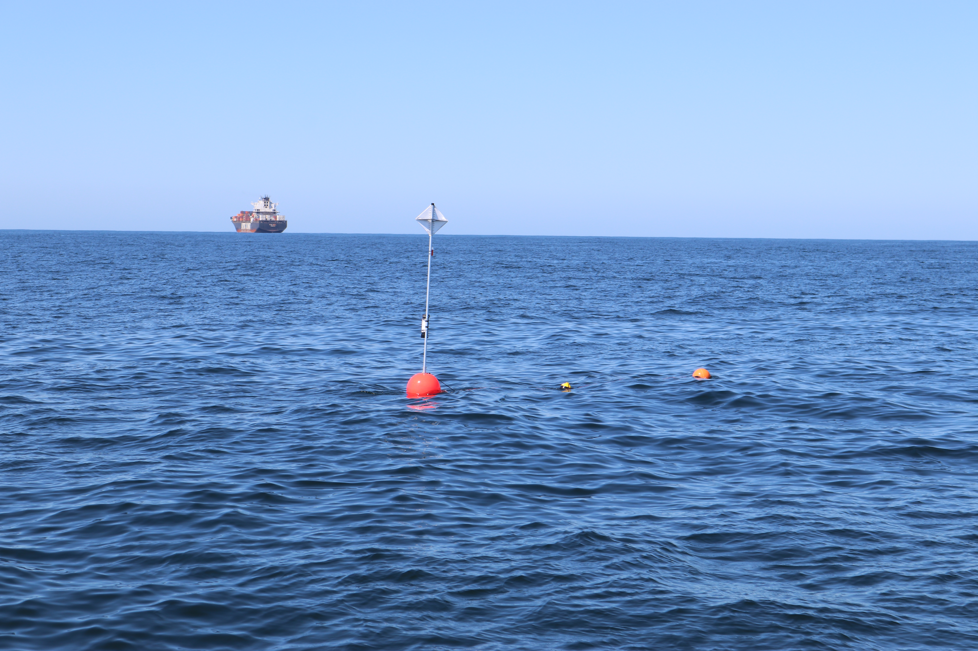](https://github.com/shannonrankin/ADRIFT_Report/blob/main/figs/drifterShip_Rankin_SWFSC_ACCESS_2021_MULTI-2019-005.JPG)

ADRIFT in the Greater Farallones and Cordell Bank Sanctuary: Passive Acoustic Monitoring in the California Current using Drifting Recorders

October, 2024

Authors:

Shannon Rankin

Anne Simonis

Kourtney Burger

Cory Hom-Weaver

Kaitlin Palmer

Taiki Sakai

Southwest Fisheries Science Center

NOAA Fisheries

8901 La Jolla Shores Dr. La Jolla, CA 92037

**DISCLAIMER**

This study was funded, in part, by the U.S. Department of the Interior, Bureau of Ocean Energy Management (BOEM), Environmental Studies Program, Washington, DC, through Interagency Agreement Number G14M20PG00013 with the Southwest Fisheries Science Center. This report has been technically reviewed by BOEM, and it has been approved for publication. The views and conclusions contained in this document are those of the authors and should not be interpreted as representing the opinions or policies of BOEM, nor does mention of trade names or commercial products constitute endorsement or recommendation for use.

**REPORT AVAILABILITY**

To download a PDF file of this report, go to the U.S. Department of the Interior, Bureau of Ocean Energy Management Data and Information Systems webpage (<http://www.boem.gov/Environmental-Studies-EnvData/>), click on the link for the Environmental Studies Program Information System (ESPIS), and search on 2024-047. The report is also available at the National Technical Reports Library at <https://ntrl.ntis.gov/NTRL/>.

**CITATION**

Rankin, S., Burger, K., Hom-Weaver, C., Palmer, K., Sakai, T., Simonis, A. (Southwest Fisheries Science Center, NOAA Fisheries, La Jolla, CA). 2024. Final Report for Adrift in the California Current Survey: Passive Acoustic Monitoring in the California Current using Drifting Recorders. Camarillo (CA): U.S. Department of the Interior, Bureau of Ocean Energy Management. 98 p. Report No.: OCS Study BOEM 2024-047. Contract No.: G14 M20PG00013.

**ABOUT THE COVER**

A drifting acoustic recorder floats offshore San Francisco with a large container ship in the background. Photo Credit Shannon Rankin, Southwest Fisheries Science Center, NOAA Fisheries.

**ACKNOWLEDGMENTS**

This project benefited from a large number of partnerships with external organizations, including: San Francisco State University (Marina Bozinovic, Jackson Vanfleet Brown), Moss Landing Marine Labs (Jack Barkowski, Alison Stimpert), National Marine Sanctuary Foundation (Lindsey Peavey, Erin Jaszczak, Cassandra Erickson), Greater Farallones National Marine Sanctuary (Jan Roletto), Cordell Bank National Marine Sanctuaries (Dani Lipski), NOAA's Ocean Acoustics Program (Jason Gedamke). We also thank the captain and crew of the R/V *Shearwater* and the R/V *Fulmar*.

This study was funded in part by the U.S. Department of the Interior, Bureau of Ocean Energy Management through Interagency Agreement M20PG00013 with the U.S. Department of Commerce, National Oceanic and Atmospheric Administration, National Marine Fisheries Service (NMFS), Southwest Fisheries Science Center (SWFSC).

Contents

List of Figures v

List of Tables vii

List of Abbreviations and Acronyms viii

1. Background 1

2. Objectives 2

3. Study Area 3

4. Drifting Recorders 8

5. Marine Mammal Detections 11

5.1. Sperm Whales 13

5.2. Beaked Whales 15

5.3. Dolphins 18

5.4. Narrow Band High Frequency Species (*Kogia* spp., porpoise) 21

5.5. Blue Whales 23

5.6. Fin Whales 26

5.7. Humpback Whales 29

5.8. Bryde’s and Sei Whales 32

5.9. Gray Whales 33

5.10. Minke Whales 35

6. Soundscape 36

6.1. Soundscape 36

6.2. Ship Noise 38

6.3. Contributors to the Soundscape 40

6.3.1. Oregon 40

6.3.2. Humboldt 41

6.3.3. San Francisco 42

6.3.4. Morro Bay 44

7. Data Sharing 46

8. Education and Outreach 47

9. Conclusions and Future Directions 49

9.1. Summary of Results 50

9.2. Recommendations 54

9.2.1. Data Collection Recommendations 54

9.2.2. Data Analysis and Archive Recommendations 54

10. References 56

Appendix A. Adrift Expanded Datasets 60

Appendix B. PASCAL Expanded Datasets 65

Appendix C. CCES Expanded Datasets 71

Appendix A. Education and Outreach Details 75

# List of Figures

Figure 3.1. Geographical regions for data collected during Adrift and related drifting recorder surveys (PASCAL, CCES). 3

Figure 3.2. Plot of all successful drifts deployed during the Adrift in the California Current project. 5

Figure 3.5. Plot of all successful drifts deployed in the San Francisco region during the Adrift project. 6

Figure 4.1. Diagram of drifting recorders used in the Adrift project. 8

Figure 5.1. Hourly sperm whale events by month, region for Adrift and combined PASCAL, CCES surveys. 14

Figure 5.2. Hourly beaked whale events by month, region for Adrift and combined PASCAL, CCES surveys. 16

Figure 5.3. Hourly goose-beaked whales and Baird's beaked whales by month, region. 17

Figure 5.4. Hourly dolphin events by month, region for Adrift and combined PASCAL, CCES surveys. 19

Figure 5.5. Hourly NBHF events by month, region for Adrift and combined PASCAL, CCES surveys. 21

Figure 5.6. Hourly blue whale events by month, region for Adrift and combined PASCAL, CCES surveys. 23

Figure 5.7. Hourly presence of blue whale D calls by month, region for Adrift. 24

Figure 5.8. Hourly fin whale events by month, region for Adrift and combined PASCAL, CCES surveys. 27

Figure 5.9. Hourly presence of fin whale 20, 40 Hz calls by month, region for Adrift. 28

Figure 5.10. Hourly humpback whale events by month, region for Adrift and combined PASCAL, CCES surveys. 29

Figure 5.11. Hourly presence of humpback song, social calls by month, region for Adrift. 30

Figure 5.12. Hourly gray whale events by month, region for Adrift and combined PASCAL, CCES surveys. 33

Figure 5.13. Hourly minke whale events by month, region for Adrift and combined PASCAL, CCES surveys. 35

Figure 6.1. Power spectral density for Adrift deployments by season and region. 37

Figure 6.2. Polar plots of seasonal detection of ship noise in Oregon, Humboldt, San Francisco, and Morro Bay regions. 39

Figure 6.3. Acoustic scene for Oregon, 2023. 40

Figure 6.4. Acoustic scene for Humboldt, 2021. 41

Figure 6.5. Acoustic scene for Humboldt, 2022. 42

Figure 6.6. Acoustic scene for Humboldt, 2023. 42

Figure 6.7. Acoustic scene for San Francisco, 2021. 43

Figure 6.8. Acoustic scene for San Francisco, 2022. 43

Figure 6.9. Acoustic scene for San Francisco, 2023. 44

Figure 6.10. Acoustic scene for Morro Bay, 2022. 45

Figure 6.11. Acoustic scene for Morro Bay, 2023. 45

Figure B‑1. Plot of all successful drifts deployed during the PASCAL Survey. 65

Figure B‑2. Hourly presence of sperm whales, beaked whales, dolphins, and NBHF during the PASCAL 2016 survey. 66

Figure B‑3. Hourly presence of blue whales (all calls), blue whale D calls, fin whale 20 Hz, and fin whale 40 Hz during the PASCAL 2016 survey. 67

Figure C‑1. Plot of all successful drifts deployed during the CCES Survey. 71

Figure C‑2. Hourly presence of sperm whales, beaked whales, dolphins, and narrow band high frequency species during the CCES 2018 survey. 72

Figure C‑3. Hourly presence of blue whales (all calls), blue whale D calls, fin whale 20 Hz, and minke whale calls during the CCES 2018 survey. 73

# List of Tables

Table 3.1. Summary of drifting recorder deployments for Adrift, PASCAL and CCES surveys. 4

Table 5.1. Summary of sperm whale detections for regular and slow clicks in hourly bins for Adrift data. 14

Table 5.2. Summary of beaked whale detections for Hubb’s beaked whales, Baird’s beaked whales, Stejneger’s beaked whales, and goose-beaked whales in hourly bins for Adrift data. 17

Table 5.3. Summary of dolphin detections (by species) in hourly bins for Adrift data. 20

Table 5.4 Summary of NBHF detections in hourly bins for Adrift data. 22

Table 5.5. Summary of blue whale detections in hourly bins for Adrift data. 25

Table 5.6. Summary of fin whale detections in hourly bins for Adrift data. 28

Table 5.7. Summary of humpback whale detections in hourly bins for Adrift data. 31

Table 5.8. Summary of gray whale detections in hourly bins for Adrift data. 34

Table A‑1. Summary of Adrift deployments. 60

Table B‑1. Summary of PASCAL deployments. 69

Table C‑1. Summary of CCES Deployments. 74

# List of Abbreviations and Acronyms

|  |  |
| --- | --- |
| ACCESS | Applied California Current Ecosystem Studies |
| BANTER | BioAcoustic EveNT ClassifiER |
| Bb | *Berardius bairdii* |
| BOEM | Bureau of Ocean Energy Management |
| BWC | Cross Seamount Beaked Whale |
| BW43 | *Mesoplodon ginkgodens* (Beaked Whale 43 kHz) |
| CCC | Central Coast Collaborative |
| CCES | California Current Ecosystem Survey |
| CHI | Channel Islands |
| COL | Columbia River |
| CRAN | Comprehensive R Archive Network |
| DCLDE | Detection, Classification, Localization and Density Estimation |
| FOSSA | Free and Open-Source Software for Acoustics |
| FFT | Fast Fourier Transform |
| Gg | Grampus griseus |
| GPL | Generalized Power Law |
| GUI | Graphical User Interface |
| HUM | Humboldt |
| ICI | Inter-Click Interval |
| IPI | Inter-Pulse Interval |
| K.spp. | *Kogia* species (*K. breviceps* and *K. simus*) |
| Lo | *Lagenorhychus obliquidens* |
| LTSA | Long Term Spectral Average |
| MBY | Monterey Bay |
| Mc | *Mesoplodon carlhubbsi* |
| Md | *Mesoplodon densirostris* |
| Mg | *Mesoplodon ginkgodens* |
| MND | Mendocino |
| MOB | Morro Bay |
| Ms | *Mesoplodon stejnegeri* |
| MTC | Matched Template Classifier |
| NBHF | Narrow Band High Frequency |
| NCEI | National Center for Environmental Information |
| NOAA | National Oceanographic and Atmospheric Administration |
| NMFS | National Marine Fisheries Service |
| ORE | Oregon |
| PACM | Passive Acoustic Cetacean Map |
| PAM | Passive Acoustic Monitoring |
| PASCAL | Passive Acoustics Survey of Cetacean Abundance Levels |
| Pd | *Phocoenoides dalli* |
| Pp | *Phocoena phocoena* |
| PTA | Point Arena |
| RoboJ | Robotic Jay |
| SFSU | San Francisco State University |
| SND | San Diego |
| SNR | Signal to Noise Ratio |
| SR | Sample Rate |
| SUD | Symantec Undodata |
| SWFSC | Southwest Fisheries Science Center |
| UC | University of California |
| US | United States (of America) |
| UTC | Universal Time Coordinated |
| WAS | Washington |
| WEA | Wind Energy Area |
| YOLO | You Only Look Once |
| Zc | *Ziphius cavirostris* |

# Background

Cetacean distribution and abundance data are traditionally collected by large vessels and aircraft conducting surveys in offshore areas. These surveys provide important data, but due to the expense and difficulty in collecting data during bad weather or during times of low visibility, these surveys are generally conducted intermittently during the summer and fall seasons. As such, these data suffer from spatial and temporal gaps, especially for cryptic species. Since sound is the primary sensory modality of marine mammals, passive acoustic monitoring (PAM) is an efficient approach to monitoring marine mammals as well as simultaneous characterization of the overall soundscape.

There are a variety of PAM platforms that vary in strengths and limitations: towing hydrophones behind a ship provides good geographic resolution, while seafloor hydrophones allow for good temporal resolution. Passive acoustic drifting recorders can record for weeks or months (depending on recording characteristics and local currents) and their low cost allows for deployment of multiple instruments, which increases spatial coverage and provides a model for intermediate geographic and temporal resolution. Furthermore, the hydrophones for drifting recorders can be positioned near animals in the water column (and away from surface noise), which allows them to collect high-quality data without affecting animal behavior. Drifting recorders have been increasingly deployed during large scale shipboard surveys to augment visual line-transect surveys for cryptic and deep-diving species (Keating et al. 2018; Simonis 2020), and methods have been developed to estimate density and abundance of goose-beaked whales (*Ziphius cavirostris*) (Barlow et al. 2021). As drifting recorders are not tethered to the seafloor or to a ship, they have shown potential as an alternative PAM platform for the wind energy areas identified in the deep waters offshore the U.S. West Coast.

The goal of the Adrift in the California Current Project ('Adrift') was to use passive acoustic drifting recorders deployed offshore the U.S. West Coast to assess the distribution of marine mammals and to characterize the marine soundscape. This three-year study was initiated in the Northern California region in 2020, was extended to Central California in 2021, and an additional pilot study off Oregon was initiated in 2022. A concerted effort was made to develop a streamlined open-source workflow for passive acoustic analysis that would promote reproducible research, with all methods, data, and metadata being publicly accessible. This report outlines methods, results, and recommendations for future research.

# Objectives

The Adrift study uses passive acoustic drifting recorders to collect acoustic data on marine mammals and the ocean soundscape offshore California and Oregon. This work will complement ongoing studies by National Oceanographic and Atmospheric Administration (NOAA) and the Bureau of Ocean Energy Management (BOEM) to assess the potential impacts of offshore renewable energy activities on marine mammals in order to inform environmentally responsible management of renewable energy efforts in the California Current.

Specific objectives include:

* Identification of marine mammal species that frequent the Wind Energy Areas (WEAs)
* Description of the seasonal occurrence/distribution of marine mammal species in the California Current Ecosystem and WEAs
* Estimate densities for various marine mammal species when data are suitable
* Describe the ambient noise level(s) in the California Current ecosystem and WEA(s) and identify the major contributors to the soundscape.

# Study Area

The Adrift project surveyed the California Current between Point Conception to the south and Newport, Oregon to the north. This greater study area was subdivided into three sub-areas: Oregon, Northern California, and Central California. Initial funding (2020) focused on Northern California, ranging from San Francisco to the California-Oregon border, and encompassing the Humboldt Wind Energy Area. In 2021, funding was expanded to include Central California, with focus on the Morro Bay Wind Energy Area. Finally, in 2022 the area studied expanded to include a pilot study in Oregon. In addition to focused data collection efforts, this study analyzed data from two previous offshore surveys: Passive Acoustic Survey of Cetacean Abundance Levels (PASCAL 2016, Keating et al. 2018) and the California Current Ecosystem Survey (CCES 2018, Simonis 2020).

Seasonal and regional designations were selected based on those identified in (Southall et al. 2023). For the purpose of identifying approximate location of data collection efforts, we subdivided our larger study area into nine smaller latitudinal regions (Figure 3.1). Seasonal variation considered the oceanographic seasons designated in (Southall et al. 2023): upwelling (March - June), post-upwelling (July - November), and winter (December - February).

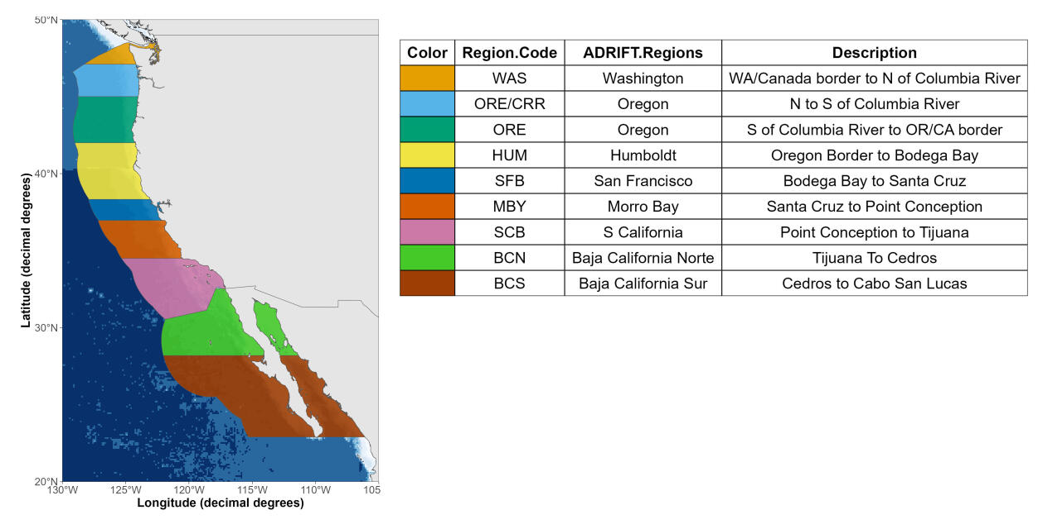

Figure .. Geographical regions for data collected during Adrift and related drifting recorder surveys (PASCAL, CCES).

Each region is named according to its geographical location, and upper and lower latitudinal bounds are provided in the description.

The Adrift project started in June 2020, during the COVID-19 Pandemic. All fieldwork in 2020 was canceled due to the pandemic, and these impacts greatly hampered research efforts in 2021. In addition to the initial cessation of all fieldwork efforts, secondary impacts continued to negatively impact fieldwork well into 2022. Secondary impacts included disruptions to the supply chain and extreme short-staffing due to outbreaks and exposure, as well as the widespread post-pandemic changes to the workforce.

Prior research efforts include the 2016 PASCAL survey and the 2018 CCES survey. These surveys were conducted in late summer through late fall during the post-upwelling season and data collection was not impacted by strong currents or inclement weather. Weather conditions are typically less ideal, and currents stronger, during the upwelling and winter season. The California Current experienced three consecutive years of La Niña between 2020-2022 (Thompson et al. 2024). The increased wind and currents caused by these conditions led to decreased windows of good weather, even during summer. After the initial loss of several drifting recorders due to extreme weather and current conditions, we limited our deployments to good weather windows, which dramatically decreased the duration of our deployments from ~ 30 days during PASCAL (10-19 days) and CCES (10-79 days), to less than 1 week during most of the Adrift study. Strong currents and high seas also created self-noise such as strumming, which periodically impacted data quality. Use of spar buoys instead of hi-flyer pole buoys may be preferred to minimize strumming.

The cumulative impacts of the pandemic and poor environmental conditions ultimately required us to shift our survey approach and abandon our efforts to coordinate data collection using vessels of opportunity. Instead, we focused on directed deployment of drifting recorders in collaboration with regional partners. Our partners in Humboldt (Cal Poly Humboldt) and Oregon (Oregon State University) were able to use a combination of opportunistic and dedicated vessel time for data collection. We partnered with the NOAA Sanctuary Applied California Current Ecosystem Studies (ACCESS) Surveys to collect data offshore San Francisco up to three times per year, and developed a collaborative partnership for fieldwork in Morro Bay.

Table .. Summary of drifting recorder deployments for Adrift, PASCAL and CCES surveys.

|  |  |  |  |
| --- | --- | --- | --- |
| **Characteristic** | **ADRIFT,** N = 104 | **CCES,** N = 15 | **PASCAL, N = 30** |
| **Status** | - | - | - |
| Complete | 90 (86.5%) | 15 (100.0%) | 29 (96.7%) |
| Failed | 8 (7.7%) | 0 (0.0%) | 0 (0.0%) |
| Unusable | 6 (5.8%) | 0 (0.0%) | 1 (3.3%) |
| **Deployment Duration (days)** | - | - | - |
| Sum | 493 | 529 | 421 |
| Median (Min - Max) | 4 (1 - 20) | 27 (5 - 80) | 19 (2 - 23) |
| **Recording Duration (hours)** | - | - | - |
| Sum | 8,736 | 11,022 | 9,451 |
| Median (Min - Max) | 93 (24 - 328) | 581 (125 - 1,800) | 362 (36 - 562) |

Note: Unsuccessful buoys are reported for Adrift.

A total of 90 drifting recorders were successfully deployed during the Adrift survey, for a total of 493 deployment days which resulted in a total of 8,736 hours of recordings (Table 3.1, Figure 3.2). Analysis included additional recordings from the 2016 PASCAL Survey (29 successful drifting recorders for a total of 421 deployment days and 9,451 hours of recordings) and the 2018 CCES Survey (15 successful drifting recorders for a total of 529 deployment days and 11,022 hours of recordings). Expanded deployment details are provided in Appendix: Adrift Expanded Datasets, Appendix: PASCAL Expanded Datasets, Appendix: CCES Expanded Datasets.

The primary focal regions included areas of importance to the initial phases of offshore renewable wind energy development, including two locations in Oregon (Coos Bay to the North, and Brookings to the South), Humboldt, and Morro Bay, with sampling of San Francisco as opportunity allowed (Figure 3.2). The 100 m and 200 m isobaths are shown on the maps to identify the shelf break and potential for increased biological activity associated with upwelling (Figure 3.2 and regional maps). Regional description of partners and data collection efforts will be presented from the northern region (Oregon) to the southern region (Morro Bay).

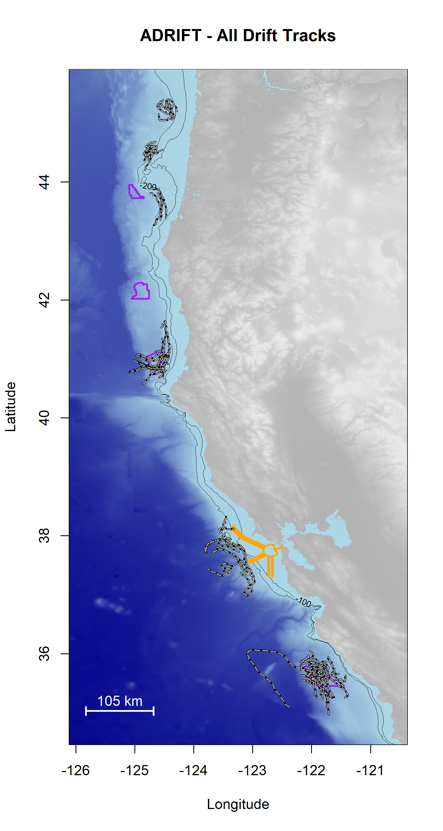

Figure .. Plot of all successful drifts deployed during the Adrift in the California Current project.

Drifts are shown as black/white lines; Wind Energy Areas are outlined in purple (Coos Bay and Brookings in Oregon, Humboldt, and Morro Bay), and shipping lanes for entry to San Francisco Bay are outlined in yellow.

We partnered with the Greater Farallones and the Cordell Bank National Marine Sanctuaries and Point Blue to participate in their tri-annual ACCESS surveys. These surveys provided an opportunity to deploy and retrieve 1-2 drifting recorders in the area offshore San Francisco Bay, providing data to inform the Sanctuaries and to provide an additional dataset between the Morro Bay and Humboldt WEAs (total 11 deployments, Figure 3.3). This partnership was mutually beneficial; however, these surveys are only conducted in late spring through late summer. Deployments in the post-upwelling season extended further south than deployments in the upwelling season (Figure 3.3); these geographic differences may contribute to seasonal differences in marine mammal detections.

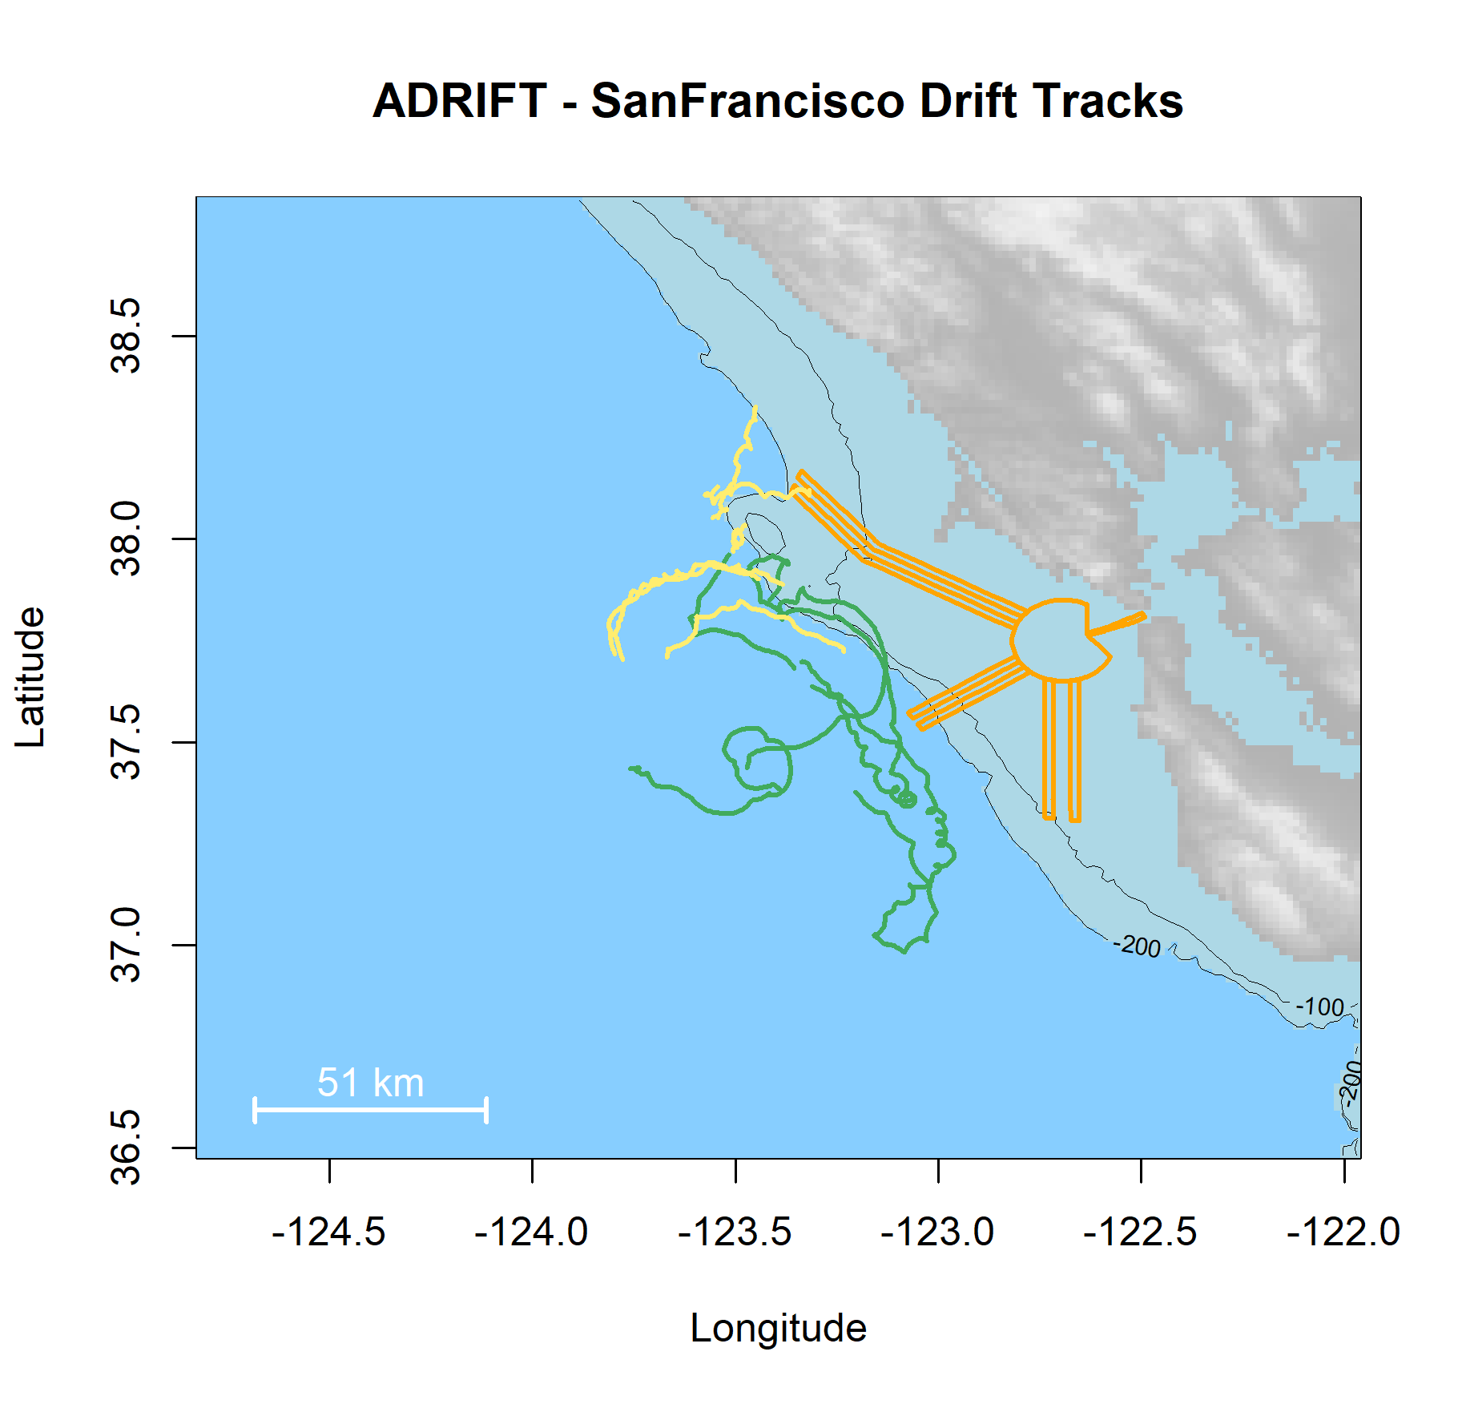

Figure .. Plot of all successful drifts deployed in the San Francisco region during the Adrift project.

Drifts deployed during upwelling are green, and post-upwelling are yellow. Wind Energy Areas are outlined in purple, and shipping lanes for entry to San Francisco Bay are outlined in yellow.

# Drifting Recorders

Drifting recorders consist of a hydrophone array and autonomous recorder at depth with a surface buoy and satellite GPS at the surface to allow for tracking and retrieval (Figure 4.1). Components are continually modified to address problems and accommodate improved technologies.

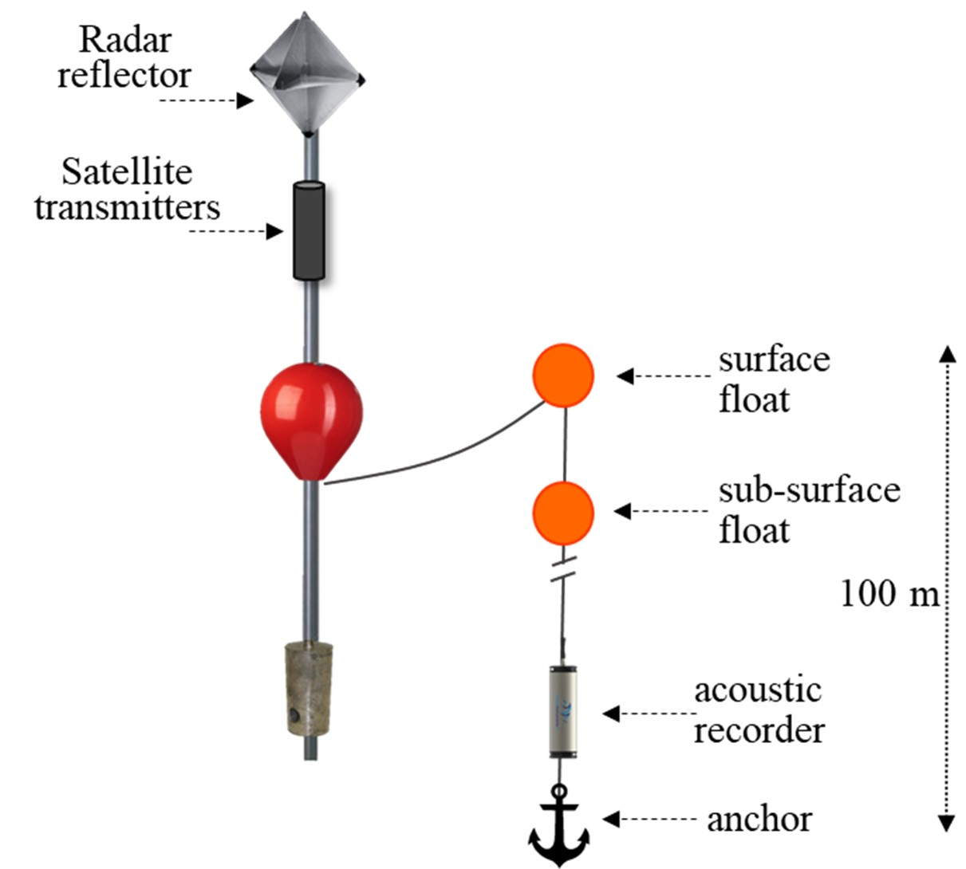

Figure .. Diagram of drifting recorders used in the Adrift project.

The surface buoy transitioned from a spar buoy to a high-flyer pole buoy after CCES and prior to Adrift in an effort to minimize buoy loss due to ship strike. The pole buoy includes a radar reflector for visibility and a satellite GPS tracker mounted to the pole. Pole buoys included the now discontinued Lindgren-Pitman high-flyer buoy, a custom high-flyer developed by Fisherman Dick Ogg, and a custom in-house high-flyer pole buoy. Initial GPS trackers included two SPOT GPS trackers (for redundancy) mounted in a waterproof canister on the pole buoy. The modifications made to these trackers to increase their battery power led to increased failure (modifications weakened the units). These were replaced with Solar GPS that were easier to use, more robust, and could be used for extended periods with solar recharge of the internal battery.

A trawl float was attached to the surface buoy with a short length of floating line to allow for retrieval using a grappling hook.

The hydrophone array, recorder, and ancillary components were deployed vertically from the surface trawl float, with the hydrophone array and recorder located 100 or 150 m depth. While movement of the surface buoys would be affected by wind, variable surface currents, and swell height, instrumentation at depth were minimally affected by modest and relatively stable subsurface current. The different forces at the surface and depth occasionally led to strumming of the line and hydrophones. Additional ancillary components were added in 2022 to minimize vertical and horizontal movement of the instruments, reduce tension induced strumming, and reduce displacement of hydrophones from a vertical orientation. Also, several initial losses were due (at least in part) to failures in the primary vertical line; this line was replaced with a significantly stronger line that eliminated this failure point.

To improve vertical alignment of the hydrophones at depth, a subsurface trawl float was placed immediately above the instruments, with a 30 lb mushroom anchor below the instruments. This effectively reduced vertical displacement of the hydrophone array. A small drogue was used to decrease horizontal movement of the hydrophone array at depth, and a dampener plate was used to minimize vertical movement. While these helped alleviate tension and movement that attributed to strumming noise, an additional bungee was added to the line to further reduce strumming. The anchor was attached using a small rope with low breaking strength as a 'weak-link' to mitigate entanglement risk.

The acoustic recording equipment consisted of a two-element vertical hydrophone array below the recorder. A Sensus Ultra depth sensor was attached directly above the top hydrophone and recorded depth at 60s intervals. The top hydrophone consisted of an HTI-92WB and the lower hydrophone consisted of an HTI-96min positioned 5m below the top hydrophone. Recorders consisted of either the (now discontinued) SoundTrap 4300 or the SoundTrap 640 which allowed for extended deployments (Ocean Instruments, NZ).

Initial recordings included a duty cycle to extend deployment, and then all recordings shifted to continuous sampling. Sample rate varied according to the instrument, with a minimum sample rate of 288 kHz. A summary of deployment details can be found in Appendix: Adrift Expanded Datasets.

More information on drifting recorder components and design can be found on our GitHub pages for Adrift field methods[1]. Methods for drifting recorders deployed during PASCAL and CCES can be found in their respective reports (Keating et al. 2018; Simonis 2020)

***Results***

Clustered drifting recorders provide an opportunity to improve our understanding of the spatial and temporal variability of the contributors to the soundscape. Preliminary results suggest that clustered drifting recorders can be used to reduce the possible range of sound source location (see Appendix: **Error! Reference source not found.**) and can provide information on the spatial variation in soundscape (see Appendix: **Error! Reference source not found.**). Drifting recorders were deployed in clusters of 4 in Humboldt and Oregon study areas, and in clusters of 8 in the Morro Bay Study area. In some cases, drifting recorders in close proximity to each other followed dramatically different drift trajectories.

There were multiple cases of equipment and data loss, especially during the initial deployments. Losses were due to a variety of reasons, including inclement weather, strong currents, and recorder failures. We mitigated these problems through modifying components and altering survey methods. A number of gear modifications were made to improve robustness and to decrease self-noise that interfered with recording quality. We recommend additional buoy modification to reduce noise associated with strong currents and inclement weather. Southwest Fisheries Science Center (SWFSC) will be using an alternative buoy design developed by Pacific Islands Fisheries Science Center during the CalCurCEAS 2024 survey, which may reduce strumming noise.

Drifting acoustic recorders are not appropriate for all geographic regions. We recommend conducting a regional pilot study to determine the region-specific environmental conditions, and to identify local partners. The Humboldt study area was especially affected by strong currents combined with the close proximity of the study area to Cape Mendocino, in which options for retrieval south of Cape Mendocino are rare. The success of the CCC-PAM survey in Morro Bay included the financial benefit of sharing vessel resources, improved scientific collaborations, and it provided an opportunity for scientists to share and learn from other community members. We recommend consideration of a collaborative fieldwork pilot study in Humboldt and other regions.

There were multiple recorder failures, and different problems were associated with different recording models, including: failure to start, instrument flooding, and low received levels on one or more channels. Initial deployments (including the previous PASCAL and CCES Surveys) used the multi-channel SoundTrap ST4300, which is easy to use and provides high quality recording for up to four channels (max 256 Gb flash drive, battery for 4-5 days continuous recording). Recorder failures for these devices included failure to start (instrument failure or user error) and low received levels on one or more channels. The SoundTrap ST4300 was discontinued and replaced by the higher capacity SoundTrap ST640 in 2021. The SoundTrap ST640 with removable components can accommodate up to 2Tb memory and has battery capacity for up to 90 days. This newer model provided the capacity needed for continuous recordings but required significantly more experience to use and had an increased risk of failure due to leaks. Four 640s were lost during a sea trial and one was lost during Adrift data collection effort.

Drifting acoustic recorders contain instrumentation at depth, and are not appropriate for use on the continental shelf. Seafloor recorders should be used for nearshore monitoring in depths less than 300 m.

# Marine Mammal Detections

The purpose of the Adrift project was to collect baseline data to identify which marine mammal species frequent the Morro Bay, Humboldt, and Oregon Wind Energy Areas, and to describe their seasonal occurrence and distribution within the greater California Current Ecosystem. Different call types are understood to be associated with specific behaviors and therefore provide information related to habitat use. For mysticete (baleen) whales, we focused on blue whales (*Balaenoptera musculus*), fin whales (*B. physalus*), Bryde’s whales (*B. edeni*), sei whales (*B. borealis*), humpback whales (*Megaptera novaeangliae*), gray whale (*Eschrichtius robustus*) and minke whales (*B. acutorostrata*). For odontocetes (toothed whales), we focused on sperm whales (*Physeter macrocephalus*), beaked whales (all regional species), dolphins (including Risso’s dolphins, *Grampus griseus*, and Pacific white-sided dolphins, *Lagenorhynchus obliquidens*), and narrow band high frequency (NBHF) species (harbor porpoise, *Phoceona phocoena*, Dall’s porpoise, *Phocoenoides dalli*, and *Kogia* spp.). Passive acoustic monitoring relies on sounds produced by animals for detection, and therefore PAM studies cannot identify the absence of animals. Data analysis for fin, sei, and Bryde’s whales was contracted through OSA (Ocean Science Analytics).[2] Specific details on detection methods are provided in our GitHub Analysis Methods.[3]

Raw data were shipped from regional partners to SWFSC for archiving, pre-processing, and acoustic analysis of marine mammals and ambient noise (soundscape). Deployment metadata and species detection metadata were stored to a Tethys database stored on a local server. Data and metadata were archived to National Centers for Environmental Information (NCEI) and detection data products were archived at the Pacific Acoustic Cetacean Map (PACM) (see Data Sharing).

Prior to analysis, compressed SUD (Symantec UndoData) data files stored on the SoundTrap recorders were downloaded, extracted, and decimated to 500Hz, 12 kHz, and 48 kHz. A series of full bandwidth Long Term Spectra Averages (LTSAs) were generated using Triton software with 200 Hz, 5 s resolution. LTSAs were then scanned to assess overall data quality and to identify recording data start and end times. A series of custom quality assurance and quality control functions provided a check for appropriate time format, eliminated spurious GPS tracks, and identified unexpected recording gaps. More information on pre-processing methods can be found on GitHub.[4]

Our intention was to develop a streamlined open-source workflow for passive acoustic analysis that would promote reproducible research. Raw recording data were processed and analyzed to detect the presence of calls associated with mysticete species (blue, fin, Bryde's, sei, humpback, gray, and minke whales) and odontocete species (sperm whales, beaked whales, dolphins, and species known to produce narrow-band high frequency sounds (porpoise and *Kogia* spp.)). Presence of sounds were noted in hourly bins; and detection methods varied by species. Analysis was not conducted on recordings deemed unusable due to excessive self-noise.

In addition, an acoustic event of unknown species (possible sei/blue whale) was detected on Adrift-060 off Oregon in 2023. This extended acoustic encounter includes a number of frequency-modulated call types. More information can be found in our GitHub Repository.[5]

Initially, our ability to access and process our archived data was extremely limited due to the COVID-19 pandemic. Our archived data was largely inaccessible for the first 6 - 12 months, and we were limited to small scale processing on our laptops. Early on we initiated the purchase of a larger server that would allow larger scale remote processing of archived data, but supply chain issues and a series of technical problems delayed use for an additional 18 months. Between accessibility and supply chain issues associated with the pandemic, processing archived data took significantly more time than expected. The cumulative effect of these problems resulted in decreased opportunity to provide higher level analysis within the timeframe of this study. Where possible, we have provided preliminary analysis within the appendices to understand potential for future analysis.



## Sperm Whales

***Methods***

An experienced analyst manually scanned 1 hr LTSA windows created with 48 kHz decimated data (Triton[6] software in MATLAB, 100 Hz and 5 s resolution) to identify the start and end times of sperm whale encounters. An encounter was defined as a series of clicks separated by no more than 30 min from other clicks. When potential sperm whale clicks were identified in the LTSA, 10 s spectrograms were used to confirm species identification. Opportunistic detections of slow clicks (lower frequency emphasis at 2-4 kHz, longer inter-click interval, ICI) associated with adult males were also logged. Sperm whale clicks can be masked by impulsive signals from ship propeller cavitation or high amplitude ambient noise. Detailed methods are provided in our GitHub online analysis methods.[7]

Additionally, a pilot study was conducted to investigate the potential for assessing sperm whale demographics by analyzing inter-click and inter-pulse intervals (see Appendix: **Error! Reference source not found.**).

***Results***

Sperm whales were detected in all regions (Table 5.1), with the most consistent detections and highest hourly probability of detection in the Humboldt deployments (Figure 5.1, Table 5.1). Most sperm whale detections were ‘regular’ clicks associated with feeding animals; ‘slow’ clicks (associated with adult males) were uncommon but detected in all regions except Morro Bay (Table 5.1). Sperm whales were detected in all regions in PASCAL and/or CCES Surveys (Figure 5.1).

Sperm whales had been documented only 3 times in the waters offshore San Francisco in over 30 years of ACCESS visual surveys (J. Roletto, pers. comm.). Our detection of sperm whales (both regular and slow clicks) from drifting recorders deployed during the ACCESS surveys suggests that passive acoustic monitoring might improve our understanding of sperm whale distribution in the busy shipping lanes off San Francisco as well as within the combined Greater Farallones and Cordell Bank National Marine Sanctuary.

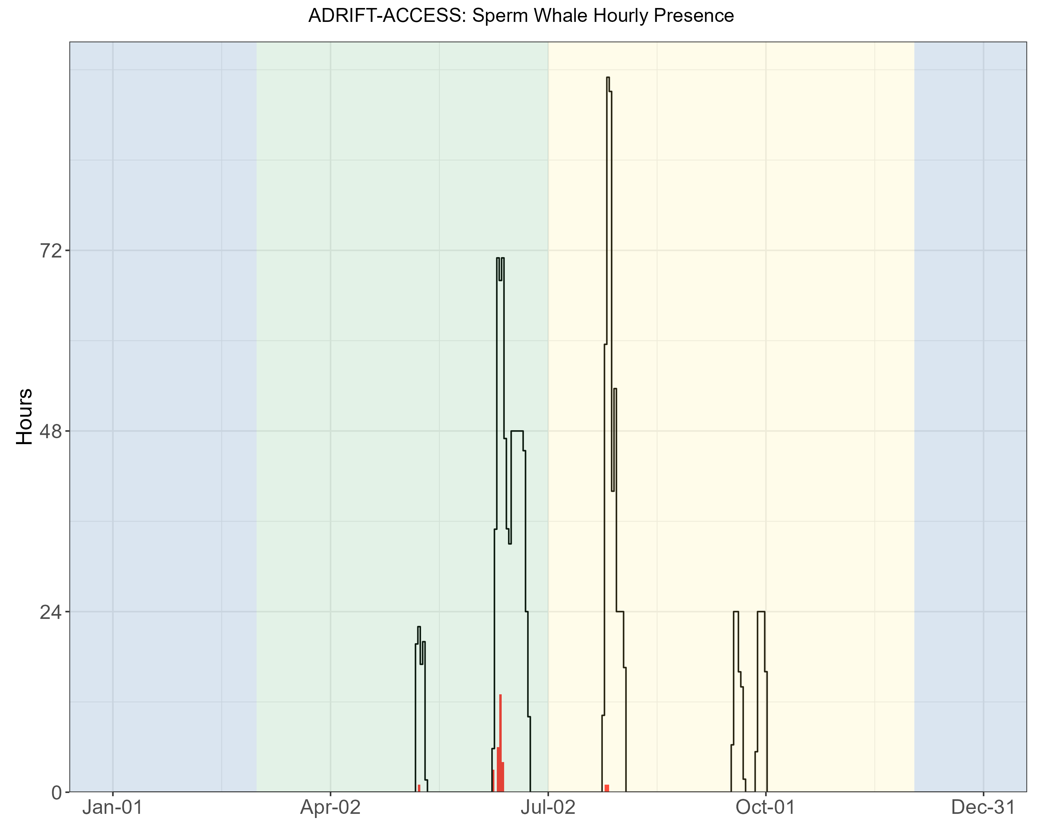

Figure .. Hourly sperm whale events by month for Adrift-ACCESS surveys.

Hourly sperm whale events (y axis) for different months for combined years (x axis) during the Adrift-ACCESS surveys. Hourly presence for duty-cycled data relates to the portion of the hour included in the duty cycled data. Black lines represent total available hours (effort) and red lines represent hours with detections. Blue shading represents winter, green represents upwelling, and yellow represents the post-upwelling oceanographic season.

A pilot study examining the potential estimation of body size based on inter-pulse and inter-click intervals found that sperm whale groups detected during November deployments in Morro Bay were comprised of females and juvenile males (see Appendix: **Error! Reference source not found.**). Sperm whales are protected under the endangered species act, and we recommend applying these methods to archived and future acoustic data to improve our understanding of sperm whale demographics within the regional WEAs as well as the greater California Current.

Table .. Summary of sperm whale detections for regular and slow clicks in hourly bins for Adrift-ACCESS surveys.

|  |  |  |  |
| --- | --- | --- | --- |
|  | **Upwelling** | **Post-Upwelling** | **Winter** |
| **Regular Clicks** | 0.03 (769) | 0.00 (626) | – |
| **Slow Clicks** | 0.01 (769) | 0.00 (626) | – |

Note: Mean hourly probability of sperm whale detection for that call type/region/season; total hourly bins are shown in parenthesis.

## Beaked Whales

***Methods***

Multiple click detectors were run on 288 kHz decimated data using PAMGuard[8] (v.2.02.09f). The Click Template Classification module in PAMGuard was used to assign correlation scores to click templates from the following click types: goose-beaked whales (Zc), Baird's beaked whales (Bb, *Berardius bairdii*), Blainville's beaked whales (Md, *Mesoplodon densirostris*), Stejneger's beaked whales (Ms, *M. stejnegeri*), Hubb's beaked whales (Mc, *M. carlhubbsi*, formerly BW37V), Cross Seamount Beaked Whale (BWC), and unidentified beaked whale BW43 (BW43, recently identified as *M. ginkgodens*, Mc, (Henderson et al., *in prep.*)). All potential beaked whale events and species identifications were manually corrected by an analyst by reviewing detection and event features in PAMGuard. Detailed methods are provided in our GitHub online analysis methods.[9]

A protocol for estimating the density of goose-beaked whales from acoustic detections using drifting hydrophone recorders was established by Barlow et al. (2022). We developed an open-source R package RoboJ[10] (Robotic Jay) for these methods (see Appendix: **Error! Reference source not found.**). We explored automated event definition based on MTC (matched template classifier) scores and developed a process that identified every manually labeled event, but ultimately included an unacceptable number of false detections. The inclusion of a computer vision model was helpful for separating false detections; however, data processing times and classification rates were not acceptable. Current ideas to improve performance of automated event definition are discussed in Appendix: **Error! Reference source not found.**. Data were prepared for future density estimation, but density estimates were not completed for Adrift or CCES survey data.

***Results***

Beaked whales were detected in all regions (Figure 5.2), and species detected in Adrift data included Baird's beaked whales (Bb), Hubb's beaked whales (Mc), Stejneger's beaked whales (Ms), and goose-beaked whales (Zc) (Table 5.2). Detection of beaked whales was higher in low latitude regions than in higher latitudes for the combined CCES and PASCAL surveys (Figure 5.2).

All beaked whale species were detected in Morro Bay, with relatively high probability of detection for goose-beaked whales (Figure 5.3, Table 5.2). While goose-beaked whales were the most common species detected overall, there were no detections of this species in either Humboldt or Oregon study areas.

There had been no visual detection of beaked whales during the 30 years of annual ACCESS surveys offshore San Francisco (J. Roletto, pers. comm.). The drifting recorders deployed during the ACCESS surveys detected both Baird's and goose-beaked whales, suggesting that beaked whales do occur in and near the shipping lanes and the combined Greater Farallones and Cordell Bank National Marine Sanctuaries (Figure 5.3). The discrepancy in these detections is likely due to the typically poor sighting conditions in this region and the cryptic surfacing behavior of beaked whales. Future surveys in this region should consider passive acoustic monitoring with sufficient bandwidth to detect echolocating beaked whales.

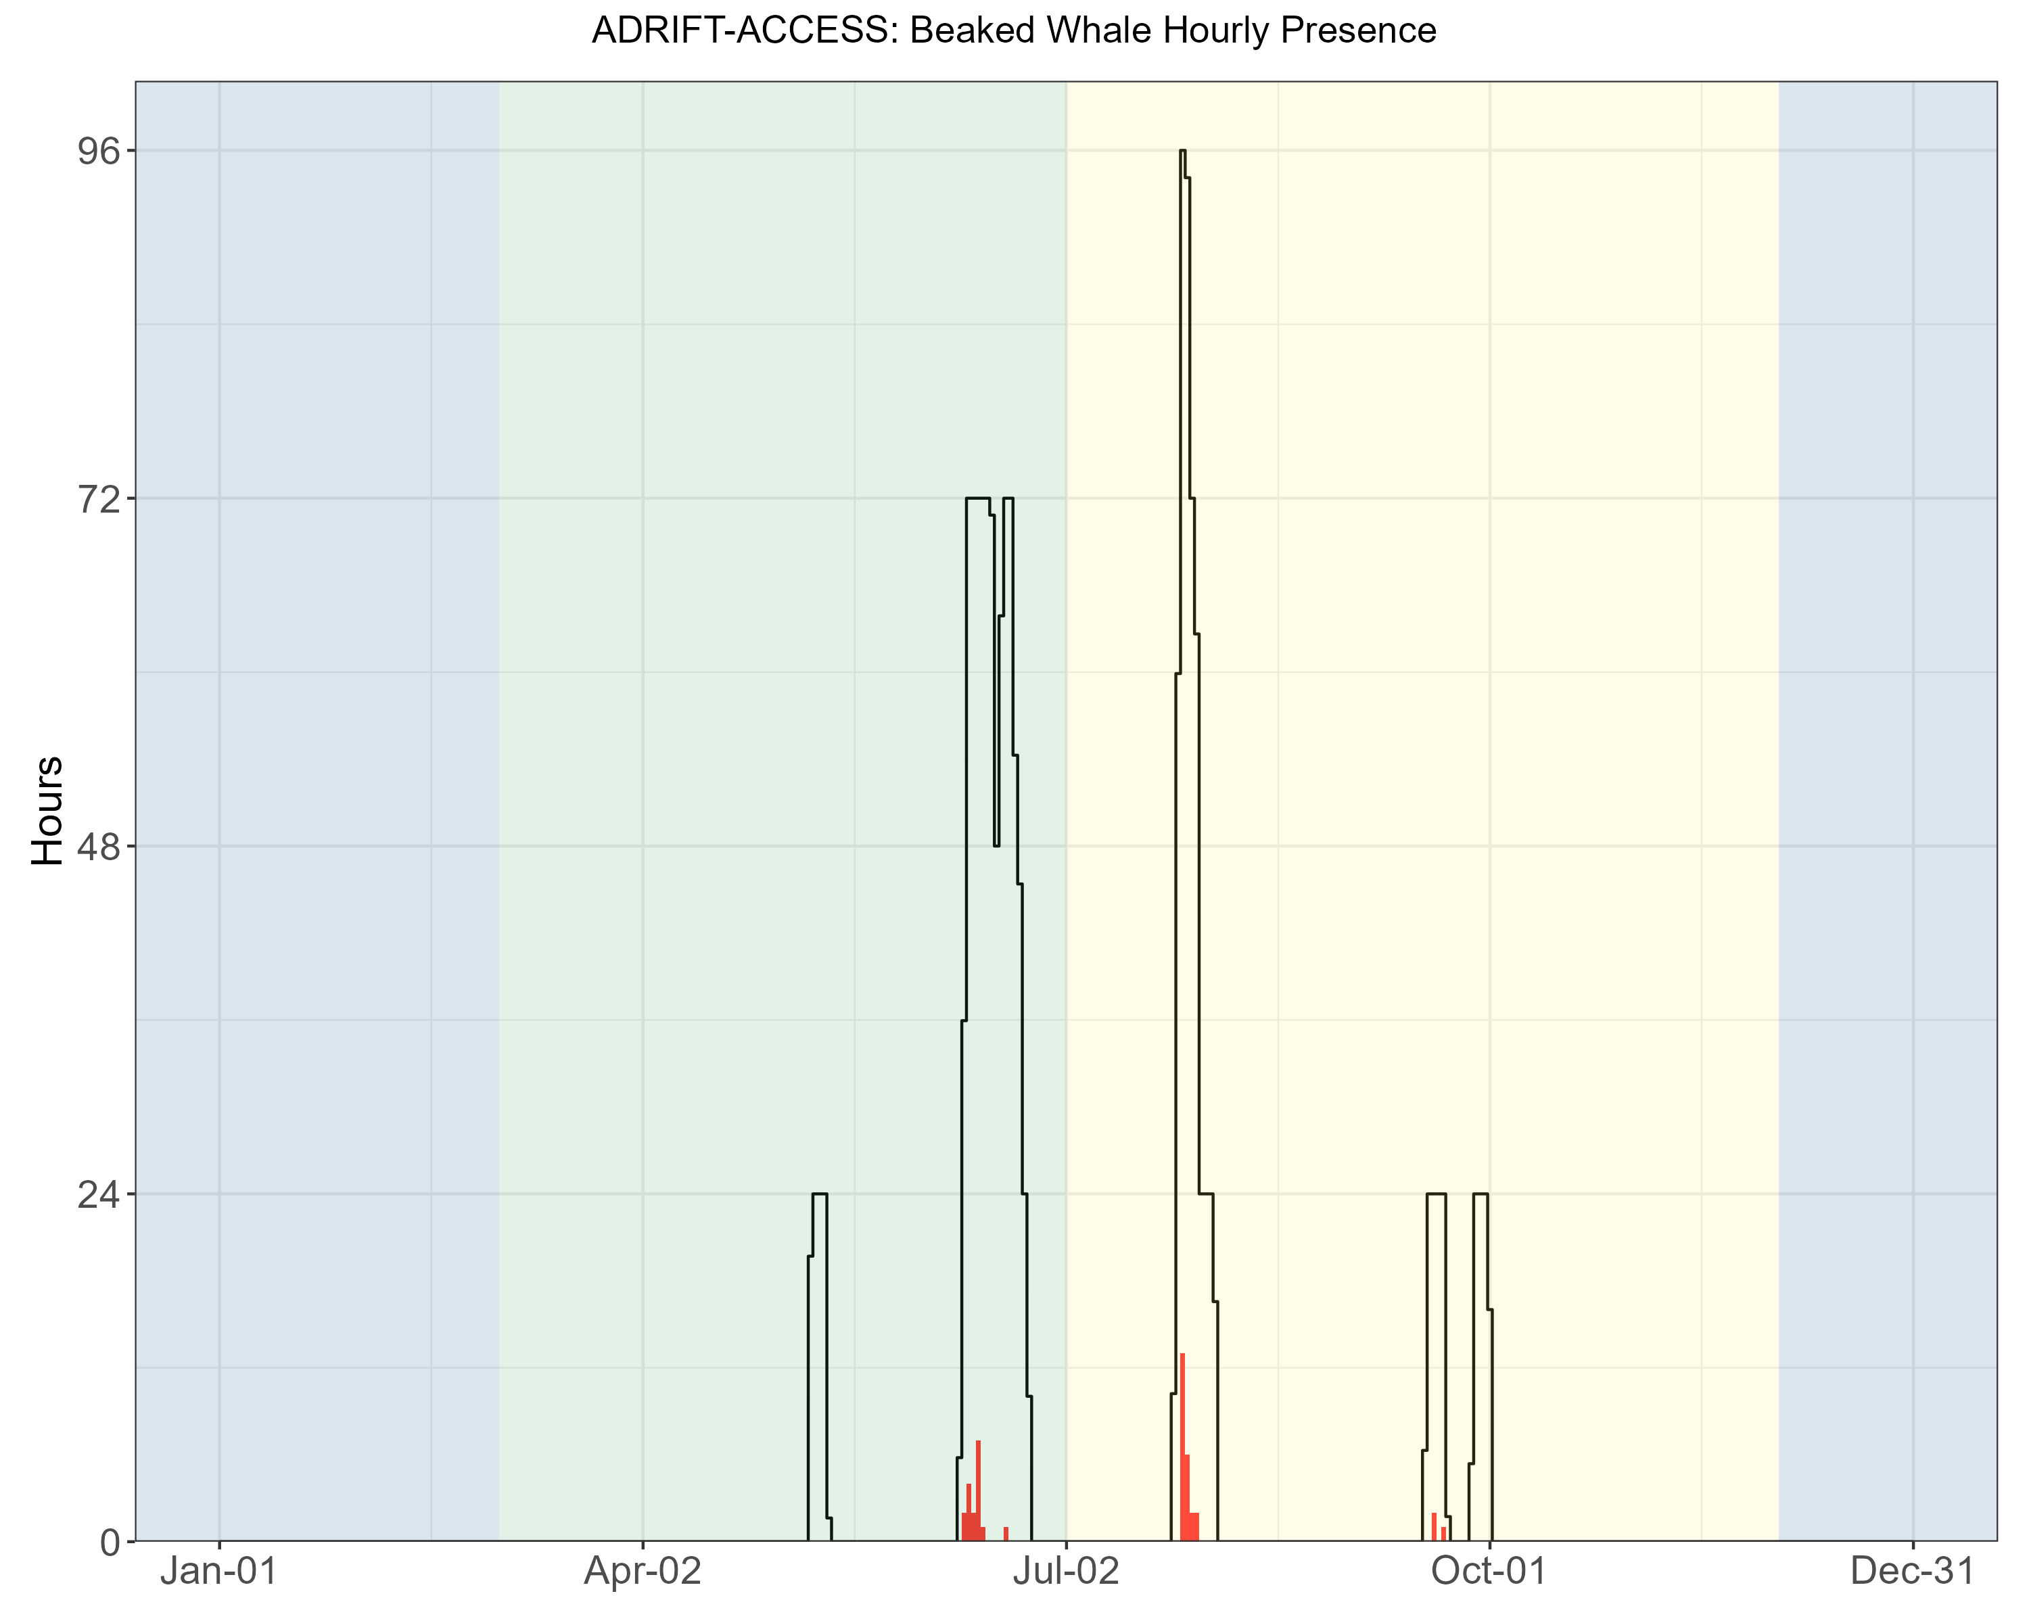

Figure .. Hourly beaked whale events by month for Adrift-ACCESS surveys.

Hourly presence of beaked whales (combined species) (y axis) for different months for combined years (x axis) during the Adrift-ACCESS surveys. Hourly presence for duty-cycled data relates to the portion of the hour included in the duty cycled data. Black lines represent total available hours (effort) and red lines represent hours with detections. Blue shading represents winter, green represents upwelling, and yellow represents the post-upwelling oceanographic season.

Many of the beaked whale detections in Morro Bay occurred during times with large numbers of dolphin detections (see Figure 6.10, Figure 6.11 for a visualization of this co-occurrence). Dolphins frequently occur in large schools with many animals echolocating simultaneously. It can be very difficult to identify beaked whales (smaller group sizes where fewer clicks are detected from each group) in these situations. The vertical hydrophone array allows for the estimation of bearing angles of incoming echolocation clicks. Beaked whales echolocate at depths below the vertical array, providing bearing angles > 90⁰ on the hydrophone array, while dolphins are typically above the array (bearing angles < 90⁰). By segregating the data based on bearing angle, we were able to identify groups of echolocating beaked whales during times where there were large numbers of echolocating dolphins. The co-occurrence of dolphins and beaked whales has not been previously reported, and it is unclear what may bring these species together. The likelihood of detecting beaked whales in these mixed species encounters would have been very low if recordings were collected from a single, seafloor sensor or from towed hydrophone arrays.

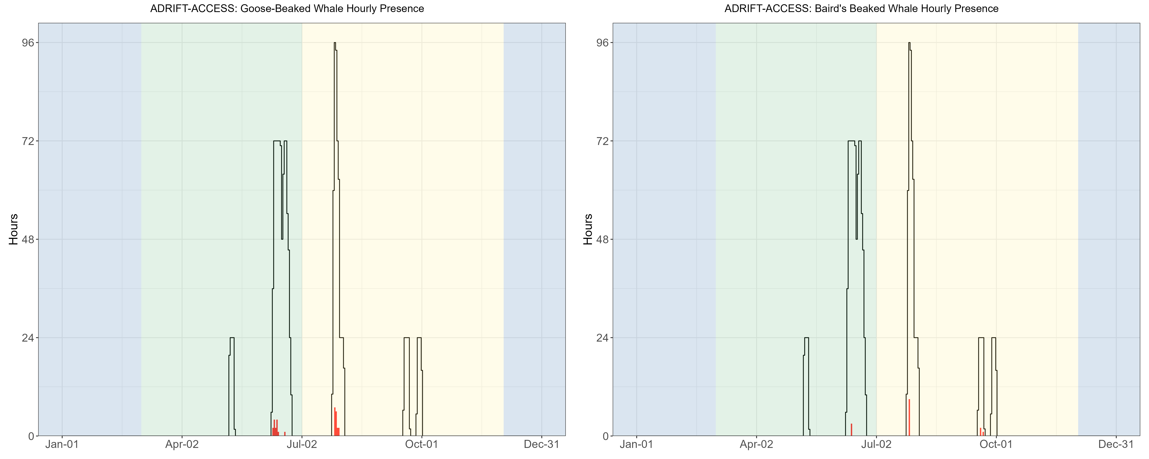

Figure .. Hourly goose-beaked whales and Baird's beaked whales by month.

Hourly presence of goose-beaked whales (left) and Baird's beaked whales (right) (y axis) for different months for combined years (x axis) during the Adrift-ACCESS surveys. Hourly presence for duty-cycled data relates to the portion of the hour included in the duty cycled data. Black lines represent total available hours (effort) and red lines represent hours with detections. Blue shading represents winter, green represents upwelling, and yellow represents the post-upwelling oceanographic season.

Table .. Summary of beaked whale detections Baird’s beaked whales and goose-beaked whales in hourly bins for Adrift-ACCESS data.

|  |  |  |  |
| --- | --- | --- | --- |
|  | **Upwelling** | **Post-Upwelling** | **Winter** |
| **Baird's beaked whale** | 0.0031 (960) | 0.0176 (688) | – |
| **Goose-beaked whale** | 0.0147 (960) | 0.0250 (688) | – |

Note: Summary of beaked whale detections for Hubb’s beaked whales, Baird’s beaked whales, Stejneger’s beaked whales, and goose-beaked whales in hourly bins for Adrift data. Mean hourly probability of detection for that species/region/season; total hourly bins are shown in parenthesis.

## Dolphins

***Methods***

An experienced analyst manually scanned 1 hr LTSA windows (Triton software in MATLAB, 200 Hz and 5 s resolution) to identify the start and end times of dolphin acoustic events. The analyst noted the presence of different click types to identify Risso's dolphins (Gg) and Pacific white-sided dolphins (Lo) within these events (Soldevilla et al. 2008). Some dolphin species produce echolocation clicks which cannot currently be classified from the LTSA; those species are not included in this analysis, but their presence may be identified by the detection of dolphin whistle events. Dolphin whistles appear in the LTSA as scattered, yet distinct pockets of energy between 2 and 20 kHz. There are no established methods to identify dolphin species by their whistles in the LTSA alone; therefore, dolphin whistle events are all attributed to "Unidentified Odontocetes". Detailed methods are provided in our GitHub online analysis methods.[11]

***Results***

Dolphins were detected during most Adrift deployments (Table 5.3), as well as during the combined PASCAL and CCES survey (Table 5.3, Figure 5.4). While dolphins were detected in all regions during the PASCAL and CCES surveys, they were more frequently detected in the San Francisco and Morro Bay regions during the Adrift study. Dolphin detections included detections that could be positively attributed to Risso's dolphins (Gg) and Pacific white-sided Dolphins (Lo), and detections that remained unidentified (UO) (Table 5.3). Dolphin acoustic events attributed to Unidentified Odontocetes (UO) were uncommon relative to the number of detections of Risso's and/or Pacific white-sided dolphins.

Dolphin schools in central and northern California are frequently encountered in large, dispersed mixed species groups (S.Rankin, pers. comm.), and here we do not distinguish mixed species from single-species groups. So, attribution of an acoustic event to Risso's dolphins does not preclude the presence of other species. We currently lack a comprehensive acoustic classification routine that includes all dolphin schools in the region. Future research should develop a publicly available acoustic classifier for dolphins that considers mixed species groups and can be applied to different passive acoustic platforms.

Previous research identified different click types for Pacific white-sided dolphins (Soldevilla et al. 2010). The dominant click type in Adrift acoustic encounters of Pacific white-sided dolphins was 'Type A'; however, there were some encounters with 'Type B'. Most of these Type A encounters were at night, similar to Soldevilla et al. (2010), and our research identified a co-occurrence of Click Type A with goose-beaked whale (see Beaked Whales). Future research could investigate this relationship between Pacific white-sided dolphins and goose-beaked whales by taking advantage of the vertical array for separating animals echolocating at the surface and at depth. Soldevilla et al. (2010) suggested Type B echolocation clicks might be attributed to a nearshore population in the southern California Current (Southern California Bight and Baja Mexico); however, our results show that Click Type B can be found in other regions. Future investigation in the geographic variation in click types for Pacific white-sided dolphins is merited.

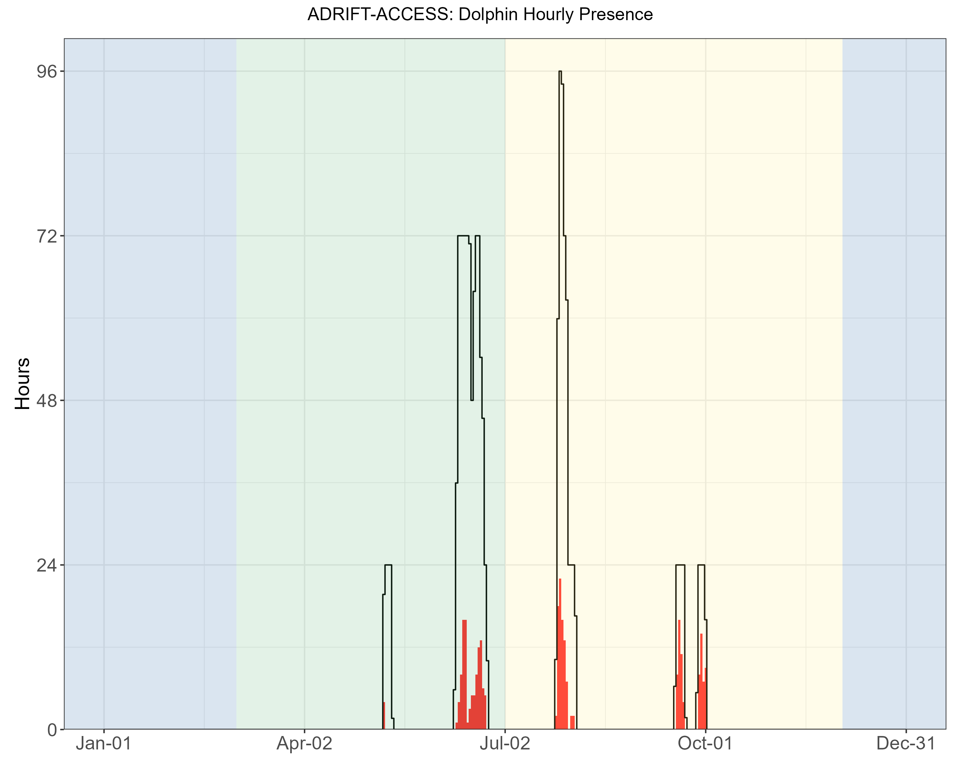

Figure .. Hourly dolphin events by month for Adrift-ACCES surveys.

Hourly presence of dolphins (combined species) (y axis) for different months for combined years (x axis) during the Adrift-ACCESS surveys. Hourly presence for duty-cycled data relates to the portion of the hour included in the duty cycled data. Black lines represent total available hours (effort) and red lines represent hours with detections. Blue shading represents winter, green represents upwelling, and yellow represents the post-upwelling oceanographic season.

Multiple click types have been described for Risso’s dolphins (Soldevilla et al. 2017). The dominant click type in all acoustic encounters of Risso’s dolphins in our analysis was the “Pelagic Pacific” (PPac) click type. Previous models had limited sample sizes from Risso’s dolphins in open ocean waters, and future investigations should incorporate the acoustic detections from Adrift, PASCAL, and CCES to improve the definition of geographic variation in click types throughout the North Pacific Ocean.

Opportunistic acoustic recordings were collected in the presence of dolphin groups with visually confirmed species, including single and mixed assemblages of Pacific white-sided, North Pacific right whale, Risso’s, and common dolphins. The sample sizes are currently too low to be used to develop classification models, but these recordings will be useful contributions to training datasets in the future.

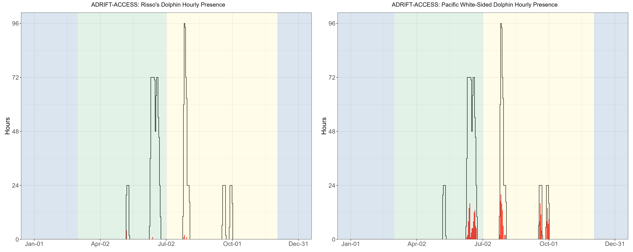

Figure .. Hourly Risso’s and Pacific white-sided dolphins by month.

Hourly presence of Risso’s dolphins (left) and Pacific white-sided dolphins (right) (y axis) for different months for combined years (x axis) during the Adrift-ACCESS surveys. Hourly presence for duty-cycled data relates to the portion of the hour included in the duty cycled data. Black lines represent total available hours (effort) and red lines represent hours with detections. Blue shading represents winter, green represents upwelling, and yellow represents the post-upwelling oceanographic season.

Table .. Summary of dolphin detections (by species) in hourly bins for Adrift data.

|  |  |  |  |
| --- | --- | --- | --- |
|  | **Upwelling** | **Post-Upwelling** | **Winter** |
| **Risso's dolphins** | 0.01 (960) | 0.01 (688) | – |
| **Pacific white-sided dolphins** | 0.10 (960) | 0.23 (688) | – |
| **Unidentified odontocetes** | 0.00 (960) | 0.00 (688) | – |

Note: Summary of dolphin detections for Risso’s dolphins, Pacific white-sided dolphins, and unidentified odontocetes for hourly bins for Adrift data. Mean hourly probability of detection for that species/region/season; total hourly bins are shown in parenthesis.

## Narrow Band High Frequency Species (*Kogia* spp., porpoise)

***Methods***

A NBHF click detector was run on full bandwidth data using PAMGuard (v2.02.09). The matched template classifier module evaluated the similarity of each detection to templates from known click types, including Harbor porpoise, Dall's porpoise, and *Kogia* spp. Potential NBHF acoustic events are automatically defined based on the presence of 3 or more clicks that exceed matched-template thresholds that occur within a 2-minute period. All NBHF events are confirmed by an analyst by reviewing detection and event features in the Click Display window of PAMGuard Viewer. Detailed methods are provided in our GitHub online analysis methods.[12]

***Results***

Calls associated with NBHF species (porpoise and *Kogia* spp.) were detected in all regions in all seasons (Figure 5.5), and the hourly probability of detection was higher for the post-upwelling season than for the upwelling season in all regions (Table 5.4). Detections were made during most drifts; however, there were no NBHF detected during the April deployments in any region (there was no effort in San Francisco during this month, Figure 5.5). During the PASCAL and CCES Surveys, most NBHF detections were in the Humboldt region (Figure 5.5).

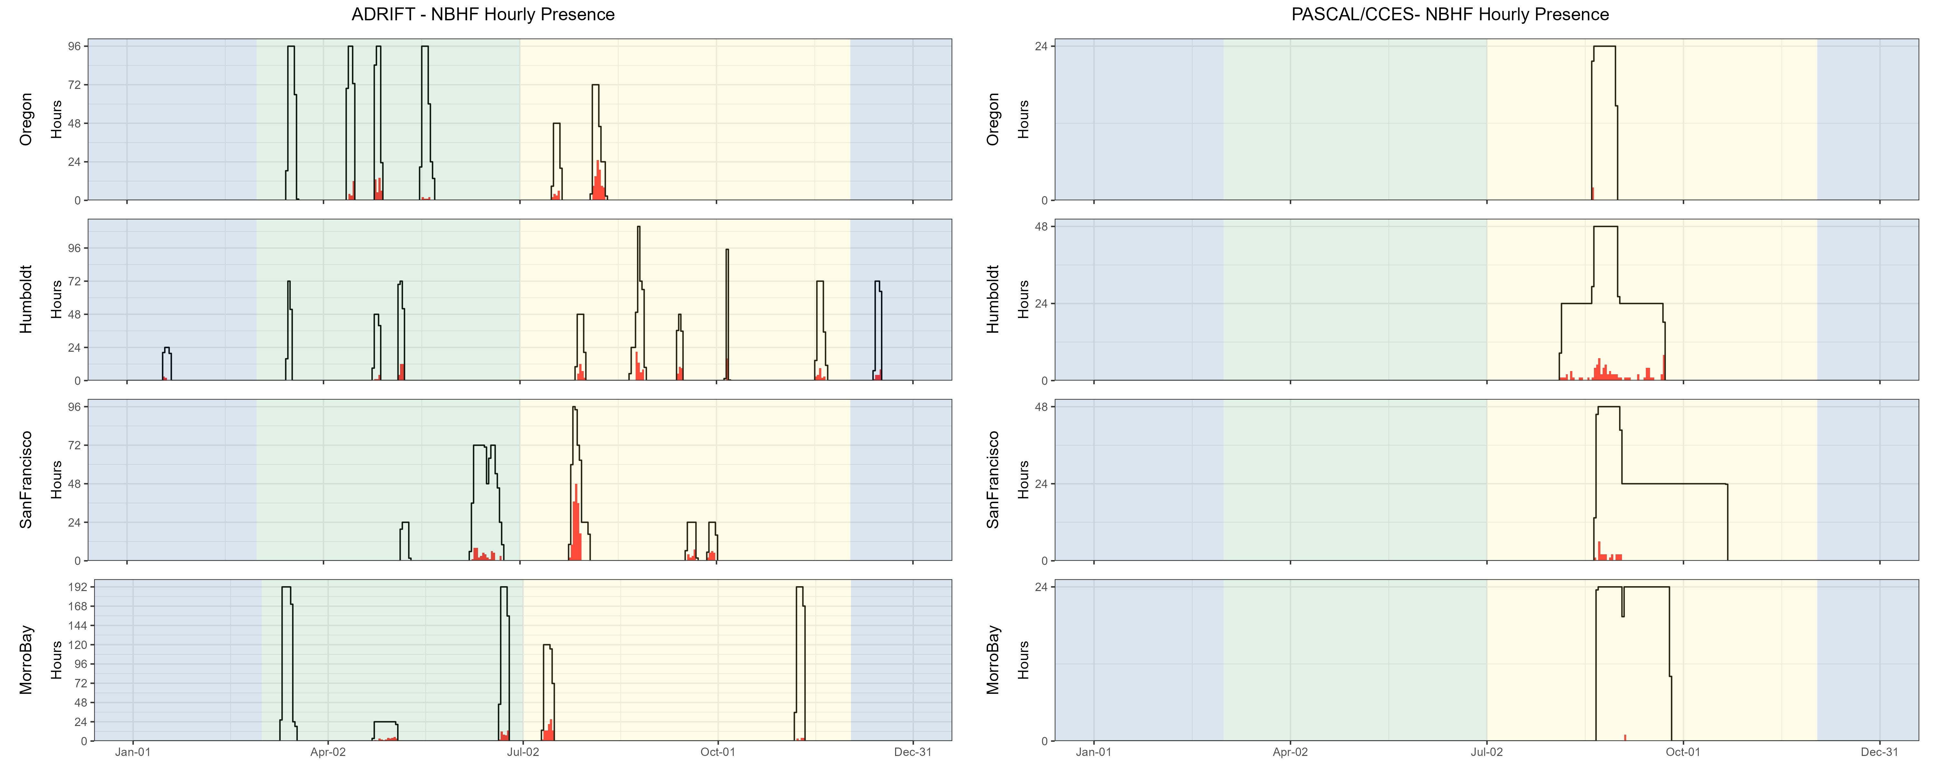

Figure .. Hourly NBHF events by month, region for Adrift and combined PASCAL, CCES surveys.

Hourly presence of NBHF events (y axis) for different months for different months for combined years (x axis) and for each region (Oregon, Humboldt, San Francisco, and Morro Bay) for Adrift (left) and combined PASCAL and CCES (right). Hourly presence for duty-cycled data relates to the portion of the hour included in the duty cycled data. Black lines represent total available hours (effort) and red lines represent hours with detections. Blue shading represents winter, green represents upwelling, and yellow represents the post-upwelling oceanographic season.

The California Current is home to 4 different species that produce NBHF echolocation clicks: harbor porpoise, Dall’s porpoise, pygmy sperm whales, and dwarf sperm whales. Despite the similarities in their echolocation clicks, these species inhabit different habitats and have different behaviors and life histories. Harbor porpoise inhabit the nearshore waters north of Point Conception, and are very sensitive to noise and other anthropogenic impacts. Dall’s porpoise are fast moving and are often found in mixed species aggregations with dolphins. Both the pygmy and dwarf sperm whales are cryptic deep diving species. Lumping these very different species into one ‘acoustic’ group is problematic, and acoustic classification to species (or at least genus) is needed.

Preliminary efforts at developing a genus-level species classifier for NBHF species in the California Current have shown positive results, and future research will further develop this classifier (see Appendix: **Error! Reference source not found.**). With some improvement, this classifier can be applied towards existing archived data to improve our understanding of the distribution of these species in the greater California Current.

Table . Summary of NBHF detections in hourly bins for Adrift data.

|  |  |  |  |
| --- | --- | --- | --- |
|  | **Upwelling** | **Post-Upwelling** | **Winter** |
| Oregon | 0.04 (1430) | 0.20 (493) | – |
| Humboldt | 0.07 (489) | 0.13 (1048) | 0.07 (308) |
| San Francisco | 0.05 (960) | 0.27 (688) | – |
| Morro Bay | 0.03 (2065) | 0.08 (1353) | – |

Note: Summary of NBHF detections for Adrift data. Mean hourly probability of NBHF detection for that region/season; total hourly bins are shown in parenthesis.

## Blue Whales

***Methods***

Detection of blue whale A, B, and D calls were identified by an experienced analyst scanning hourly LTSA windows created using custom MATLAB software, Triton (500 Hz decimated data and 1 Hz, 5 s resolution). Detection of at least one call of any call type (A, B, or D) was required to determine presence of blue whales in hourly bins. Deployments with excessive self-noise (such as strumming) that consistently impacted our ability to detect blue whales were eliminated from this analysis. Detailed methods are provided in our GitHub online analysis methods.[13]

***Results***

Blue whales were detected in all regions except Oregon (Figure 5.6), with most detections during the post-upwelling season (Table 5.5). Similar to the overall Adrift project, blue whales were detected in all regions during the combined PASCAL/CCES surveys, with low detections of blue whales off Oregon (Figure 5.6).

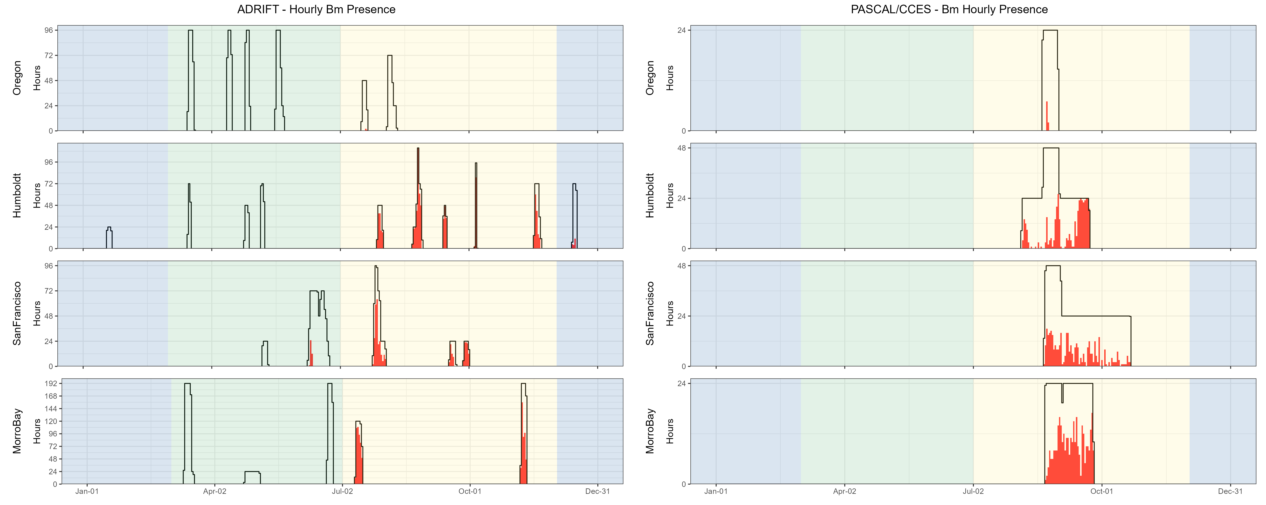

Figure .. Hourly blue whale events by month, region for Adrift and combined PASCAL, CCES surveys.

Hourly presence of blue whale calls (A, B, and D types, combined) (y axis) for different months for combined years (x axis) and for each region (Oregon, Humboldt, San Francisco, and Morro Bay) for Adrift (left) and combined PASCAL and CCES (right). Hourly presence for duty-cycled data relates to the portion of the hour included in the duty cycled data. Black lines represent total available hours (effort) and red lines represent hours with detections. Blue shading represents winter, green represents upwelling, and yellow represents the post-upwelling oceanographic season.

Detection of blue whale calls were primarily A and B calls associated with song, with few detections of D calls during the summer months (Figure 5.7).

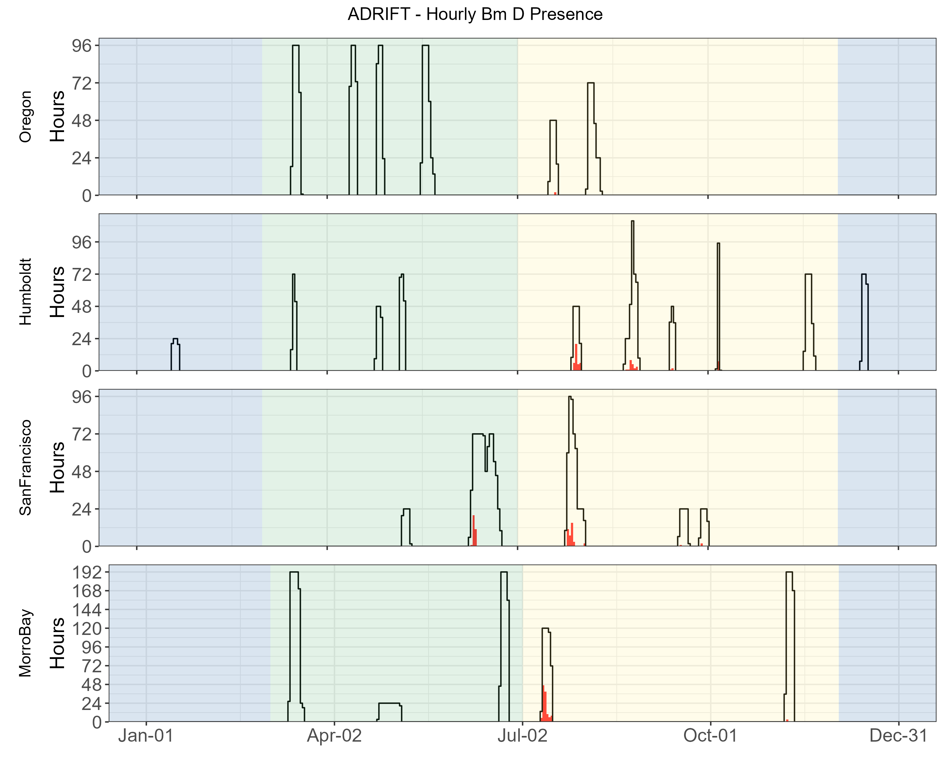

Figure .. Hourly presence of blue whale D calls by month, region for Adrift.

Hourly presence of blue whale D calls (y axis) for different months for combined years (x axis) and for each region (Oregon, Humboldt, San Francisco, and Morro Bay). Adrifts 001-012 were duty cycled and hourly presence relates to the portion of the hour included in the duty cycled data (6 min of 12 min). Black lines represent total available hours (effort) and red lines represent hours with detections. Blue shading represents winter, green represents upwelling, and yellow represents the post-upwelling oceanographic season.

Blue whale ‘song’ consists of both A and B calls, which can occur individually or in A-B pairs. Detection of both A and B calls were higher during the post-upwelling seasons in all areas (Table 5.5). The hourly probability of detecting blue whale A and B calls during the limited data off Humboldt in the winter were higher than during the upwelling season, but lower than the post-upwelling season. There were only a few blue whale B calls detected during the upwelling season off San Francisco; no other calls associated with song were detected during the upwelling season in any region. The probability of detecting blue whale B calls was consistently higher than A calls for all regions (and seasons), which reflects research showing that blue whale B calls can be detected at greater ranges than blue whale A calls (McDonald et al. 2001). Blue whale B calls can be readily classified by an experienced analyst when the SNR (signal to noise ratio) is low.

Blue whale D calls have been associated with feeding behavior (Oleson et al. 2007), and detection of D calls were primarily during the post-upwelling season (Figure 5.7). The probability of detecting D calls was much lower than detecting A and/or B calls, and there were no detection of D calls off Oregon (Table 5.5). Low SNR D calls are more readily confused with low frequency downsweep calls produced by other species, reducing the overall effective detection range for these calls.

There were an additional 227 ad hoc detections of blue whales during the OSA analysis of other low-frequency baleen whale species.[14] The majority of those detections were either low SNR calls or were masked by noise while scanning the LTSAs.

Table .. Summary of blue whale detections in hourly bins for Adrift data.

|  |  |  |  |
| --- | --- | --- | --- |
|  | **Upwelling** | **Post-Upwelling** | **Winter** |
| **A Calls** |  |  |  |
| Oregon | 0.00 (1430) | 0.00 (493) | – |
| Humboldt | 0.00 (489) | 0.50 (1048) | 0.01 (308) |
| San Francisco | 0.00 (960) | 0.31 (688) | – |
| Morro Bay | 0.00 (2034) | 0.31 (1353) | – |
| **B Calls** |  |  |  |
| Oregon | 0.00 (1430) | 0.00 (493) | – |
| Humboldt | 0.00 (489) | 0.74 (1048) | 0.07 (308) |
| San Francisco | 0.02 (960) | 0.50 (688) | – |
| Morro Bay | 0.00 (2034) | 0.63 (1353) | – |
| **D Calls** |  |  |  |
| Oregon | 0.00 (1430) | 0.00 (493) | – |
| Humboldt | 0.00 (489) | 0.07 (1048) | 0.00 (308) |
| San Francisco | 0.03 (960) | 0.06 (688) | – |
| Morro Bay | 0.00 (2034) | 0.09 (1353) | – |

Note: Summary of blue whale detections for A, B, and D calls in hourly bins for Adrift data. Mean hourly probability of blue whale detection for that call type/region/season; total hourly bins are shown in parenthesis.

## Fin Whales

***Methods***

Due to complications associated with fin whale call structure, we implemented multiple methods to detect fin whale 20 and 40 Hz calls. Fin whale 20 Hz calls consist of low frequency pulses; we used both a tonal and click detector to identify fin whale 20 Hz pulses in our datasets. Tonal detectors are commonly used for detecting tonal baleen whale call, whereas click detectors are typically used for echolocation clicks, but are suitable for detecting short duration fin whale 20 Hz pulses. Fin whale 40 Hz calls were detected using a tonal detector.

For all datasets, fin whale 20 and 40 Hz calls were analyzed by our research partner OSA using a PAMGuard whistle and moan detector (v2.02.09) and reviewed by an experienced analyst in PAMGuard's Viewer Mode. Detections were grouped into acoustic events using the Detection Group Localiser module. Acoustic events were then binned into hourly presence for the 40 Hz fin whale call type. Due to the variability in sampling rates and duty cycles during the CCES and PASCAL datasets, presence of fin whale 20 Hz calls were detected by manual scanning of LTSAs using Triton (500 Hz decimated data and 1 Hz, 5 s resolution). Identification of at least three fin whale 20 Hz calls by an experienced analyst were required to consider this species 'present' during any given hour.

Fin whale 20 Hz calls were also detected using the click detector in PAMGuard (v2.02.09). A stratified sub-sampling method was used to validate 20% of the wav files in each drift. A random forest model was developed using validated data from 14 drifts from three different geographic areas between 2021-2023. This model was used to predict the presence of fin whales in hourly bins. For each hourly bin, if there were less than 3 predictions with scores over 0.5, these classifications were automatically rejected to eliminate false positives. Hourly bins with at least 3 predictions with scores greater than 0.5 were manually reviewed by an experienced analyst for final classification.

Deployments with excessive self-noise (such as strumming) that consistently impacted our ability to detect fin whales were eliminated from this analysis. Detailed methods are provided in our GitHub online analysis methods[15], in a report provided by OSA and archived on our GitHub Repository.[16]

A pilot study to develop a deep learning network to detect and classify fin whale 20 and 40 Hz calls was initiated by Ocean Science Analytics and preliminary results can be found in Appendix: **Error! Reference source not found.**.

***Results***

Fin whales were detected throughout the study area and at different times of year (Figure 5.8). Detection of fin whales during the combined PASCAL/CCES surveys showed strong presence in the Morro Bay and San Francisco regions, with low detections in Humboldt and Oregon (Figure 5.8).

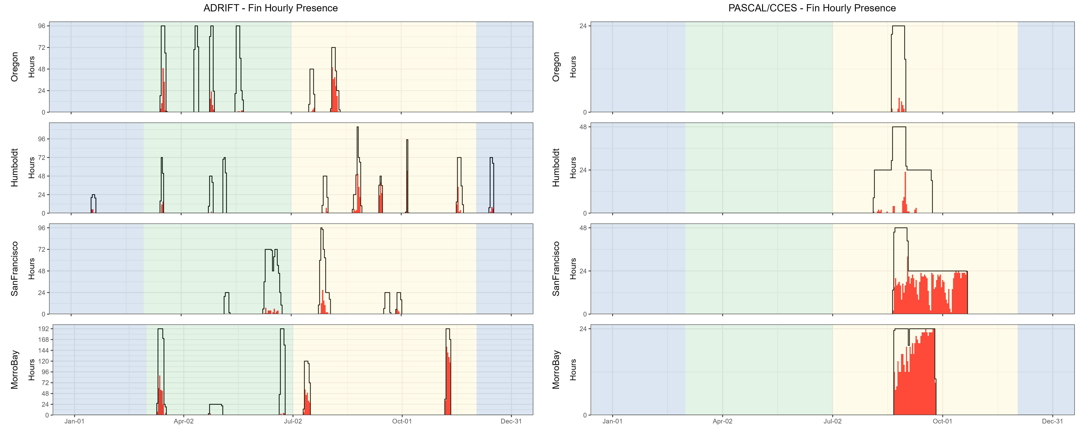

Figure .. Hourly fin whale events by month, region for Adrift and combined PASCAL, CCES surveys.

Hourly presence of fin whales (combined call types) (y axis) for different months for combined years (x axis) and for each region (Oregon, Humboldt, San Francisco, and Morro Bay) for ADRIFT (left) and combined Pascal and CCES (right). Hourly presence for duty-cycled data relates to the portion of the hour included in the duty cycled data. Black lines represent total available hours (effort) and red lines represent hours with detections. Blue shading represents winter, green represents upwelling, and yellow represents the post-upwelling oceanographic season.

Fin whale 20 Hz pulses had higher detection probabilities in the post-upwelling seasons for all locations (Figure 5.9, Table 5.6). This detection probability dropped during the (limited) winter data for Humboldt. Fin whale 20 Hz detections were lower off San Francisco than other areas, though detection of low frequency fin whale calls in this area may be compromised by low frequency noise associated with high levels of low frequency noise associated with large shipping traffic (container ships). The fin whale 20 Hz call is the most commonly reported and is thought to be used as a social call to establish and maintain contact when produced in irregular sequences (Edds-Walton 1997) and it may serve a reproductive function when produced by males in a regular sequence forming song (Croll et al. 2002). Here we did not differentiate between irregular and regular sequencing.

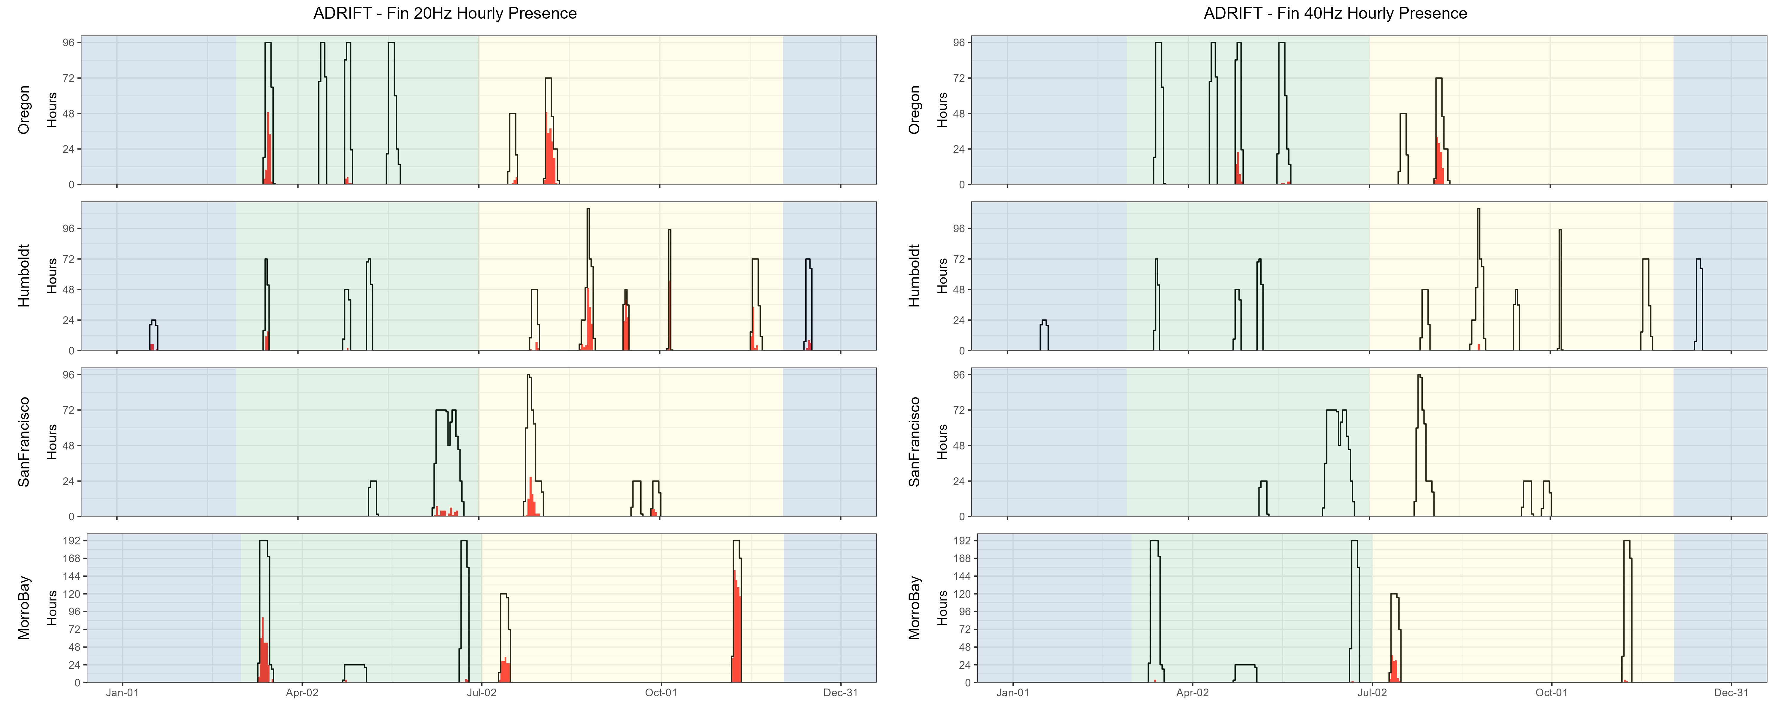

Figure .. Hourly presence of fin whale 20, 40 Hz calls by month, region for Adrift.

Hourly presence of fin 20 Hz calls (left) and fin 40 Hz calls (right) (y axis) for different months for combined years (x axis) and for each region (Oregon, Humboldt, San Francisco, and Morro Bay). Adrifts 001-012 were duty cycled and hourly presence relates to the portion of the hour included in the duty cycled data (6 min of 12 min). Black lines represent total available hours (effort) and red lines represent hours with detections. Blue shading represents winter, green represents upwelling, and yellow represents the post-upwelling oceanographic season.

The 40 Hz call has a more irregular pattern and has been positively associated with prey biomass, providing evidence that it is associated with a foraging function (Romagosa et al. 2021). Most 40 Hz fin whale detections occurred off Oregon, with a few detections off Morro Bay. Detection probability was highest during the post-upwelling season for both Oregon and Morro Bay (there were no detections during the upwelling season off Morro Bay).

Table .. Summary of fin whale detections in hourly bins for Adrift data.

|  |  |  |  |
| --- | --- | --- | --- |
|  | **Upwelling** | **Post-Upwelling** | **Winter** |
| **20 Hz** |  |  |  |
| Oregon | 0.08 (1430) | 0.37 (493) | – |
| Humboldt | 0.06 (489) | 0.31 (1048) | 0.09 (308) |
| San Francisco | 0.04 (960) | 0.12 (688) | – |
| Morro Bay | 0.15 (2034) | 0.54 (1353) | – |
| **40 Hz** |  |  |  |
| Oregon | 0.04 (1430) | 0.20 (493) | – |
| Humboldt | 0.00 (489) | 0.00 (1048) | 0.00 (308) |
| San Francisco | 0.00 (960) | 0.00 (688) | – |
| Morro Bay | 0.00 (2034) | 0.09 (1353) | – |

Note: Summary of fin whale 20 Hz and 40 Hz detections in hourly bins for Adrift data. Mean hourly probability of fin whale detection for that call type/region/season; total hourly bins are shown in parenthesis.

## Humpback Whales

***Methods***

An experienced analyst manually scanned spectrograms of 12 kHz decimated data using Raven Pro v. 1.6.4[17] (4096pt FFT length, Hann window, 90% overlap resulting in a resolution of 341 ms and 4.21 Hz) to detect the presence of humpback whale calls. Humpback whale calls were categorized as song, social, or undetermined calls. Cross validation of a portion of calls was completed with Dr. Alison Stimpert to ensure consistency with expert annotations. Detailed methods are provided in our GitHub online analysis methods.[18]

***Results***

Humpback whales were detected during most deployments (Figure 5.10), with higher probability of detection in the post-upwelling season in Humboldt and San Francisco (Table 5.7). Hourly detection rates were lower for the PASCAL and CCES surveys (Table 5.7); these deployments were further offshore (west) of the Adrift study areas (see Appendices: PASCAL Expanded Datasets, CCES Expanded Datasets). Historical sighting data shows fewer humpback whales in these offshore waters (see Ocean Biodiversity Information System Seamap[19]). Humpback whales were not detected in Oregon during the PASCAL and CCES Surveys (Figure 5.10).

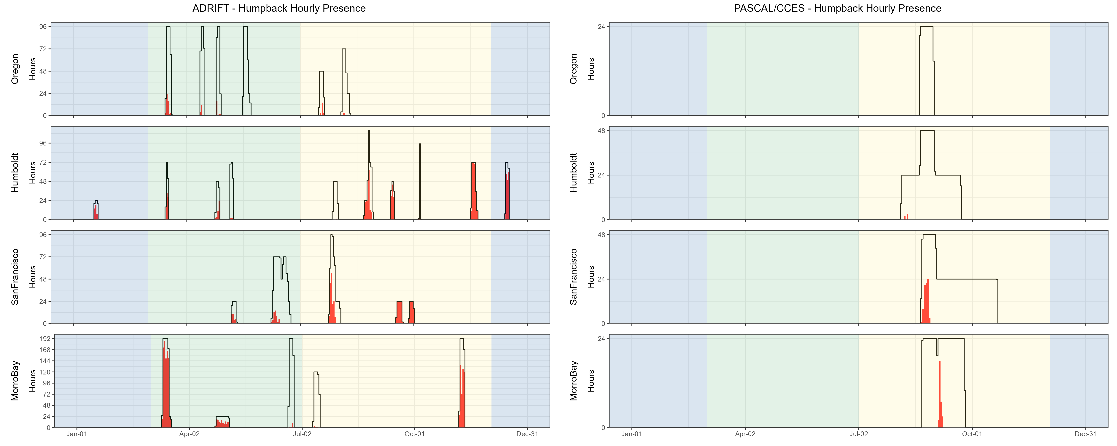

Figure .. Hourly humpback whale events by month, region for Adrift and combined PASCAL, CCES surveys.

Hourly presence of combined humpback whales call types (y axis) for different months for combined years (x axis) and for each region (Oregon, Humboldt, San Francisco, and Morro Bay) for Adrift (left) and combined PASCAL and CCES (right). Hourly presence for duty-cycled data relates to the portion of the hour included in the duty cycled data. Black lines represent total available hours (effort) and red lines represent hours with detections. Blue shading represents winter, green represents upwelling, and yellow represents the post-upwelling oceanographic season.

There were few acoustic detections of humpback whales during the late June/early July surveys off Morro Bay (Figure 5.10). Multiple humpback whales were visually sighted during the June 2022 and July 2023 CCC surveys in Morro Bay; however, the bulk of the visual survey effort (and sightings) were south of the area acoustically surveyed. The disconnect between the visual sightings and acoustic detections could be due to local differences in the sampling areas or that the animals were not particularly vocal during this sampling period.

Hourly probability of detecting song was higher in the post-upwelling than the upwelling season for Humboldt and San Francisco, but the opposite was true for Morro Bay (Table 5.7). Deployments were limited in winter, but high probability of detecting humpback song aligns with the production of song during the southern winter migration (Clapham and Mattila 1990). There were several drifts in which humpback song dominated the recordings (Figure 5.11). The acoustic features of humpback whale song, including high source level and series of calls produced over long time spans, naturally lead to high detection rates (Au et al. 2006). While recordings dominated by song may be attributed to one or a few animals, social sounds may be attributed to larger numbers of animals (Ryan et al. 2019). There were few detections of humpback song in Oregon.

Humpback whales produce many non-song (social) calls that may be associated with feeding or social behaviors. Humpback whale social sounds most frequently detected in these analyses included the grunts, 'wops' and 'thwops' (Dunlop et al. 2008). We were unable to dedicate the time required to differentiate these sounds during this study. Highly annotated datasets exist, and we recommend development of machine learning models to classify humpback non-song, which may allow for an improved understanding of spatial and temporal variation in habitat use in the California Current, allowing us to identify potential critical habitat.

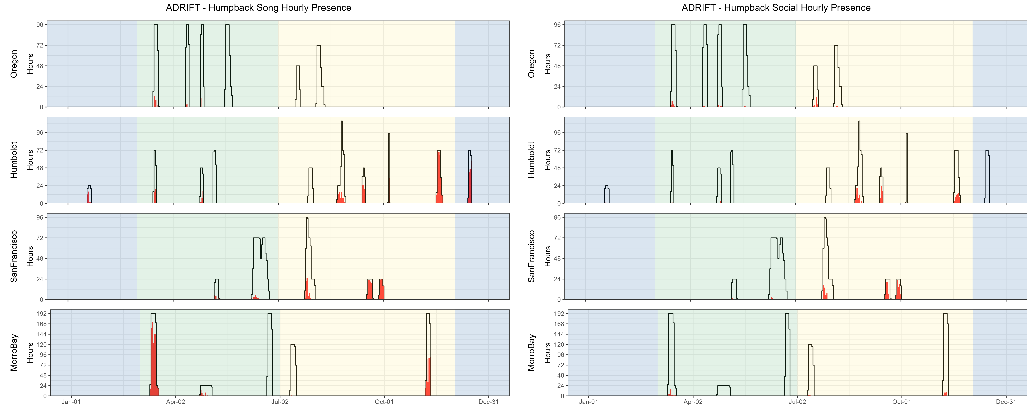

Figure .. Hourly presence of humpback song, social calls by month, region for Adrift.

Hourly presence of humpback song (left) and humpback social calls (right)(y axis) for different months for combined years (x axis) and for each region (Oregon, Humboldt, San Francisco, and Morro Bay). Adrifts 001-012 were duty cycled and hourly presence relates to the portion of the hour included in the duty cycled data (6 min of 12 min). Black lines represent total available hours (effort) and red lines represent hours with detections. Blue shading represents winter, green represents upwelling, and yellow represents the post-upwelling oceanographic season.

Table .. Summary of humpback whale detections in hourly bins for Adrift data.

|  |  |  |  |
| --- | --- | --- | --- |
|  | **Upwelling** | **Post-Upwelling** | **Winter** |
| **Song** |  |  |  |
| Oregon | 0.03 (1430) | 0.00 (493) | – |
| Humboldt | 0.13 (489) | 0.42 (1048) | 0.58 (308) |
| San Francisco | 0.03 (960) | 0.36 (688) | – |
| Morro Bay | 0.40 (2034) | 0.24 (1353) | – |
| **Social Calls** |  |  |  |
| Oregon | 0.01 (1430) | 0.04 (493) | – |
| Humboldt | 0.01 (489) | 0.16 (1048) | 0.00 (308) |
| San Francisco | 0.01 (960) | 0.24 (688) | – |
| Morro Bay | 0.02 (2034) | 0.02 (1353) | – |
| **Undetermined Humpback Calls** |  |  |  |
| Oregon | 0.03 (1430) | 0.01 (493) | – |
| Humboldt | 0.15 (489) | 0.26 (1048) | 0.18 (308) |
| San Francisco | 0.06 (960) | 0.28 (688) | – |
| Morro Bay | 0.16 (2034) | 0.21 (1353) | – |

Note: Summary of humpback whale detections for Song, Social sounds, and Unidentified calls in hourly bins for Adrift data. Mean hourly probability of humpback whale detection for that call type/region/season; total hourly bins are shown in parenthesis.

## Bryde’s and Sei Whales

***Methods***

Detection of calls associated with Bryde’s and sei whales was conducted by our partners at OSA. PAMGuard's (v2.02.09) whistle and moan detector was used to detect calls associated with Bryde's (Be4) and sei whales (frequency modulated downsweep calls identified in Rankin and Barlow (2007)). Potential calls were reviewed by an experienced OSA analyst in PAMGuard's Viewer Mode. Detections were grouped into acoustic events using the Detection Group Localiser module. Acoustic events were then binned into hourly presence for the presence of Bryde's and sei whales. Deployments with excessive self-noise (such as strumming) that consistently impacted our ability to detect Bryde's and sei whales were eliminated from this analysis. Detailed methods are provided in our GitHub online analysis methods[20] and an OSA Report archived on our GitHub repository.[21]

***Results***

There were no confirmed detections of calls associated with Bryde's or sei whales during Adrift, and a single possible sei whale encounter was detected during PASCAL (see spectrogram of possible sei whale in GitHub Repository).[22]

Bryde’s whale distribution is in the tropical and subtropical waters, with occasional northward incursion into the Southern California Bight (Kerosky et al. 2012). The Adrift deployments were north of Point Conception (and the Southern California Bight), and it is not unexpected to fail to detect animals on our recordings. Warming oceans associated with climate change may lead to more consistent detection of these species in the California Current, and these detections may occur in increasingly northern latitudes over time. We recommend that future acoustic studies in the California Current include detection of Bryde’s whales.

Little is known about sei whales in the North Pacific, and to our knowledge there is only one confirmed recording of sei whales in the North Pacific, near Hawaii (Rankin and Barlow 2007). Future research should take advantage of opportunities to understand the vocal repertoire of sei whales in the North Pacific Ocean.

## Gray Whales

***Methods***

An experienced analyst manually scanned spectrograms of 12 kHz decimated data using Raven Pro v. 1.6.4 (4096pt FFT length, Hann window with 90% overlap resulting in a resolution of 341 ms and 4.21 Hz) to detect calls associated with gray whales. Presence of gray whales were indicated, but call classes were not specified. Cross validation of a portion of calls was verified by Dr. Alison Stimpert to ensure consistency with expert annotations. Detailed methods are provided in our GitHub online analysis methods.[23]

***Results***

Sounds associated with gray whales were only detected on a few recordings in the upwelling and post-upwelling seasons in Oregon and San Francisco regions (Table 5.8), and only during a few hours on the combined PASCAL and CCES surveys (Figure 5.12). There is a significant overlap in spectral content for humpback and gray whale calls and most drifts were outside primary gray whale migration routes; care should be taken when inferring gray whale presence from data with concurrent humpback whale presence.

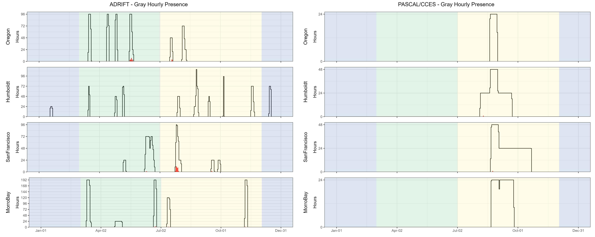

Figure .. Hourly gray whale events by month, region for Adrift and combined PASCAL, CCES surveys.

Hourly presence of gray whale calls (y axis) for different months for combined years (x axis) and for each region (Oregon, Humboldt, San Francisco, and Morro Bay) for Adrift (left) and combined PASCAL and CCES (right). Hourly presence for duty-cycled data relates to the portion of the hour included in the duty cycled data. Black lines represent total available hours (effort) and red lines represent hours with detections. Blue shading represents winter, green represents upwelling, and yellow represents the post-upwelling oceanographic season.

Most Eastern North Pacific gray whales use the California Current to migrate between their feeding grounds in the north and their winter breeding grounds in Baja California. A subpopulation of these whales known as the ‘Pacific Coast Feeding Group’ feed in the California Current off Northern California, Oregon, and Washington during the upwelling and post-upwelling seasons (Barlow et al. 2024). Gray whales are typically found in the nearshore waters, but do occur in offshore waters.[24]

Table .. Summary of gray whale detections in hourly bins for Adrift data.

|  |  |  |  |
| --- | --- | --- | --- |
|  | **Upwelling** | **Post-Upwelling** | **Winter** |
| Oregon | 0.01 (1430) | 0.01 (493) | – |
| Humboldt | 0.00 (489) | 0.00 (1048) | 0.00 (308) |
| San Francisco | 0.00 (960) | 0.07 (688) | – |
| Morro Bay | 0.00 (2065) | 0.01 (1353) | – |

Note: Summary of gray whale detections for Adrift data. Mean hourly probability of gray whale detection for that region/season; total hourly bins are shown in parenthesis.

## Minke Whales

***Methods***

Minke whale ‘boing’ calls were detected using PAMGuard’s Generalized Power Law (GPL) detector on 10 kHz decimated data (Butterworth low pass filter at 5 kHz). GPL settings were modified from a template tuned to fit our data (Helble, pers. comm). The GPL detector returned a low number of detections, and all detections were manually validated using the PAMGuard spectrogram annotation tool. A stratified sub-sampling method was then used to randomly sample 20% of all data void of detections to verify the GPL was not missing boings. Detailed methods are provided in our GitHub online analysis methods.[25]

***Results***

There were no detections of minke whale boings during the Adrift study, and only a few minke whale detections in the CCES and PASCAL datasets (Figure 5.13). Minke whale boing calls are considered 'song' and typically detected during the winter and early spring months where our study has limited effort (Rankin and Barlow 2005). In November 2023 there was a minke whale sighting near Morro Bay; however, there were no boings detected from our offshore drifts. The lack of detections could be due to low population densities or that minkes use coastal waters. Research is needed to improve our knowledge of the minke whale vocal repertoire.

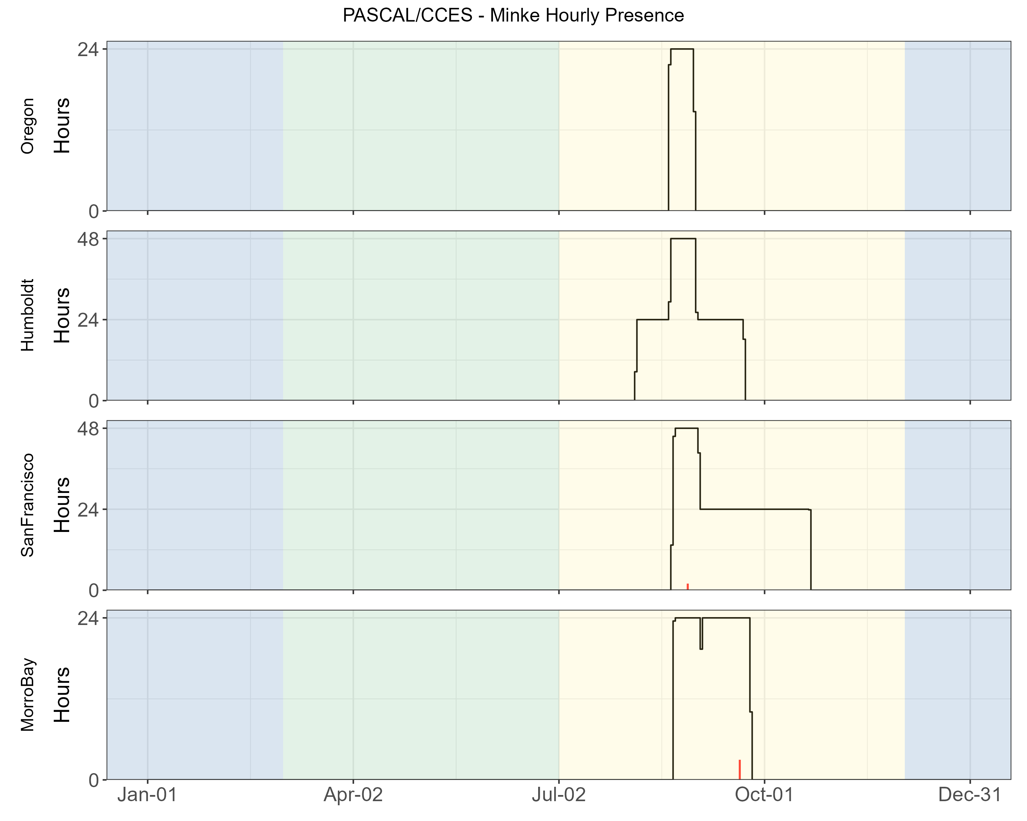

Figure .. Hourly minke whale events by month, region for Adrift and combined PASCAL, CCES surveys.

Hourly presence for minke whale boing calls (y axis) for different months for combined PASCAL 2016 and CCES 2018 survey (x axis) for each region (Oregon, Humboldt, San Francisco, and Morro Bay). There were no detections of minke whale boings during the Adrift study. Buoys were duty cycled and hourly presence relates to the portion of the hour included in the duty cycled data. Black lines represent total available hours (effort), and red lines represent hours with detections. Blue shading represents winter, green represents upwelling, and yellow represents the post-upwelling oceanographic season.

# Soundscape

## Soundscape

The purpose of soundscape monitoring was to describe the ambient noise level(s) in the California Current Ecosystem (including the Morro Bay and Humboldt Wind Energy Areas) and to identify the major contributors to the soundscape. To that end, we measured soundscape metrics and identified two primary sources of noise: self-noise and ship noise. Weather (wind, rain) is a significant contributor to soundscape and varies by season/region. Although we did not quantify this in our analysis, we recommend that future research include weather as a contributor to the soundscape. These data were combined with the detection of biological sounds from marine mammals to examine the biological and anthropogenic contributors to the soundscape.

Soundscape metrics aligned with SanctSound protocols[26] and were measured using Triton (Wiggins and Hildebrand 2007) with the Soundscape Remora. Data were decimated to 48 kHz, and LTSAs were calculated with a 1 Hz, 1 s resolution. The full system calibration value was calculated from the combined hydrophone and SoundTrap sensitivity. Soundscape LTSAs were used to calculate sound levels in 2-minute windows from 100 - 24,000 Hz, including broadband sound pressure levels, third-octave levels, and power spectral densities. Median (50th percentile), mean, and various statistical sound levels (1st, 5th, 10th, 25th, 75th, 90th, and 95th percentiles) are calculated for each metric. Soundscape metrics were archived to NCEI and linked with the original raw data.

The SanctSound methods were initially adopted to provide data consistent with previously analyzed data. Soundscape methods have changed significantly in the last three years, and the most recent recommendation is to report sound levels in hybrid millidecade bands. While there is now open-source software that can produce these metrics, it was not available for our analysis. All of our data is publicly available and the LTSAs were retained so that the data can be converted in the future. We recommend that data be reanalyzed to report sound levels in hybrid millidecade bands to align with current standards.

Periods of low frequency self-noise (strumming, knocking sounds resulting from movement of buoy components) were identified by scanning the 1- or 2-hour LTSA windows created with 500 Hz decimated files (5 Hz and 1 s resolution). Start and end times of noisy data were logged with the highest frequency affected (up to the 250 Hz maximum provided by the 500 Hz decimated data). Noisy data with energy above the 100 Hz lower bounds of the soundscape methods were removed from analysis. Additional details are provided in online analysis methods.[27]

The Power Spectral Density (PSD) is the measure of the signal's power as a function of frequency, and the PSD plots provide a visualization of the ambient noise for each region and season (Figure 6.1). Contributing sounds include biological sounds (marine mammals, fish, invertebrates), environmental noise (wind, rain), and anthropogenic noise (vessel noise, depth sounders, seal bombs). While Figure 6.1 includes all contributors to the soundscape, seasonal and regional differences can be informative and provide valuable pre-development information regarding the general soundscape. In general, noise levels ranged from 50 dB re 1uPa to nearly 150 dB re 1uPa, with the highest density of sound in the 75 - 100 dB range (Figure 6.1).

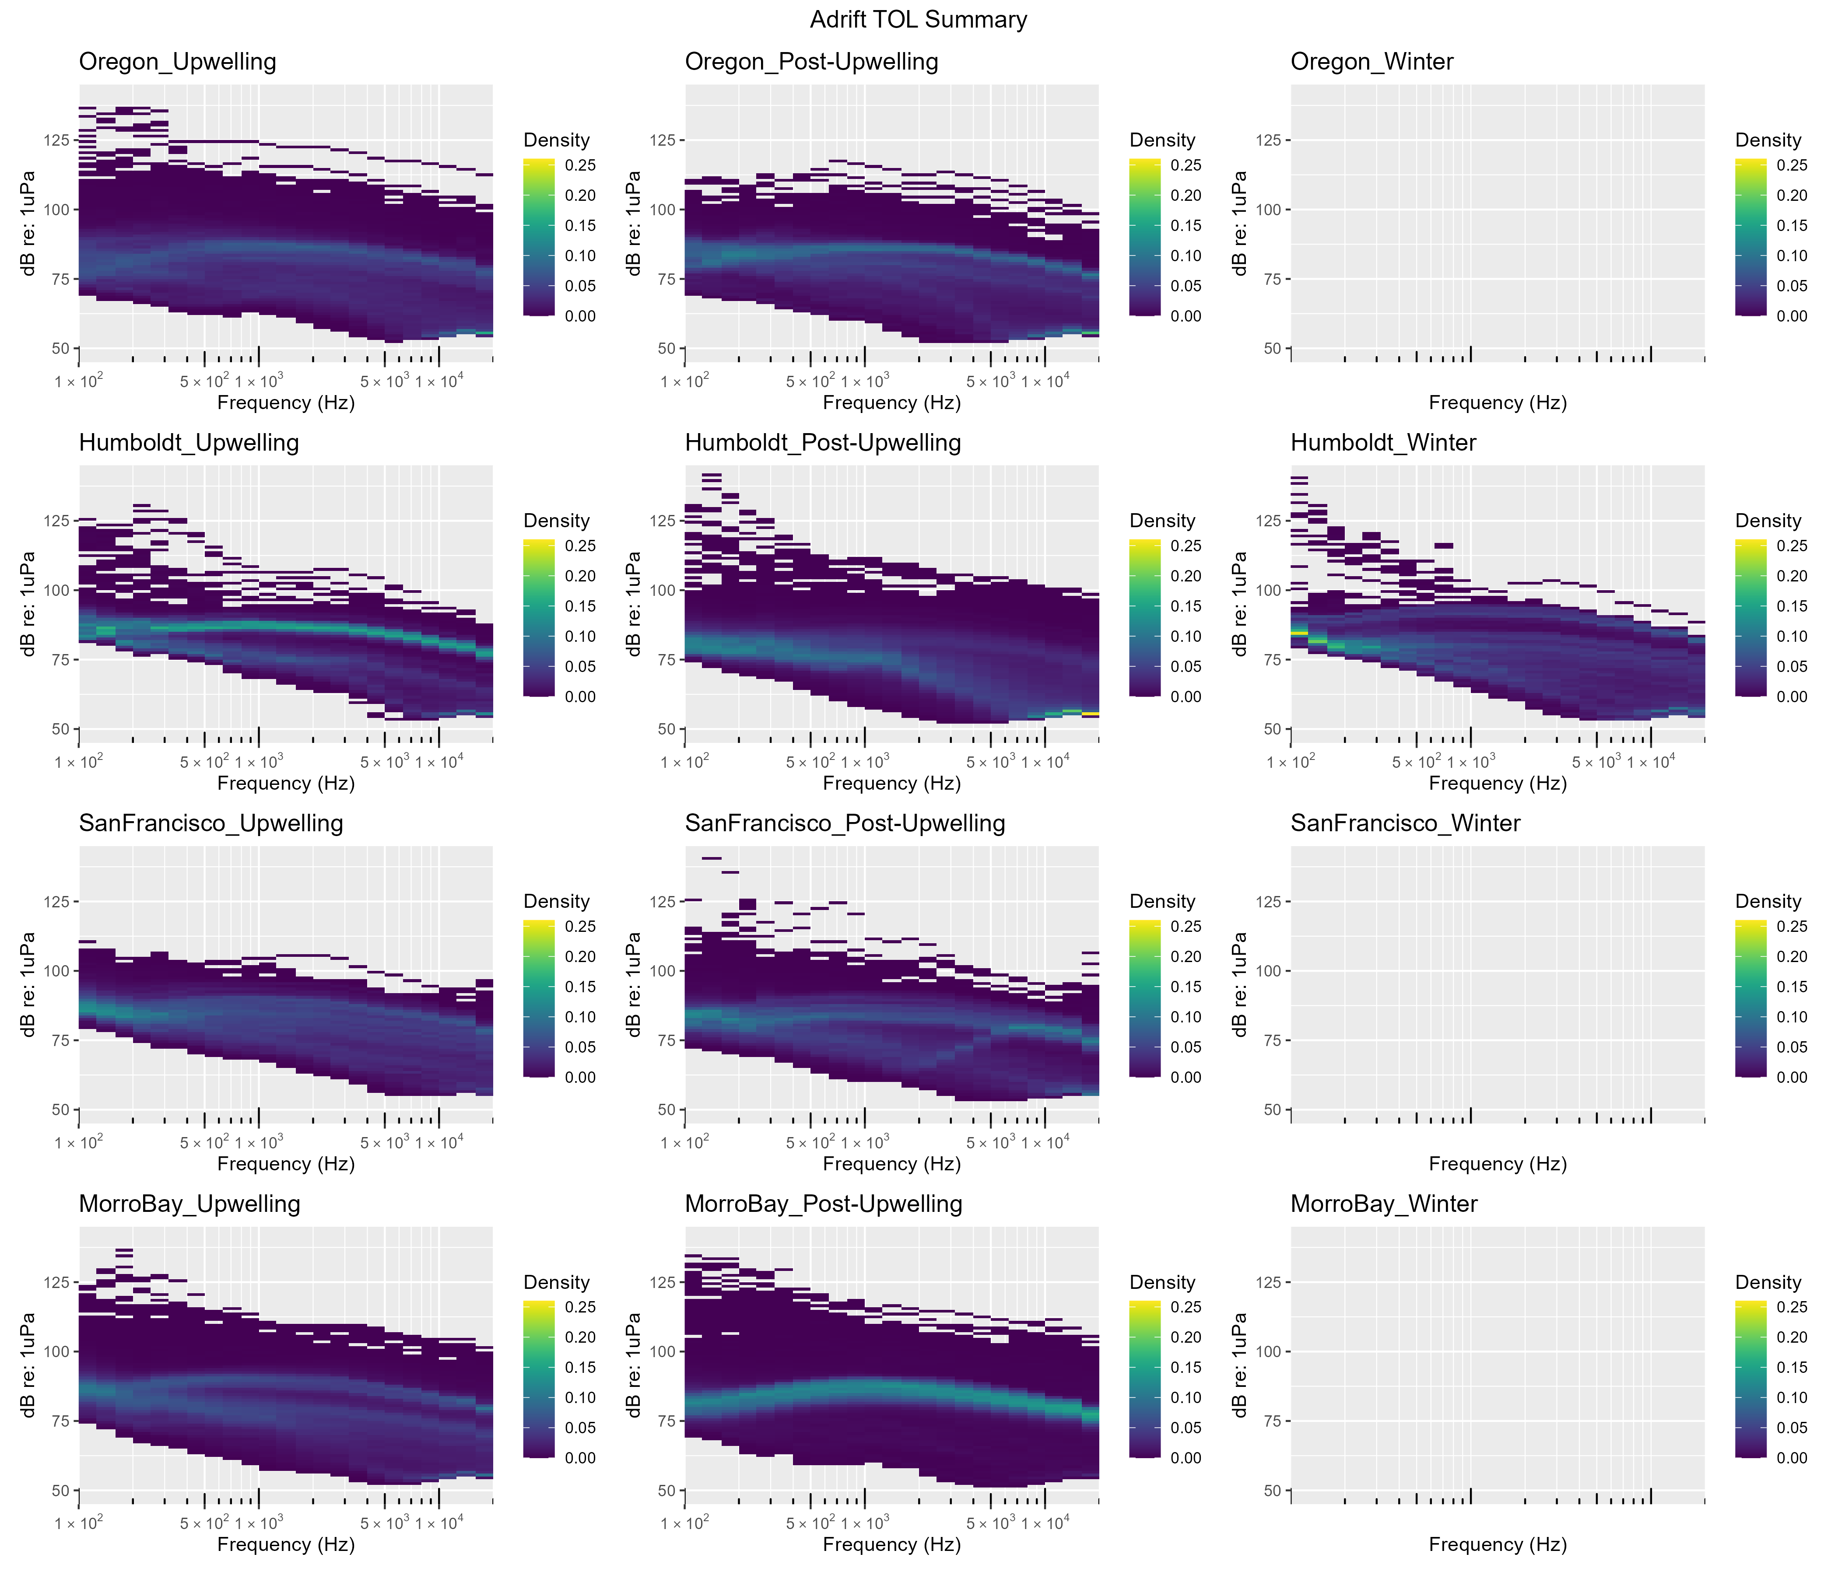

Figure .. Power spectral density for Adrift deployments by season and region.

Other researchers have developed models to separate the distinct contributions of ship and wind noise to soundscapes (Erbe et al. 2021; ZoBell et al. 2024). These models have been validated with empirical data and can be in close agreement in certain times and places, but validation has been very limited to small spatiotemporal scales. The data collected in offshore waters throughout the California Current by drifting recorders during PASCAL, CCES, and Adrift surveys can be used to validate models which separate wind and shipping contributions to sound levels. This will be an important next step for evaluating changes in the soundscape associated with offshore wind development areas.

Low frequency noise associated with strumming precluded consistent analysis of soundscape below 100Hz. Future drifting recorder studies should consider alternative configurations that eliminate strumming and other self-noise to allow for broadband soundscape analysis.

## Ship Noise

Ships produce different sounds while operating, such as impulsive signals from ship propeller cavitation or echosounder signals that can be easily identified in the LTSA and confirmed with a spectrogram. Vessel noise was identified by a trained analyst scanning 1-hour LTSA windows using the Logger Remora in Triton (100 Hz and 5 s resolution). Once a ship was identified, 10 s spectrograms were used to confirm identification (2000 point FFT, 75% overlap). Ships were either logged as being broadband (high amplitude with frequency content above 5 kHz) or narrowband/low frequency (lower amplitude). Ship noise was assessed in full for the Adrift study and in part for CCES (not analyzed for PASCAL). Additional details are provided in online analysis methods.[28] The manual methods used in this study were time consuming, but our initial efforts to analyze data with an existing ship detector found that the detector was unreliable on identifying ship tracks with our dataset. We recommend development of an open-source approach to vessel detection that includes classification of vessels to vessel type, and integration of this data into a systematic approach to quantifying the contribution of ship noise to the soundscape.

The percent of recording hours with vessel presence varied across region, season, and time of day (Figure 6.2). Vessel presence was higher in Oregon and Humboldt than in San Francisco or Morro Bay. Vessel presence in Humboldt shifted from night-time during the upwelling season to daytime during the post-upwelling season (summer), with winter variability likely relating to low effort. Morro Bay region experienced the lowest amount of vessel traffic, with extremely low levels of vessel traffic (<20%) detected in the post-upwelling season.

Hourly presence of ships in San Francisco appears to be lower than other regions (Figure 6.2). Overall sound levels were much higher in this region (Figure 6.1), and may have masked some individual ship passages. Future work can include an Automatic Identification System metric such as the number of unique large vessels with relatively close approaches.

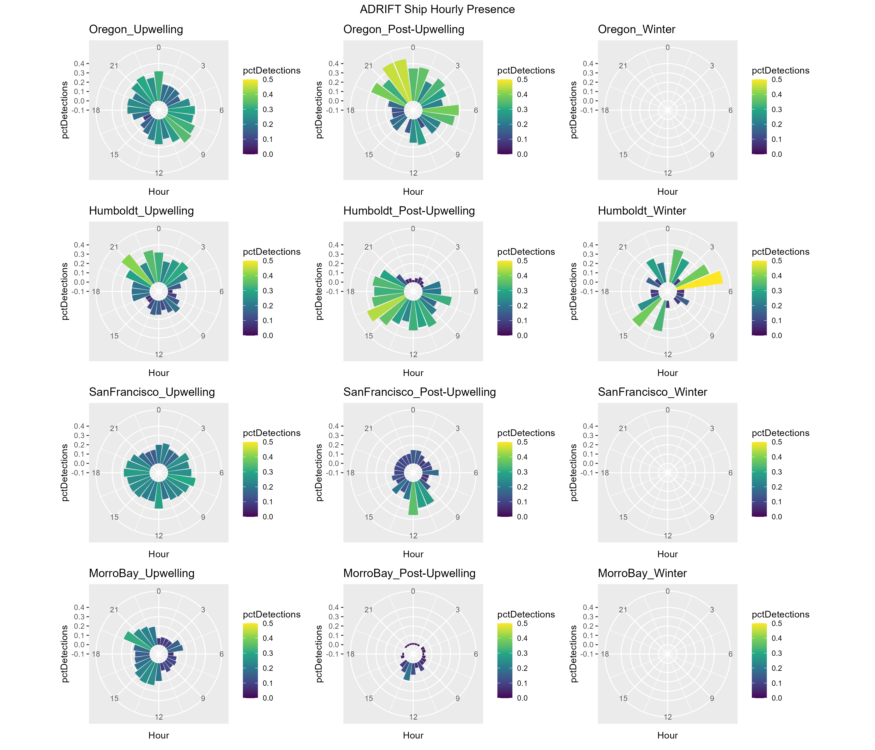

Figure .. Polar plots of seasonal detection of ship noise in Oregon, Humboldt, San Francisco, and Morro Bay regions.

The hourly percent of effort with vessel detections is shown in color ranging from dark blue (0%) to yellow (50%). The diurnal variation in vessel noise is shown by detection in bins on polar plot ranging from 0 to 24 hr of the day (UTC, Universal Time Coordinated).

## Contributors to the Soundscape

The marine soundscape includes sounds associated with physical drivers (rain, waves, earthquakes), biological sources (sounds produced by marine mammals, fish, and invertebrates), as well as anthropogenic sounds. In this study we examined sounds attributed to a number of marine mammal species as well as ship noise. Temporal variation (marked in hourly bins) in the contribution of these sounds to the overall soundscape are provided by the acoustic scene. An acoustic scene provides a visualization of the spectral variation in the contributors to the soundscape, where detection of various species classes is noted by the approximate frequency of their sounds. For this visualization, we used the following frequency range for these detections: blue whale (15 - 25 Hz), fin whale (20 - 50 Hz), humpback whale (50 - 2,000 Hz), sei whale (50 - 500 Hz), gray whale (100 - 2,000 Hz), minke whale (1,000 -2,000 Hz), sperm whale (1,000 - 20,000 Hz), dolphins (1,000 - 25,000 Hz), beaked whales (25,000 - 60,000 Hz), NBHF species (80,000 - 120,000 Hz) and ship noise (100 - 1,000 Hz).

### Oregon

The 2023 Oregon Pilot study consisted of multiple deployments during the upwelling and post-upwelling season (Figure 6.3). NBHF and sperm whales were detected during both the upwelling and post-upwelling seasons, but they were not detected during all deployments. Dolphins were detected during all deployments during both seasons, with variable occurrence. There was a single detection of beaked whales during the upwelling season.

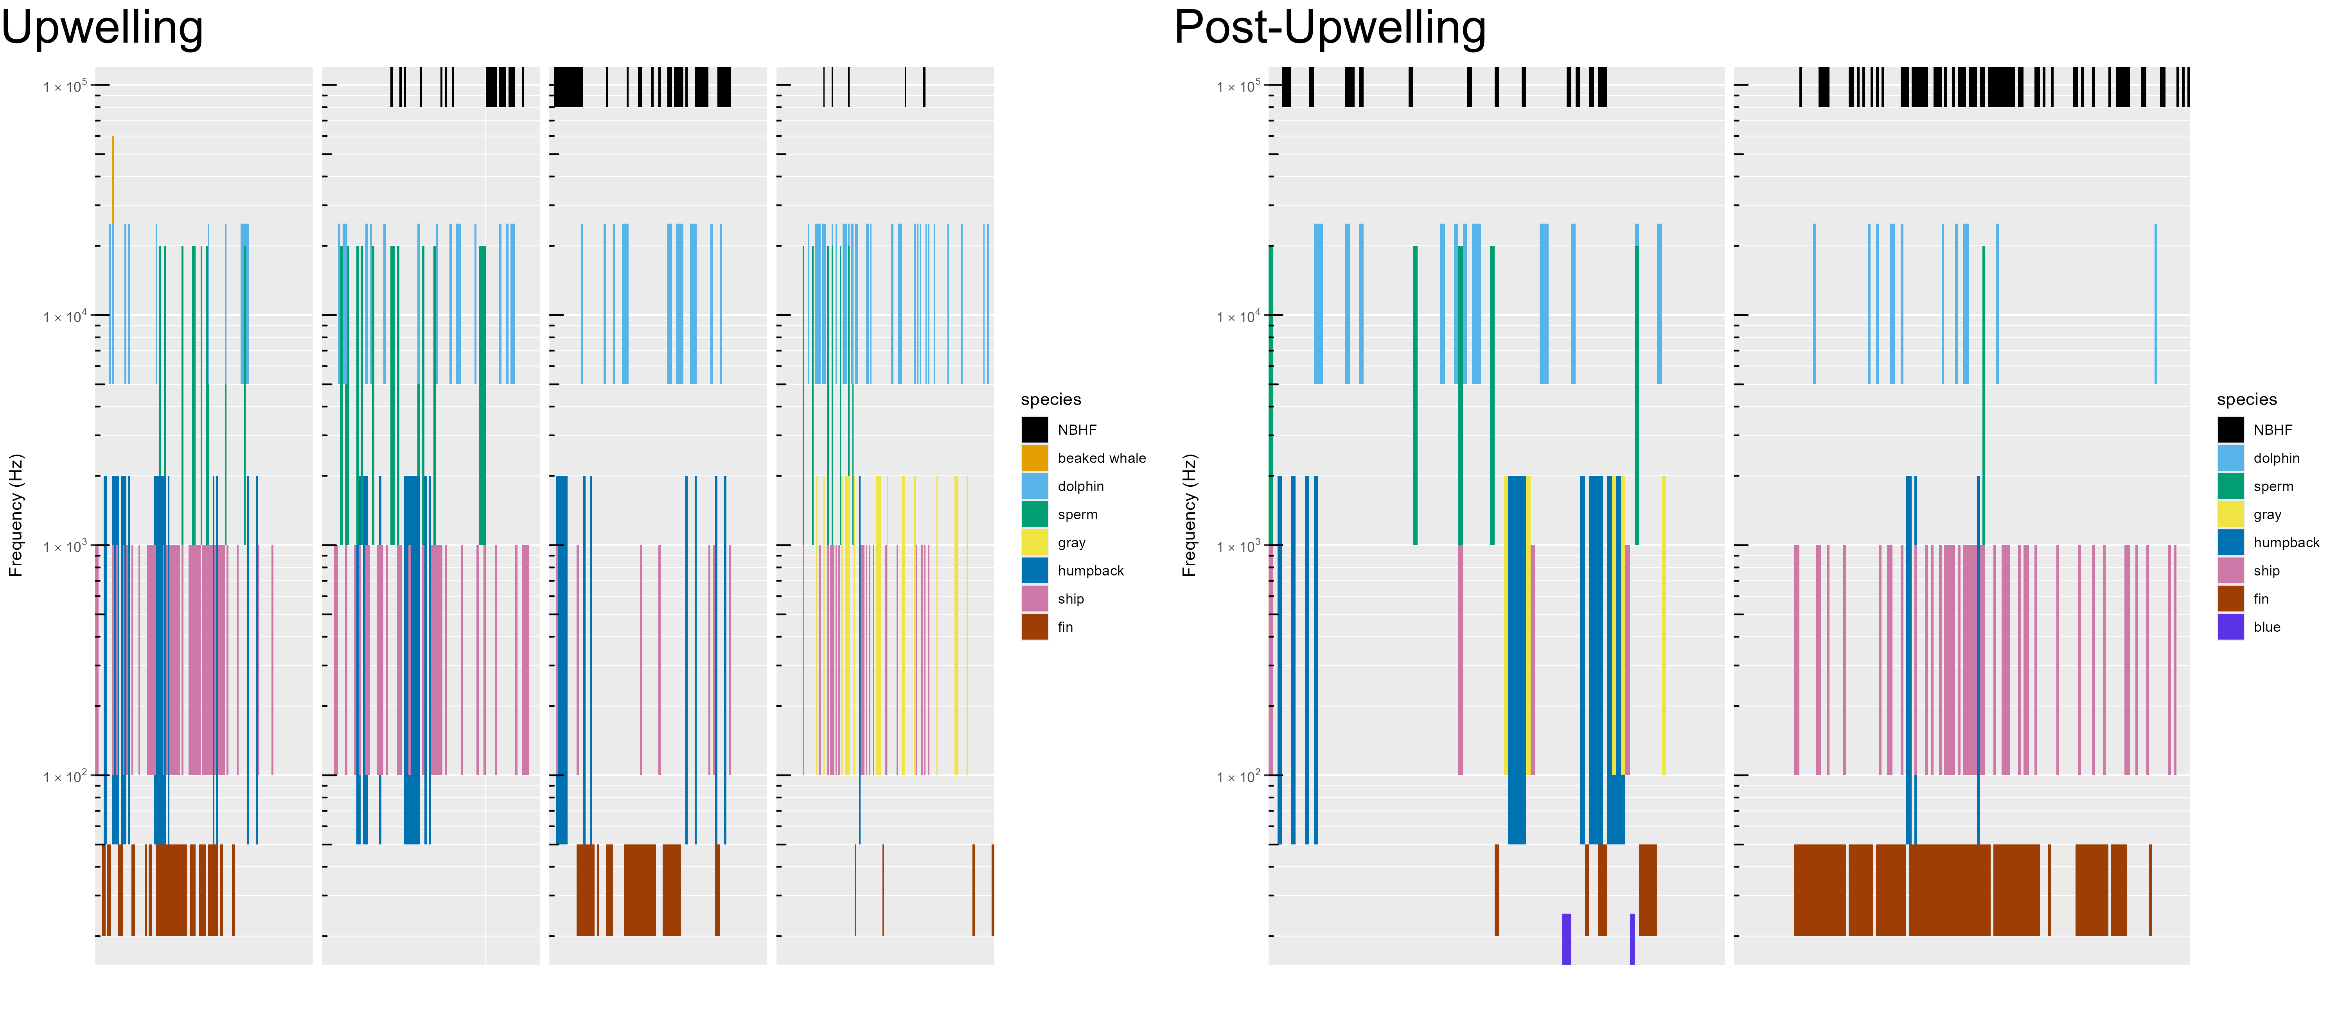

Figure .. Acoustic scene for Oregon, 2023.

Acoustic scene showing detections of various contributors to the soundscape for the 2023 Oregon pilot study deployments in the upwelling and post-upwelling oceanographic seasons.

Fin, humpback, and gray whales were detected during both the upwelling and post-upwelling seasons off Oregon, with a few detections of blue whales during the post-upwelling season (Figure 6.3). While ship noise was detected during both seasons, detection of vessel noise varied by deployment.

There were no deployments during the winter oceanographic season in Oregon, and the single year study did not allow us to assess annual variation.

### Humboldt

In Humboldt, NBHF, dolphins, and sperm whales were detected during all seasons, but not during all deployments (Figure 6.4, Figure 6.5, Figure 6.6). There were fewer dolphins detected in 2021 (Figure 6.4) than in subsequent years. Similar to Oregon, there were few detections of beaked whales in this region.

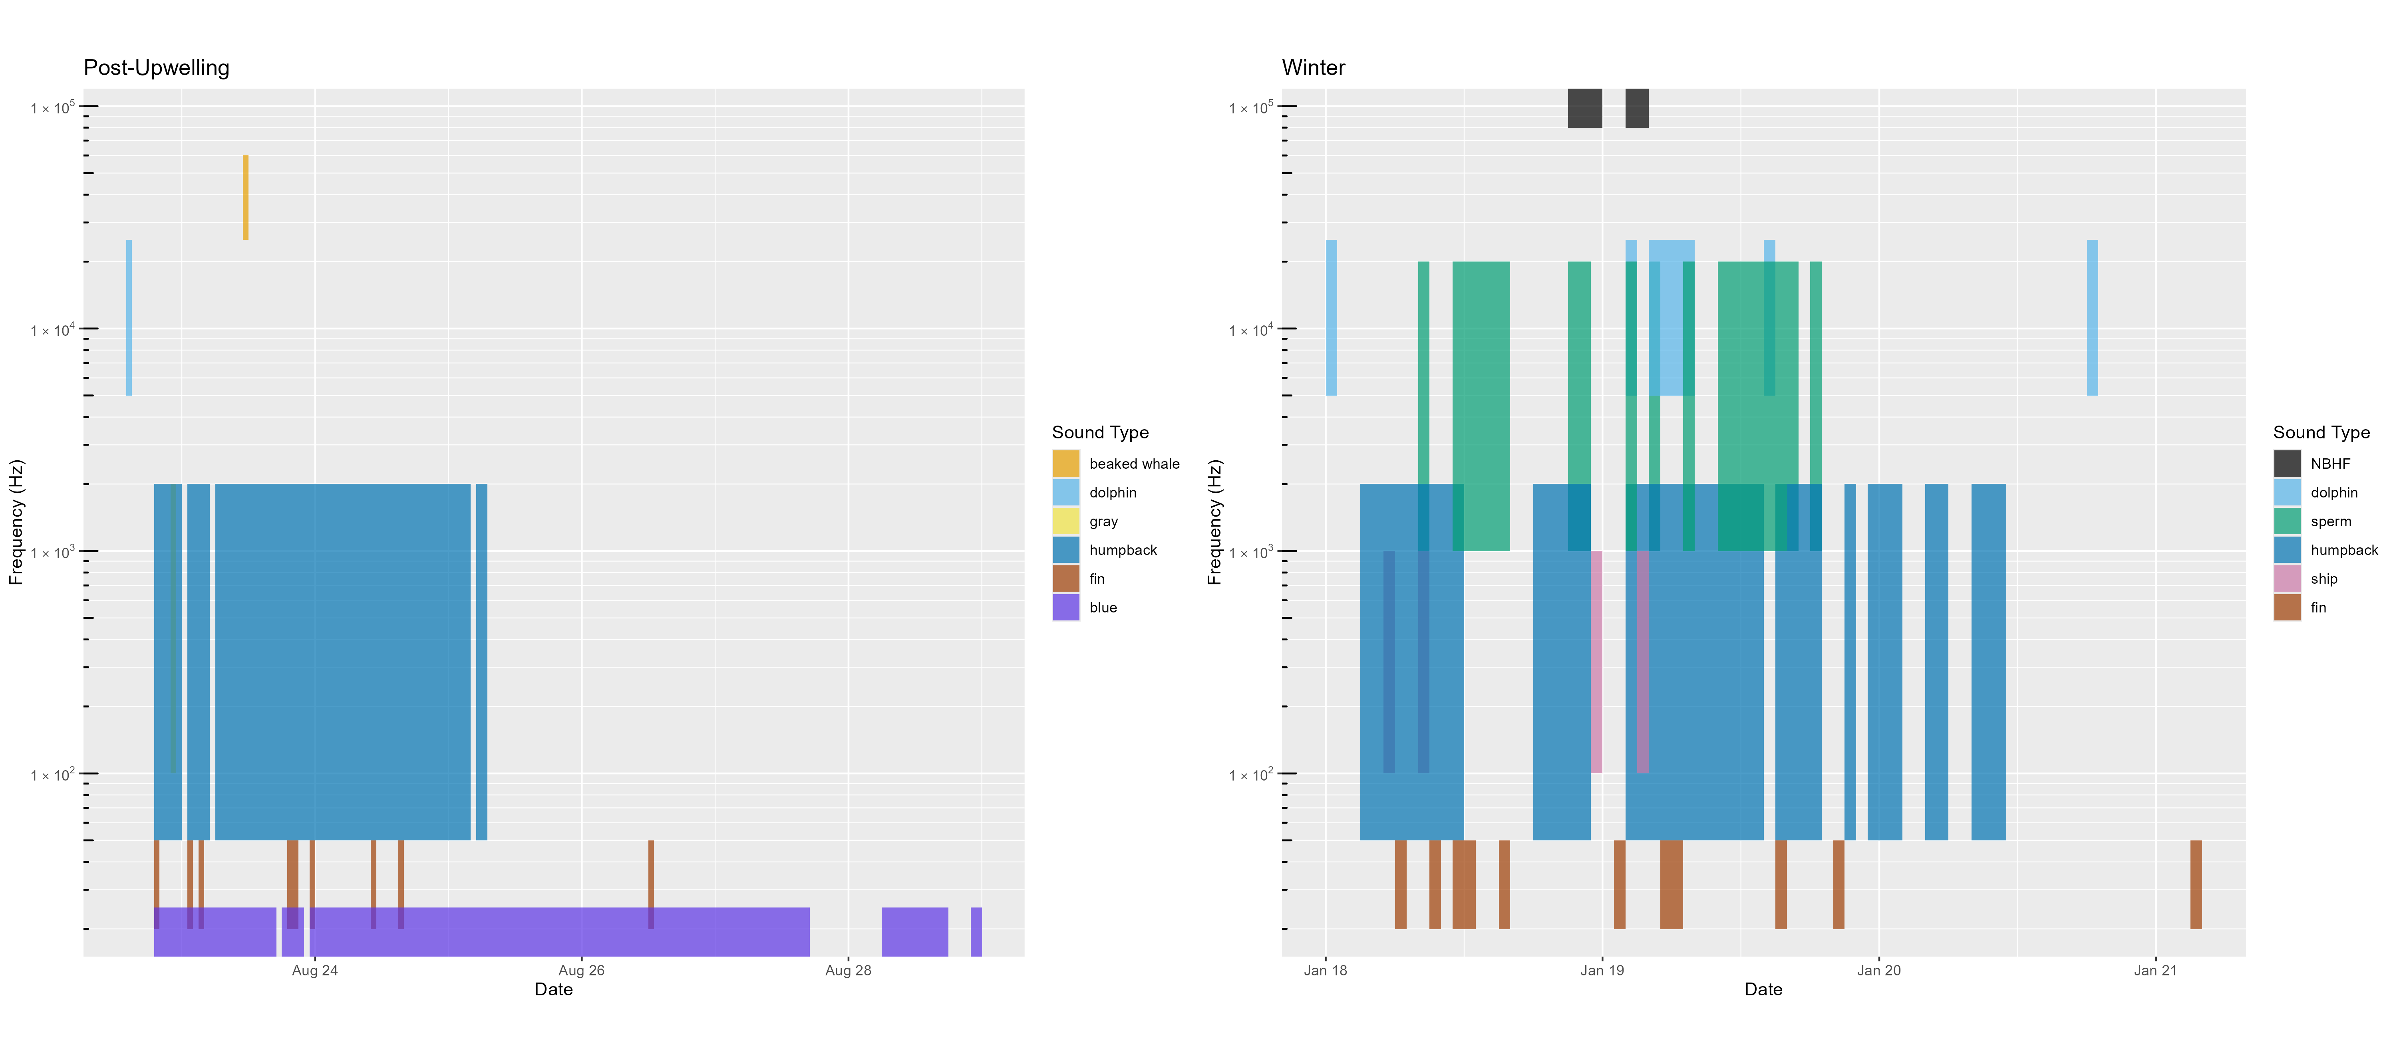

Figure .. Acoustic scene for Humboldt, 2021.

Acoustic scene showing detections of various contributors to the soundscape for the 2021 Humboldt deployments in the post-upwelling and winter oceanographic seasons. No data was collected during the 2021 upwelling season.

Blue whales were consistently detected during the post-upwelling season in all years (Figure 6.4, Figure 6.5, Figure 6.6). While fin whales were detected in all seasons, they were most consistently detected in the post-upwelling season. Humpback whales were frequently detected across seasons and years.

There was little ship noise detected during 2021 (Figure 6.4), which may be due to the ongoing pandemic; ship noise was more consistent during the 2022 and 2023 deployments (Figure 6.5, Figure 6.6).

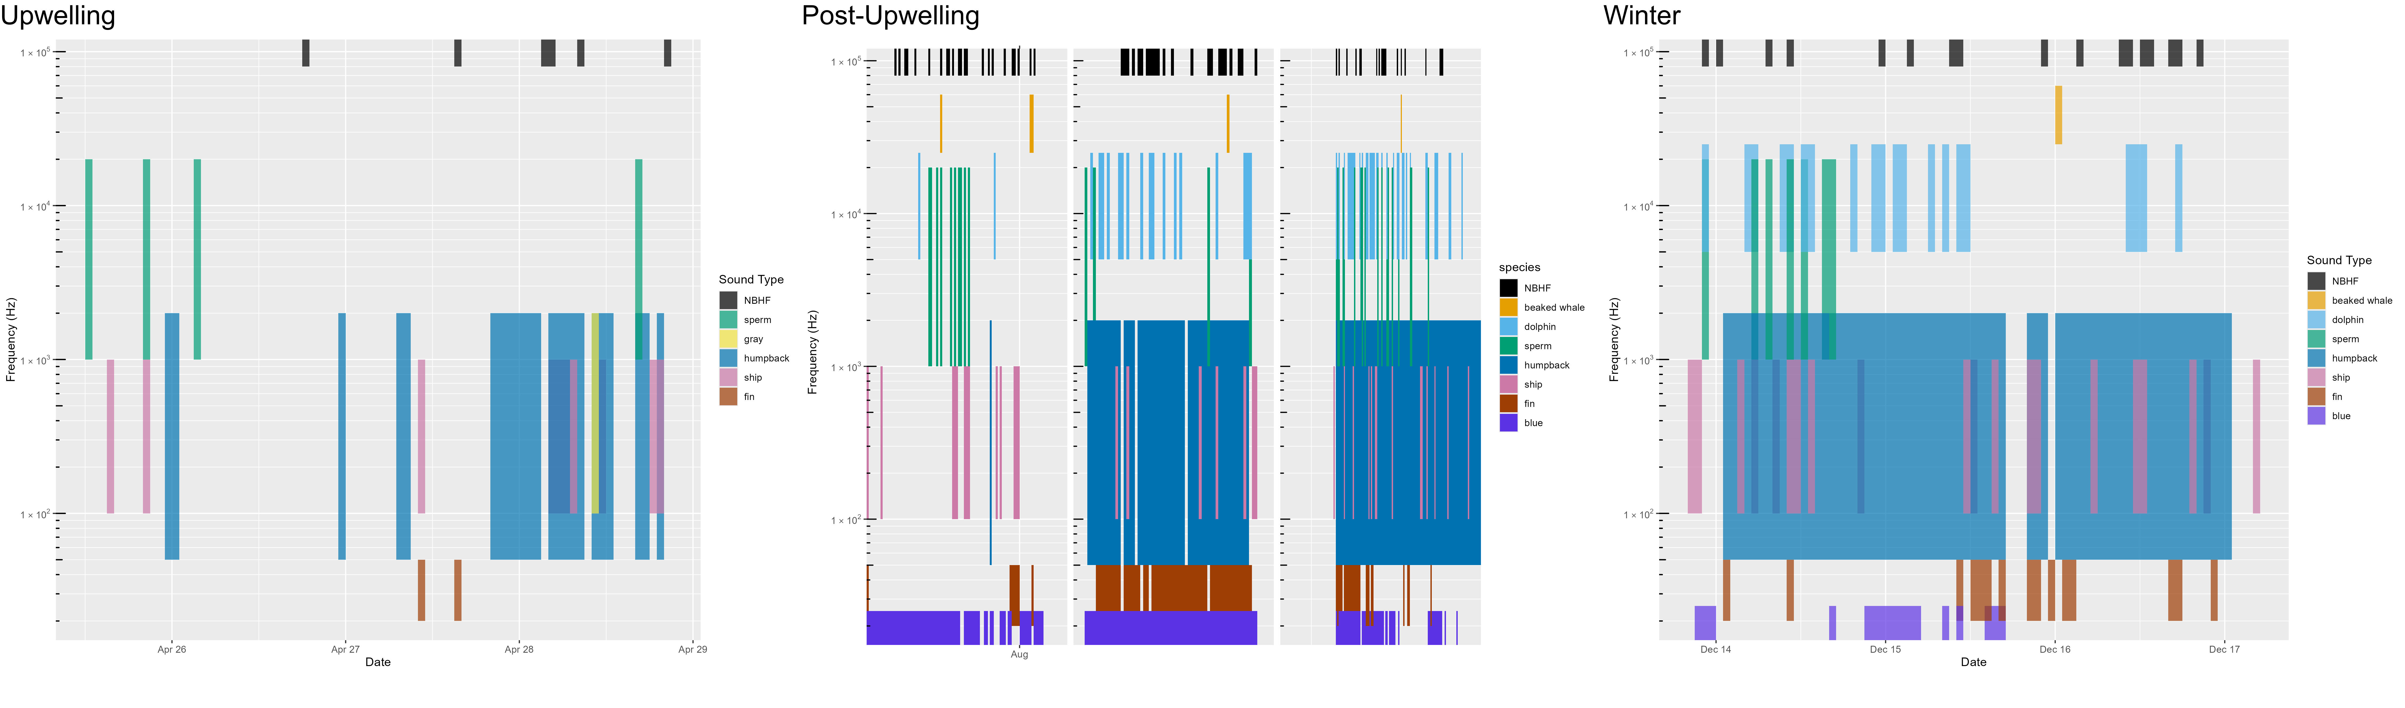

Figure .. Acoustic scene for Humboldt, 2022.

Acoustic scene showing detections of various contributors to the soundscape for the 2022 Humboldt deployments in the upwelling, post-upwelling, and winter oceanographic seasons.

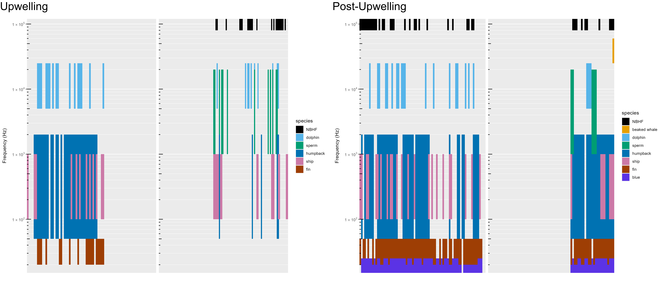

Figure .. Acoustic scene for Humboldt, 2023.

Acoustic scene showing detections of various contributors to the soundscape for the 2023 Humboldt deployments in the upwelling and post-upwelling oceanographic seasons.

### San Francisco

Deployments offshore San Francisco were coordinated with NOAA Sanctuaries' ACCESS Surveys during the upwelling and post-upwelling oceanographic seasons (Figure 6.7, Figure 6.8, Figure 6.9). Contrary to other deployments, buoys were not deployed in clusters as part of the ACCESS survey (to broaden survey area), and therefore data represent data from 1 or 2 buoys at greater distance from each other. Differences in geographic location of deployments in the upwelling and post-upwelling seasons may complicate interpretation of seasonal differences in marine mammal detections (see Figure 3.3).

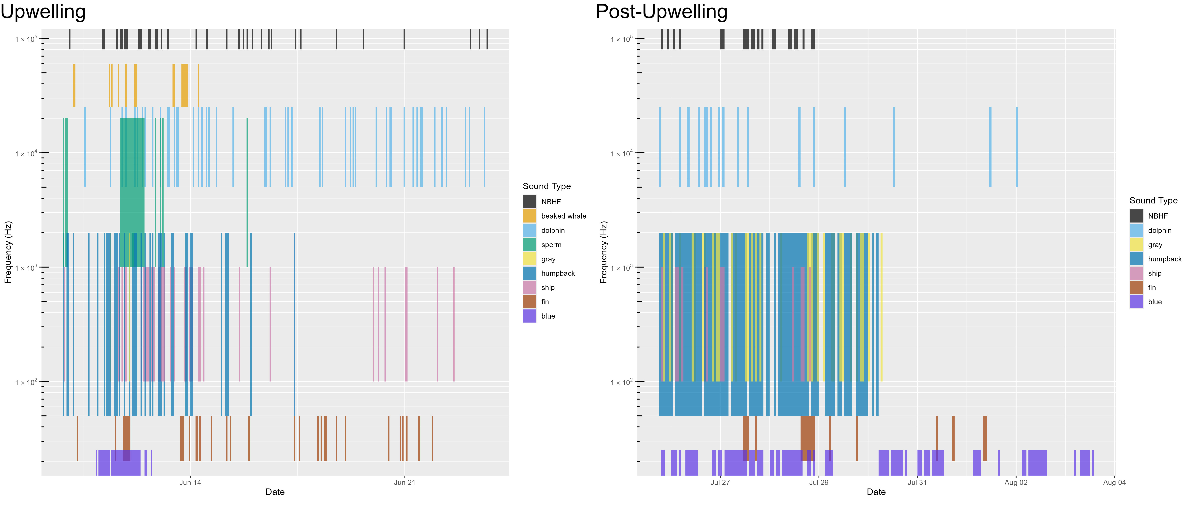

Figure .. Acoustic scene for San Francisco, 2021.

Acoustic scene showing detections of various contributors to the soundscape for the 2021 San Francisco deployments in the upwelling and post-upwelling oceanographic seasons.

Detection of odontocetes (including NBHF, beaked whales, sperm whales, and dolphins) varied by drift (Figure 6.7, Figure 6.8, Figure 6.9). Detection of baleen whales (humpback, gray, fin, and blue whales) varied by drift, with a general increase in detections of many baleen whale species during the post-upwelling season.

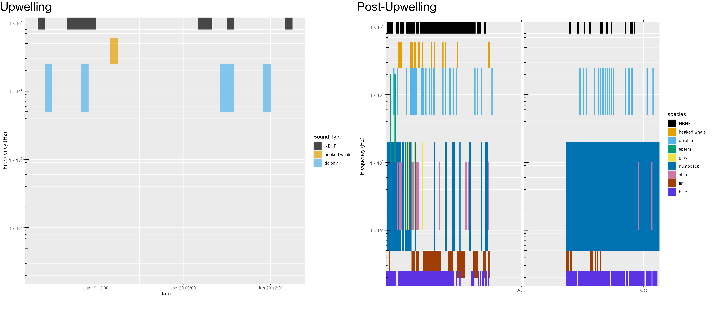

Figure .. Acoustic scene for San Francisco, 2022.

Acoustic scene showing detections of various contributors to the soundscape for the 2022 San Francisco deployments in the upwelling and post-upwelling oceanographic seasons.

Despite the drift locations being near a convergence of shipping lanes entering San Francisco Bay, detection of specific vessels was relatively modest. Analysts noted an overall high level of ambient noise associated with background ship noise (Figure 6.1) and a reduced ability to detect individual vessels. Detection of vessels used manual detection methods (existing automated vessel detectors were not reliable for this dataset); development of a standardized vessel detector that works across datasets could be used to determine if individual ship tracks are difficult to detect in high traffic areas.

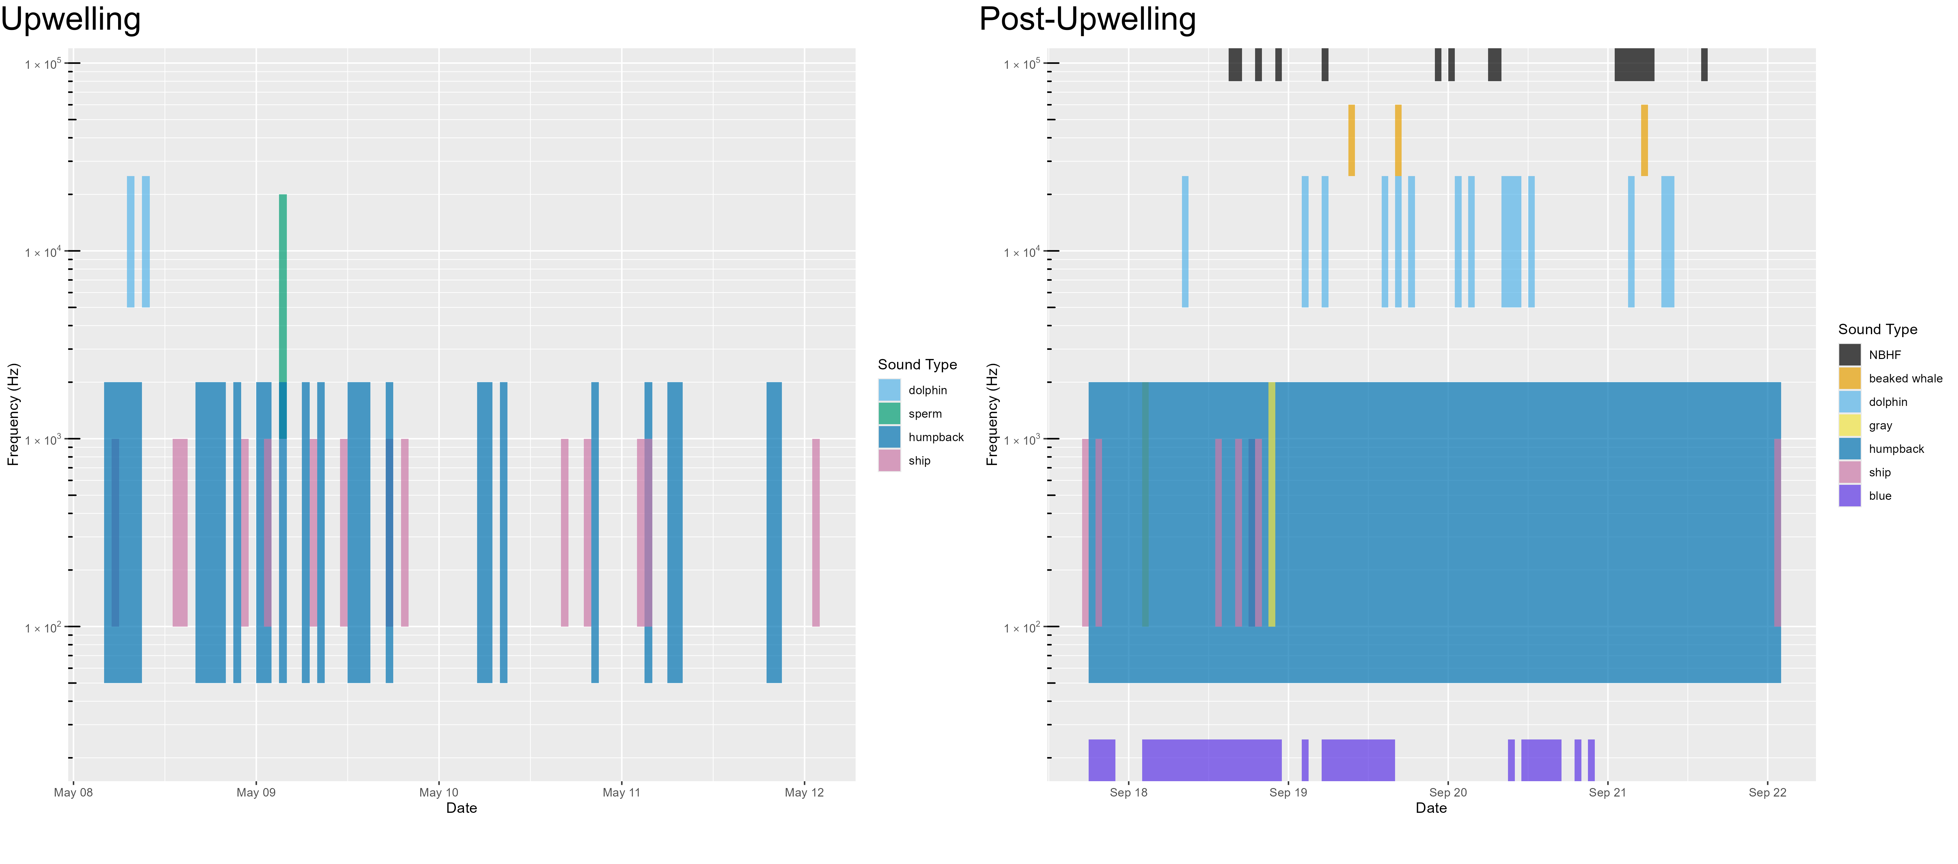

Figure .. Acoustic scene for San Francisco, 2023.

Acoustic scene showing detections of various contributors to the soundscape for the 2023 San Francisco deployments in the upwelling and post-upwelling oceanographic seasons.

### Morro Bay

Morro Bay deployments included between 7 and 8 drifting recorders deployed over a larger area, which allowed for improved geographic sampling during the limited time for each deployment. Detection of NBHF, beaked whales, and dolphins were much lower during the initial upwelling deployments in 2022 (Figure 6.10), but high during the second upwelling deployments in 2022 and in the 2023 deployments. Detection of high numbers of beaked whales during times with dolphin echolocation was possible due to the vertical hydrophone configuration that allows for differentiating deep diving beaked whale species (echolocating below the hydrophones) from dolphins echolocating near the surface. Sperm whales were detected on some, but not all, drifts during both the upwelling and post-upwelling surveys (Figure 6.10, Figure 6.11).

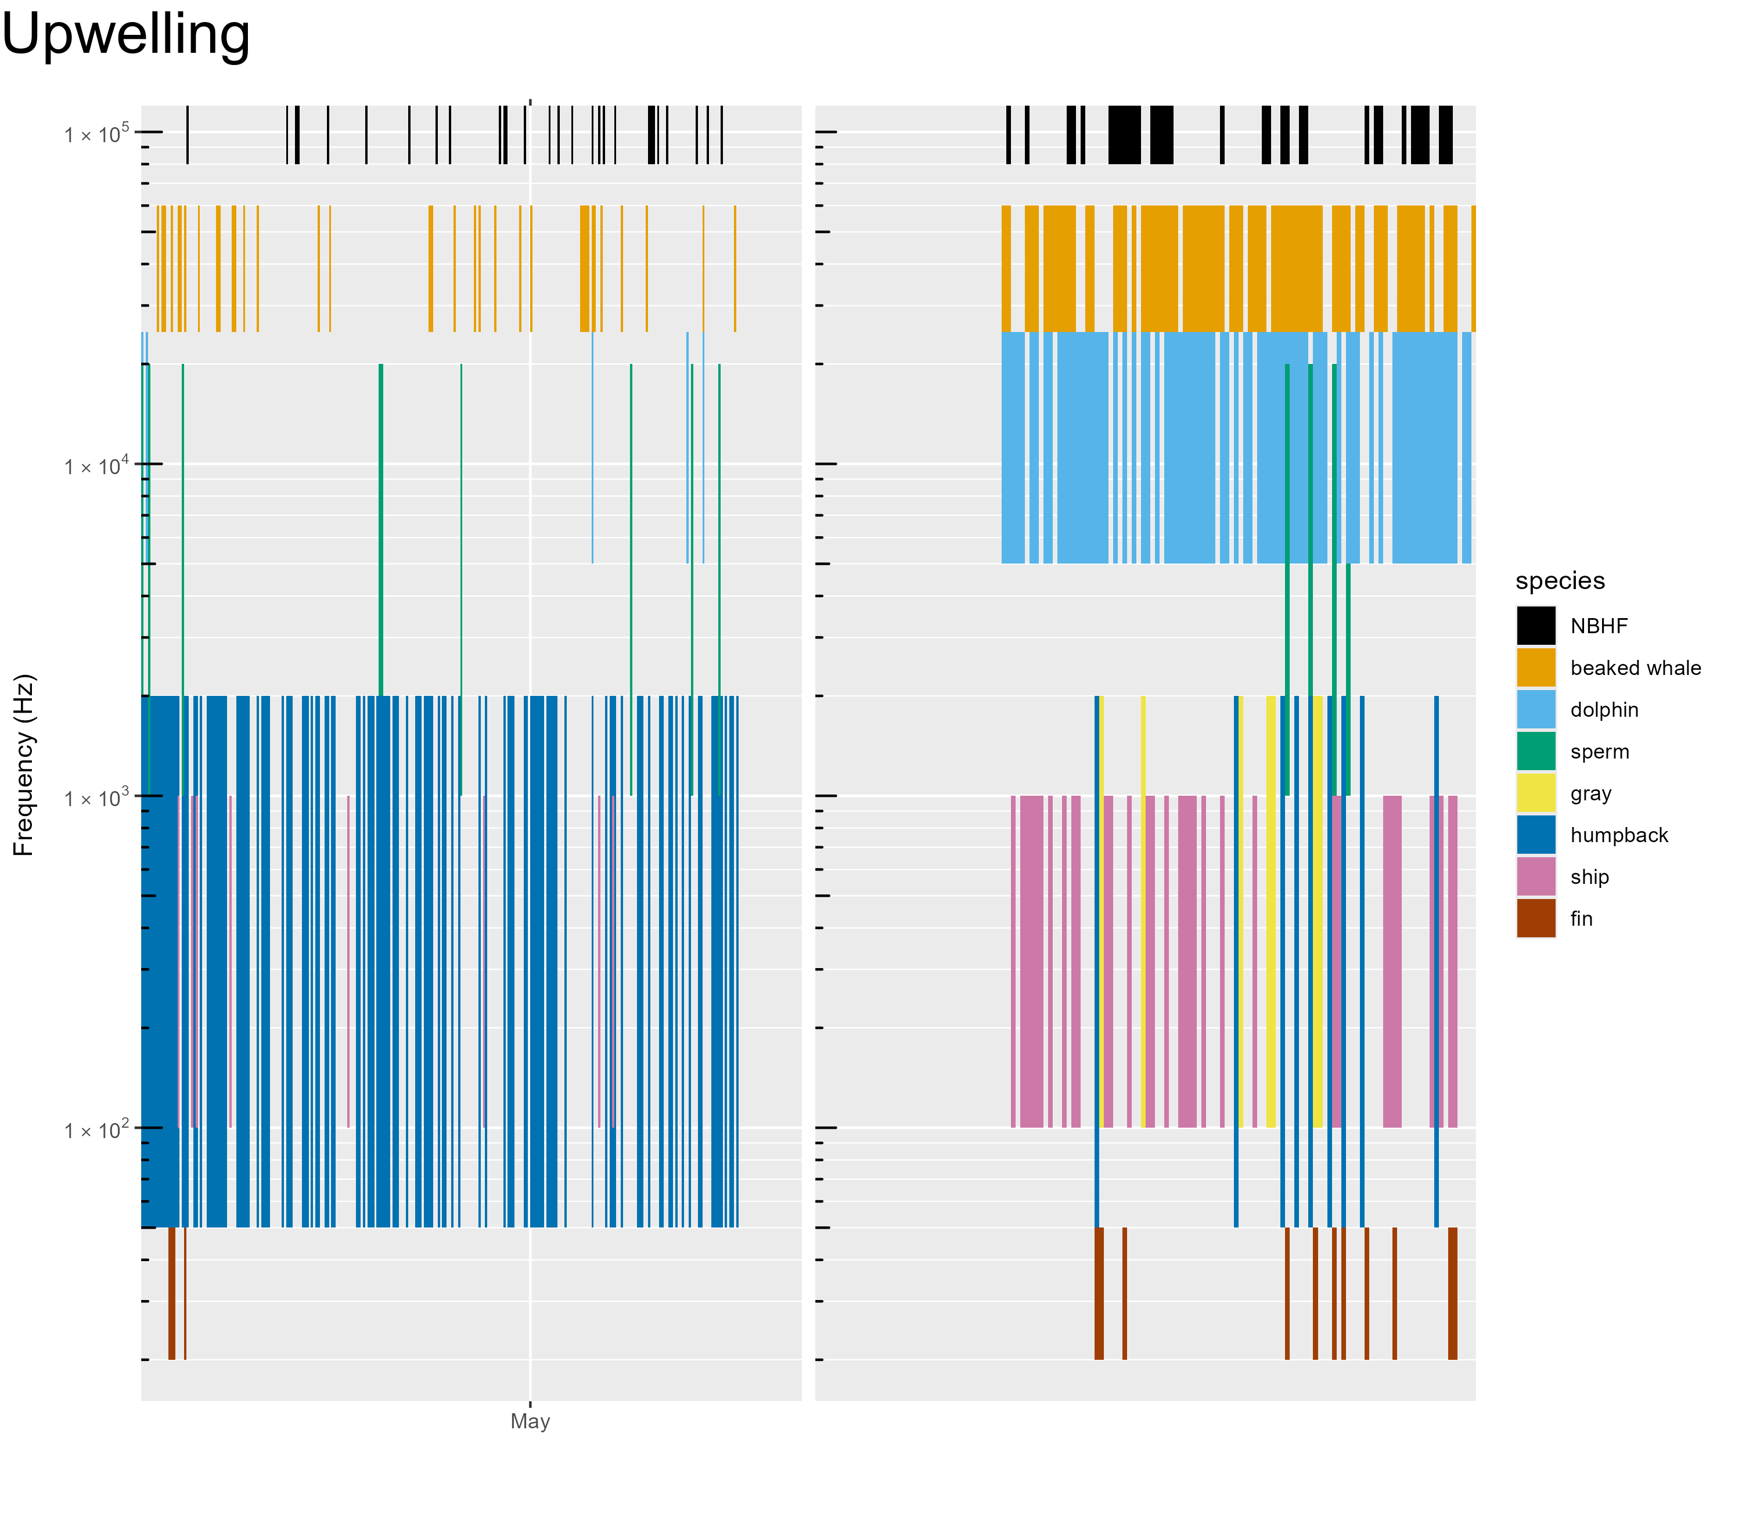

Figure .. Acoustic scene for Morro Bay, 2022.

Acoustic scene showing detections of various contributors to the soundscape for the 2022 Morro Bay deployments in the upwelling oceanographic season.

Fin and humpback whales were detected during all surveys. Blue whales dominated the post-upwelling deployments in 2023 (Figure 6.11), but there were no blue whale detections during either of the upwelling deployments. Periodic vessel noise was detected during all deployments.

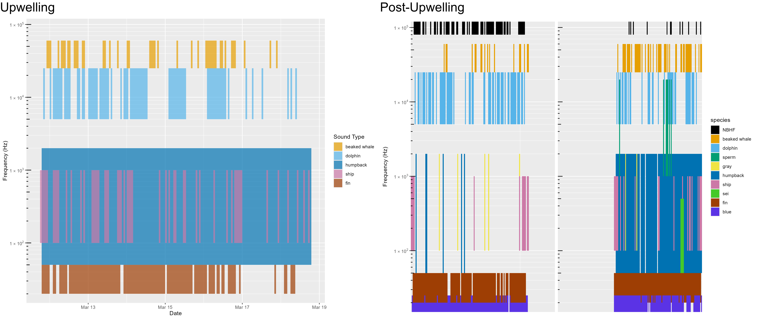

Figure .. Acoustic scene for Morro Bay, 2023.

Acoustic scene showing detections of various contributors to the soundscape for the 2023 Morro Bay deployments in the upwelling and post-upwelling oceanographic seasons.

# Data Sharing

NOAA is committed to increasing the accessibility of publications and digital data produced by federal researchers through the Public Access to Research Results. Publications (including reports) can be accessed at the NOAA Institutional Repository. Raw acoustic data (wav files) are stored at the NCEI and can be accessed after an initial waiting period required as part of the NOAA Fisheries agreement with the U.S. Navy. Metadata include information related to data collection (hardware characteristics, geopositions, recording specifications), soundscape metrics, and species acoustic detection data. Recording metadata associated with data collection and Soundscape metrics will be stored at NCEI. Acoustic detection of species will be accessible via PACM[29]. Details on data archive and sharing methods are provided in our analysis methods.[30]

In addition to public sharing of our research results, the Southwest Acoustic Ecology Lab firmly believes that analysis methods should be publicly accessible. We dedicated time to develop a streamlined approach to data analysis, data visualization, and archival processes to create a reproducible product. These include developing methods in open-source software and publishing analytical methods as R packages, available on CRAN[31] (Comprehensive R Archive Network). This approach requires substantial initial investment, but ultimately provides improved efficiency and reproducible research results. Development of open-source analytical methods for detecting baleen whales required additional research and development investment; complications that arose due to the COVID-19 pandemic thwarted these efforts. Many of these data methods and data products are being adopted by other researchers and across NOAA Fisheries more broadly, providing future cost savings to NOAA and BOEM into the future.

Additional details regarding open Science efforts can be found in Appendix: **Error! Reference source not found.**.

# Education and Outreach

The study of ocean sound is interdisciplinary and provides a natural opportunity for community engagement in formal education (K-12), informal science learning (museums), and online crowd-source citizen science participation. Our team engaged with students, journalists, and educators to develop materials and tools to make our science accessible to the public. Education and Outreach efforts included mentoring students and interns on authentic research projects, inviting journalists to participate in fieldwork, collaborating with educators to develop lesson plans for many age groups, and developing a preliminary crowd-sourced Zooniverse platform for community involvement in our research.

The interdisciplinary nature of passive acoustics along with the natural appeal of whales and dolphins provides an opportunity for engaging the public in science and the scientific process. To that end, we developed a series of education and outreach materials to reach a diverse populace.

In 2020 we collaborated with San Diego Unified School District (SDUSD) to host a teachers' workshop to develop a series of phenomena-based instructional curricula. Lessons aligned with Next Generation Science Standards and included instructional units for elementary schools (Dolphins have Needs[32]), Middle School (You can recognize different species by the sounds they make[33]) and High School (Ocean noise impacts marine mammals[34]). Lessons plans are publicly available on the Project Phenomena Database[35] website.

Data Nuggets are free classroom activities designed to bring contemporary research and authentic data into the classroom. Data Nuggets were recommended by our teacher collaborators during the SDUSD workshop as a highly useful format for Science Technology Engineering Mathematics in the classroom. We collaborated with Data Nuggets to create 'Eavesdropping on the Ocean’[36]. This Data Nugget provides background on the research question, authentic data to allow classrooms to work with real data to apply to the research question, as well as links for additional information. This has been made publicly available for teachers at no cost.

In addition, we initiated a Zooniverse Project, Ocean Voices[37]. The initial intention of this effort was to use citizen scientists to label datasets as either humpback whales or ship noise; these annotations would then be used to develop an improved machine learning classifier. This required significant effort to automate development of paired spectrograms and acoustic recordings for the platform. The citizen scientist portion of this project will be delayed until future continuation of the work done during the Adrift study, however, the platform can currently function as an education learning tool. The software tools designed to manipulate acoustic data for input to Zooniverse are available on GitHub.[38]

Our periodic 'Sound Bytes' blog provides a general audience with insight into the day-to-day work behind the science. Topics range from 'Lessons learned from Fishermen'[39] to how we ‘Gear up for Fieldwork’[40] to how we ‘Hook young scientists on Research’.[41] We have had a host of guest bloggers, including students, interns, and collaborators. These blogs are shared on NOAA's website[42] and they have been promoted through numerous NOAA newsletters. Cory Hom-Weaver led these efforts and was recognized for an Award by NOAA's Southwest Fisheries Science Center for the excellent education and outreach provided by the Sound Bytes blog.

Additional details regarding our education and outreach efforts can be found in Appendix: Education and Outreach Details.

# Conclusions and Future Directions

The Adrift in the California Current survey was intended to provide additional baseline data on marine mammals and the marine soundscape to inform management of offshore renewable resource development in the California Current. In addition to conducting data collection efforts in and around the Morro Bay, Humboldt, and Oregon WEAs, we also analyzed archived data from previous large scale acoustic surveys.

The first phase of Adrift was initiated in June 2020 off Northern California, with a special focus on the Humboldt WEA. We partnered with NOAA Sanctuaries to provide additional sampling off San Francisco between late Spring and late Summer. Initial deployments were delayed until August 2021 due to the COVID-19 pandemic. The second phase extended this effort to the Morro Bay WEA offshore Central California in 2021. In 2022 we initiated a pilot study to examine the potential for extending this study northward to include offshore Oregon. Data collection efforts were severely limited due to the COVID-19 pandemic as well as inclement weather and oceanographic conditions aggravated by La Niña. Despite these limitations, we deployed 90 drifting recorders in our four study areas for a total of 8,736 recording hours.

Prior to this study, NOAA had successfully deployed drifting acoustic recorders during two large-scale surveys and developed methods to estimate beaked whale density for the larger California Current region. Southwest Fisheries Science Center in partnership with BOEM’s Pacific Region is currently conducting an additional large-scale survey with drifting acoustic recorders (Pacific Marine Assessment Partnership for Protected Species – PacMAPPS II/CalCurCEAS).

While we have been successful using drifting recorders during these large-scale surveys during the late post-upwelling season, we encountered significant challenges in using them during other oceanographic seasons. There were multiple cases of equipment and data loss, especially during the initial deployments. Losses were due to a variety of reasons, including inclement weather, strong currents, and recorder failures. We mitigated these problems through modifying components and altering survey methods. A number of gear modifications were made to improve robustness and to decrease self-noise that interfered with recording quality.

Drifting acoustic recorders provide a low-cost alternative to traditional PAM systems and they can provide additional geographic and temporal resolution in remote offshore areas. Clustered drifting recorders provide an opportunity to improve our understanding of the spatial and temporal variability of the contributors to the soundscape. Preliminary results suggest that clustered drifting recorders can be used to reduce the possible range of possible source location for sound sources (see Appendix: **Error! Reference source not found.**) and can provide information on the spatial variation in soundscape (see Appendix: **Error! Reference source not found.**). Drifting recorders were deployed in clusters of 4 drifting recorders in Humboldt and Oregon study areas, and in clusters of 8 in the Morro Bay Study area. In some cases, drifting recorders in close proximity to each other followed dramatically different drift trajectories.

Below we present a summary of our results and a summary of recommendations for future work.

## Summary of Results

Drifting acoustic recorders can provide high quality PAM for some offshore regions, especially when deployed in clusters to enhance spatial monitoring. Pilot studies are recommended for new regions, to ensure that environmental conditions and local resources support effective sampling. Hardware continues to evolve to allow for improved data collection, and newly developed sub-surface drifting recorders may prove preferable to existing drifting recorders with surface buoys. Our experience suggests that deployment of clustered drifting recorders seasonally in areas of interest could provide additional spatial context to co-located seafloor recorders. Seasonal sampling of these clustered deployments during collaborative cruises, such as our Morro Bay fieldwork, promotes collaborative science and reduces vessel costs.

This dataset provides additional (publicly available) data to support management needs as well as new information on several species. Data analysis included most cetacean species found within the California Current; though several rare species (north Pacific right whales, pilot whales) were not included, nor were pinnipeds. The data are publicly available for future expansion of analysis to include these species.

**Sperm whales** are listed as endangered and their consistent, stereotyped vocalizations make them ideal candidates for PAM. Sperm whales were detected in all study areas, with high detection probabilities in Humboldt during all seasons. PAM data can also be used to determine the demographic composition of sperm whales, and a pilot study of a Morro Bay dataset found that all animals were social groups consisting of females and their young, or juvenile males. There was insufficient time to complete this analysis for our entire archived data, but future research should include acoustic estimations of demographic composition for sperm whales.

**Beaked whales** are difficult to detect, and even harder to classify to species, based on traditional visual observation methods. As with sperm whales, beaked whales are ideal candidates for PAM, and most species can be acoustically classified to species. As an example, there were no detections of beaked whales in 30 years of ACCESS surveys; however, during our limited Adrift deployments, there were numerous detections of both Baird’s beaked whales and goose-beaked whales. Beaked whales were found in all regions, with goose-beaked whales the most common species overall (though none of these species were detected in either Humboldt or Oregon). During the Adrift study, methods to estimate beaked whale density using drifting recorders were automated (to improve efficiency), and data were prepared for analysis, but we were unable to complete this analysis during the time available.

Many of the beaked whales detected in Morro Bay co-occurred with echolocating dolphins. The vertical hydrophone array of the drifting recorders allows for estimation of bearing angles for incoming echolocation clicks, and subsequent differentiation between echolocating beaked whales at depth from echolocating dolphins near the surface. By segregating the echolocation clicks based on bearing angle, we were able to identify the small numbers of beaked whale clicks within thousands (or even millions) of echolocating dolphins. The co-occurrence of dolphins and beaked whales has not been previously reported, and it is unclear what may bring these species together. The likelihood of detecting beaked whales in these mixed species encounters would have been very low if recordings were collected from a single, seafloor sensor or from towed hydrophone arrays.

The California Current has a high diversity of **dolphin species**, and species classification is difficult. While there are several potential approaches to species classification, they have either been developed for towed arrays at the surface (Rankin et al. 2017) or for seafloor hydrophones (Frasier et al. 2017). Currently, there is insufficient validated data for drifting recorders to test the efficacy of existing classifiers on these data, or to develop a drifting-recorder specific classifier. That said, there are robust methods to identify echolocation clicks from Pacific white-sided dolphins and Risso’s dolphins. Dolphin schools in central and northern California are frequently encountered in large, dispersed mixed species groups, and here we do not distinguish mixed species from single-species groups.

Risso’s dolphins were detected in all regions except Oregon, and had the highest probability of detection during the upwelling season in Humboldt. The dominant click type detected was the ‘Pelagic Pacific’ type identified by Soldevilla 2017. Pacific white-sided dolphins were detected in all regions, with higher detection probabilities in the post-upwelling season for Humboldt and San Francisco, and during the upwelling season in Morro Bay. The dominant click type for Pacific white-sided dolphins was ‘Type A’, though ‘Type B’ click types were detected northward of the range identified in Soldevilla 2010. There were relatively few detections of ‘Unidentified odontocetes’ during the post-upwelling season in Oregon and Morro Bay.

The California Current is home to four different species that produce **NBHF** echolocation clicks: harbor porpoise, Dall’s porpoise, pygmy sperm whales, and dwarf sperm whales. Despite the similarities in their echolocation clicks, these species inhabit different habitats and have different behaviors and life histories. Student work to develop a NBHF classifier for this study (see Appendix: **Error! Reference source not found.**) will be further developed in the near future and applied to these data to expand our understanding of the distribution of these species in the California Current as well as the regional WEAs.

**Blue whales** were detected in all regions except Oregon, and the probability of detecting blue whales was higher during the post-upwelling season. Blue whale acoustic detections were dominated by the A/B song call types produced by males. Foraging associated ‘D’ calls were primarily detected during the post-upwelling season, and at much lower detection probabilities than A/B call types. Blue whale calls, especially the ‘B’ call type, can be detected at great ranges and the range of potential sound source locations can be large. Preliminary methods to localize low frequency sounds on clustered drifting recorders shows promise (see Appendix: **Error! Reference source not found.**), and adoption of these methods may improve our understanding of the habitat use of these species in the greater area.

**Fin whales** were detected throughout the study area at different times of year. Fin whale 20 Hz pulses had a higher detection probability during the post-upwelling season for all regions. Here we did not differentiate between irregular and stereotyped patterns of 20 Hz calls. The 40 Hz call associated with foraging were detected off Oregon and during the post-upwelling season off Morro Bay. These data were used to improve and test a fin whale classifier with excellent results (Appendix: **Error! Reference source not found.**), and future adoption of these methods may allow for an improved approach of classifying variability in fin whale call patterns.

**Humpback whales** were detected during most deployments, though detection off Oregon was relatively low. The probability of detecting humpbacks was higher for the upwelling season for Morro Bay, while the probability of detecting humpbacks was lower during the upwelling season for both San Francisco and Humboldt. While there were few detections of humpback whales during the late June/early July surveys off Morro Bay, these animals were frequently sighted nearshore, highlighting the variability of their distribution within these greater regions.

Humpback whales are notoriously difficult PAM subjects due to their very active vocal behavior (in quantity and variability). Many recordings can be dominated by humpback song, and this song may be the result of a single individual. There is significant research on many of the non-song vocalizations, but detection and classification of these sounds require expertise and manual classification. There are significant numbers of annotated datasets, and development of a machine learning method to detect and classify these sounds would allow researchers to better understand how the detection of humpback sounds can inform the demographic composition and habitat use of these species throughout the California Current.

**Bryde’s whales** occur in the tropical and sub-tropical Pacific Ocean, with occasional incursions into the Southern California Bight. We did not detect sounds associated with Bryde’s whales in this analysis, but we do expect these species may become more common with global ocean warming.

Little is known of the vocal repertoire of **sei whales**, and our research only found one potential sei whale acoustic detection. Future research should take advantage of opportunities to understand the vocal repertoire of sei whales in the North Pacific Ocean.

Most **gray whales** use more shallow, coastal waters for their migration between their feeding grounds in the north and their winter breeding grounds in Baja California. Gray whales were detected off Oregon, where there is a resident population, and during the post-upwelling season in the San Francisco and Morro Bay areas. There is a significant overlap in spectral content for humpback and gray whale calls and care should be taken when inferring gray whale presence from data with concurrent humpback whale presence.

There were no detections of **minke whale** ‘boings’ during our Adrift study, and only a few during the combined PASCAL/CCES surveys. There was one visual sighting of a minke whale in coastal waters near Morro Bay harbor in November 2023; however, there were no recordings during our offshore drifts during this same survey. The lack of detections could be related to low seasonal population densities or that calling animals use coastal waters.

In addition to detecting marine mammal species, we manually detected **ship tracks** in these data (existing ship noise detectors were not reliable on our data). The percent of recording hours with vessel presence varied across region, season, and time of day, and vessel presence was generally higher in Oregon and Humboldt than in San Francisco or Morro Bay. Vessel presence in Humboldt shifted from night-time during the upwelling season to daytime during the post-upwelling season (summer), with winter variability likely relating to low effort. Morro Bay region experienced the lowest amount of vessel traffic, with extremely low levels of vessel traffic (<20%) detected in the post-upwelling season. The relatively low detection of ships off San Francisco may be related to masking of individual ship passages due to the overall higher sound levels in this region. Development of a standardized approach to detecting vessels that works across platforms and compensates for elevated ambient noise due to high vessel track is warranted.

These biological and anthropogenic sounds contribute to the overall soundscape, and measurement of sound levels allows us to examine variation in the soundscape over time. **Soundscape metrics** aligned with previously analyzed SanctSound data for consistency, but preferred methods recommend reporting sound levels in hybrid millidecade bands. Our soundscape data will be publicly accessible to allow for this conversion. Our results show variability in sound levels over time and space, with general noise levels ranging from 50 dB re 1µPa to nearly 150 dB re 1 µPa (and the highest density of sound in the 75 – 100 dB range).

The marine soundscape includes sounds associated with physical drivers (rain, waves, earthquakes), biological sources (sounds produced by marine mammals, fish, and invertebrates), as well as anthropogenic sounds. In this study we examined sounds attributed to a number of marine mammal species as well as ship noise. We also developed automated methods to integrate these data to better understand these various contributors to the soundscape, and how they change over time. While we had limited time to conduct advanced analyses, our research efforts took a significant step forward so that future researchers can more readily integrate these methods into their analyses. These methods will be adopted and expanded by NOAA PAM researchers at a national scale as part of a new PAM strategic initiative.

All data have been publicly archived to NCEI[43] and detection data archived to PACM[44].

## Recommendations

We believe that drifting recorders provide high quality data to address certain research questions, and that they complement additional PAM studies using traditional methods. Here we provide a list of recommendations that may serve to guide future research efforts.

### Data Collection Recommendations

* **Clustered deployments** provide improved spatial and temporal data to understand variability in contributors to the soundscape and should be considered for surveys.
* **Conduct regional pilot studies** to determine region-specific environmental conditions and to identify local partners prior to initiating full scale surveys, as drifting recorders are not appropriate for all geographic regions.
* **Collaborative field surveys** should be considered in all regions (including Humboldt) to share vessel resources, improve scientific collaborations, and provide opportunities for scientists to share and learn from other community members.
* **Alternative buoy designs** to reduce strumming should be considered; design developed by Pacific Islands Fisheries Science Center may reduce strumming and associated self-noise. New sub-surface drifting recorders (in development and testing) may be an alternative approach that reduces risk of ship strike or data loss due to self-noise.
* **Seafloor recorders are the preferred platform for depths < 300 m**. depth. Drifting recorders are suitable for monitoring offshore, deep water habitats.

### Data Analysis and Archive Recommendations

* **Expand beaked whale density estimation methods** to include (1) further development of an automated approach to acoustic event delineation to improve standardization of methods and reduce manual workload, and (2) expansion of this analysis to species beyond goose-beaked whales.
* **Expand analytical methods to localize sound sources from clustered recorders** based on pilot study (Appendix: **Error! Reference source not found.**) to apply these data to population assessment, if future work with clustered buoys will be adopted.
* **Expand methods to assess the spatial and temporal variability in soundscape from clustered recorders** based on preliminary methods outlined in (Appendix: **Error! Reference source not found.**) if future work with clustered buoys will be adopted.
* **Develop a comprehensive machine learning acoustic classifier for dolphins in California Current** using existing archived datasets, including these data.
* **Develop an open-source platform to share bioacoustics annotations** to make annotations of publicly available datasets available for developing deep learning classifiers.
* **Encourage Open Science methods**, including the development of analytical methods using open-source software, open sharing of data and metadata in accessible environments, and public sharing of research methods to accommodate reproduction of methods.
* **Develop machine learning methods for humpback whale calls**, including differentiation of specific social sounds and song. Detection of humpback whales was dominated by humpback whale song; however, detection of specific social calls may be more appropriate for identifying larger aggregations of humpback whales.
* **Exclude gray whale analysis from offshore data** collection efforts if these efforts are outside their primary migration routes.
* **Assess demographic composition of sperm whales in California Current** from new and archived datasets by applying methods outlined in (Appendix: **Error! Reference source not found.**).
* **Estimate beaked whale density for the Adrift dataset**; data were prepared but we were unable to complete this analysis due to delays caused by the COVID-19 pandemic.
* **Encourage research on sei whale vocal repertoire in the Pacific Ocean** to allow for PAM description of this little-known species.
* **Examine the co-occurrence of beaked whales with echolocating dolphins** and how this may impact studies based on single sensors.
* **Examine geographic variation in acoustic characteristics of Pacific white-sided and Risso's dolphins** to better understand the geographic variation in these two species and potential underlying environmental variables.
* **Reanalyze Adrift sound levels** in hybrid millidecade bands to conform to recently developed standards.
* **Develop vessel noise detectors** that provide standardized output for different platforms for a systematic approach to quantifying the contribution of ship noise to the soundscape.

# References

Au WWL, Pack AA, Lammers MO, Herman LM, Deakos MH, Andrews K. 2006. Acoustic properties of humpback whale songs. The Journal of the Acoustical Society of America. 120(2):1103–1110. <doi:10.1121/1.2211547>.

Barlow DR, Strong CS, Torres LG. 2024. Three decades of nearshore surveys reveal long-term patterns in gray whale habitat use, distribution, and abundance in the Northern California Current. Sci Rep. 14(1):9352. <doi:10.1038/s41598-024-59552-z>.

Barlow J, Fregosi S, Thomas L, Harris D, Griffiths ET. 2021. Acoustic detection range and population density of Cuvier’s beaked whales estimated from near-surface hydrophones. The Journal of the Acoustical Society of America. 149(1):111–125. <doi:10.1121/10.0002881>.

Barlow J, Moore JE, McCullough JLK, Griffiths ET. 2022. Acoustic-based estimates of Cuvier’s beaked whale (*Ziphius cavirostris*) density and abundance along the U.S. West Coast from drifting hydrophone recorders. Marine Mammal Science. 38(2):517–538. <doi:10.1111/mms.12872>.

Becker EA, Forney KA, Miller DL, Barlow J, Moore JE. 2020. Habitat-based density estimates for cetaceans in the California Current Ecosystem based on 1991–2018 survey data. <doi:https://doi.org/10.25923/3znq-yx13>.

Beslin WAM, Whitehead H, Gero S. 2018. Automatic acoustic estimation of sperm whale size distributions achieved through machine recognition of on-axis clicks. The Journal of the Acoustical Society of America. 144(6):3485–3495. <doi:10.1121/1.5082291>.

Carretta JV. 2023. U.S. Pacific marine mammal stock assessments: 2022. <doi:10.25923/5YSF-GT95>. https://repository.library.noaa.gov/view/noaa/51022.

Clapham PJ hillip, Mattila DK. 1990. Humpback Whale Songs as Indicators of Migration Routes. Marine Mammal Science. 6(2):155–160. <doi:10.1111/j.1748-7692.1990.tb00238.x>.

Croll DA, Clark CW, Acevedo A, Tershy B, Flores S, Gedamke J, Urban J. 2002. Only male fin whales sing loud songs. Nature. 417(6891):809–809. <doi:10.1038/417809a>.

Dunlop RA, Cato DH, Noad MJ. 2008. Non-song acoustic communication in migrating humpback whales (*Megaptera novaeangliae*). Marine Mammal Science. 24(3):613–629. <doi:10.1111/j.1748-7692.2008.00208.x>.

Edds-Walton PL. 1997. Acoustic Communication Signals of Mysticete Whales. Bioacoustics. 8(1–2):47–60. <doi:10.1080/09524622.1997.9753353>.

Erbe C, Schoeman RP, Peel D, Smith JN. 2021. It Often Howls More than It Chugs: Wind versus Ship Noise Under Water in Australia’s Maritime Regions. Journal of Marine Science and Engineering. 9(5):472. <doi:10.3390/jmse9050472>.

Frasier KE, Roch MA, Soldevilla MS, Wiggins SM, Garrison LP, Hildebrand JA. 2017. Automated classification of dolphin echolocation click types from the Gulf of Mexico. PLOS Computational Biology. 13(12):e1005823. <doi:10.1371/journal.pcbi.1005823>.

Griffiths ET, Archer F, Rankin S, Keating JL, Keen E, Barlow J, Moore JE. 2020. Detection and classification of narrow-band high frequency echolocation clicks from drifting recorders. The Journal of the Acoustical Society of America. 147(5):3511–3522. <doi:10.1121/10.0001229>.

Henderson EE, Ballance L, Cárdenas-Hinojosa G, Barlow J, DeAngelis AI, Martinez S, Hayslip C, Pusser T, Márquez Segovia M, Baker S, et al. *In Preparation.* First at-sea identifications of gingko-toothed beaked whale (*Mesoplodon gingkodens*): acoustics, genetics, and biological observations off Baja California, Mexico. Marine Mammal Science.

Hildebrand JA, Frasier KE, Baumann-Pickering S, Wiggins SM. 2021. An empirical model for wind-generated ocean noise. Journal Acoustical Society America. 149(6):4516–4533. <doi:https://doi.org/10.1121/10.0005430>.

Keating J, Barlow J, Griffiths ET, Moore JE. 2018. Passive acoustics survey of cetacean abundance levels (PASCAL-2016) final report. US Department of the Interior, Bureau of Ocean Energy Management Report No.: 25. <https://www.boem.gov/sites/default/files/environmental-stewardship/Environmental-Studies/Pacific-Region/Studies/BOEM-2018-025.pdf>.

Kerosky SM, Širović A, Roche L, Baumann-Pickering S, Wiggins SM, Hildebrand JA. 2012. Bryde’s whale seasonal range expansion and increasing presence in the Southern California Bight from 2000 to 2010. Deep Sea Research. 65:125–132. <doi:https://doi.org/10.1016/j.dsr.2012.03.013>.

Largier JL, Magnell BA, Winant CD. 1993. Subtidal circulation over the northern California shelf. Journal of Geophysical Research: Oceans. 98(C10):18147–18179. <doi:10.1029/93JC01074>.

McDonald MA, Calambokidis J, Teranishi AM, Hildebrand JA. 2001. The acoustic calls of blue whales off California with gender data. The Journal of the Acoustical Society of America. 109(4):1728–1735. <doi:10.1121/1.1353593>.

Møhl B, Wahlberg M, Madsen PT, Miller LA, Surlykke A. 2000. Sperm whale clicks: Directionality and source level revisited. The Journal of the Acoustical Society of America. 107(1):638–648. <doi:10.1121/1.428329>.

Oleson EM, Wiggins SM, Hildebrand JA. 2007. Temporal separation of blue whale call types on a southern California feeding ground. Animal Behaviour. 74(4):881–894. <doi:10.1016/j.anbehav.2007.01.022>.

Posdaljian N, Solsona-Berga A, Hildebrand JA, Soderstjerna C, Wiggins SM, Lenssen K, Baumann-Pickering S. 2023. Sperm Whales Demographics in the Gulf of Alaska and Bering Sea/Aleutian Islands: An Overlooked Female Habitat. <doi:10.1101/2023.04.16.537097>. http://biorxiv.org/lookup/doi/10.1101/2023.04.16.537097.

Rankin S, Archer F, Keating JL, Oswald JN, Oswald M, Curtis A, Barlow J. 2017. Acoustic classification of dolphins in the California Current using whistles, echolocation clicks, and burst pulses. Marine Mammal Science. 2(33):520–540. <doi:10.1111/mms.12381>.

Rankin S, Barlow J. 2005. Source of the North Pacific “boing” sound attributed to minke whales. The Journal of the Acoustical Society of America. 118(5):3346–3351. <doi:10.1121/1.2046747>.

Rankin S, Barlow J. 2007. Vocalizations of the sei whale Balaenoptera borealis off the Hawaiian Islands. Bioacoustics. 16(2):137–145. <doi:10.1080/09524622.2007.9753572>.

Romagosa M, Pérez-Jorge S, Cascão I, Mouriño H, Lehodey P, Pereira A, Marques TA, Matias L, Silva MA. 2021. Food talk: 40-Hz fin whale calls are associated with prey biomass. Proceedings of the Royal Society B: Biological Sciences. 288(1954):20211156. <doi:10.1098/rspb.2021.1156>.

Ryan JP, Cline DE, Joseph JE, Margolina T, Santora JA, Kudela RM, Chavez FP, Pennington JT, Wahl C, Michisaki R, et al. 2019. Humpback whale song occurrence reflects ecosystem variability in feeding and migratory habitat of the northeast Pacific. PLOS ONE. 14(9):e0222456. <doi:10.1371/journal.pone.0222456>.

Simonis AE. 2020. Passive Acoustic Survey Of Deep-Diving Odontocetes in the California Current Ecosystem 2018: Final Report. NOAA-TM-NMFS-SWFSC-630. <doi:10.25923/W5XX-JZ73>. https://repository.library.noaa.gov/view/noaa/27223.

Soldevilla M, Wiggins S, Hildebrand J. 2010. Spatio-temporal comparison of Pacific white-sided dolphin echolocation click types. Aquat Biol. 9:49–62. <doi:10.3354/ab00224>.

Soldevilla MS, Baumann-Pickering S, Cholewiak D, Hodge LEW, Oleson EM, Rankin S. 2017. Geographic variation in Risso’s dolphin echolocation click spectra. The Journal of the Acoustical Society of America. 142(2):599–617. <doi:10.1121/1.4996002>.

Soldevilla MS, Henderson EE, Campbell GS, Wiggins SM, Hildebrand JA, Roch MA. 2008. Classification of Risso’s and Pacific white-sided dolphins using spectral properties of echolocation clicks. The Journal of the Acoustical Society of America. 124(1):609–624.<doi:10.1121/1.2932059>.

Solsona-Berga A, Posdaljian N, Hildebrand JA, Baumann-Pickering S. 2022. Echolocation repetition rate as a proxy to monitor population structure and dynamics of sperm whales. Remote Sensing in Ecology and Conservation. 8(6):827–840. <doi:10.1002/rse2.278>.

Southall B, Mazurek R, Eriksen R. 2023. Vulnerability Index to Scale Effects of Offshore Renewable Energy on Marine Mammals and Sea Turtles Off the U.S. West Coast (VIMMS). Aptos, CA: Southall Environmental Associates, Inc. Report No.: BOEM-2023-057. <https://espis.boem.gov/Final%20Reports/BOEM_2023-057.pdf>.

Thompson AR, Swalethorp R, Alksne M, Santora JA, Hazen EL, Leising A, Satterthwaite E, Sydeman WJ, Anderson CR, Auth TD, et al. 2024. State of the California Current Ecosystem report in 2022: a tale of two La Niñas. Front Mar Sci. 11. <doi:10.3389/fmars.2024.1294011>. https://www.frontiersin.org/articles/10.3389/fmars.2024.1294011.

Westell A, Rowell TJ, Posdaljian N, Solsona-Berga A, Van Parijs SM, DeAngelis AI. 2024 Feb 19. Acoustic presence and demographics of sperm whales (*Physeter macrocephalus*) off southern New England and near a US offshore wind energy area. ICES Journal of Marine Science. <doi:10.1093/icesjms/fsae012>.

Wiggins SM, Hildebrand JA. 2007. High-frequency Acoustic Recording Package (HARP) for broad-band, long-term marine mammal monitoring. In: 2007 Symposium on Underwater Technology and Workshop on Scientific Use of Submarine Cables and Related Technologies. Tokyo, Japan: IEEE. p. 551–557. . <http://ieeexplore.ieee.org/document/4231090/>.

Zahn M, Ladegaard M, Simon M, Stafford K, Sakai T, Laidre K. 2024. Accurate species classification of Arctic toothed whale echolocation clicks using one-third octave ratios. The Journal of the Acoustical Society of America. 155:2359–2370. <doi:10.1121/10.0025460>.

ZoBell VM, Hildebrand JA, Frasier KE. 2024. Comparing pre-industrial and modern ocean noise levels in the Santa Barbara Channel. Marine Pollution Bulletin. 202:116379. <doi:10.1016/j.marpolbul.2024.116379>.

1. Adrift Expanded Datasets

Complete list of drifting acoustic recorder deployments (Table A‑1) during the Adrift in the California Current Survey. Sites include Oregon (ORE), Humboldt (HUM), San Francisco Bay (SFB), Half Moon Bay (HMB), Monterey Bay (MBY) and Morro Bay (MOB). See Figure 3.1 for more information on regions.

Table ‑. Summary of Adrift deployments.

|  |  |  |  |  |  |  |  |  |  |  |  |  |  |  |  |  |  |  |  |  |  |  |  |  |  |  |  |  |  |  |  |  |  |  |  |  |  |  |  |  |  |  |
| --- | --- | --- | --- | --- | --- | --- | --- | --- | --- | --- | --- | --- | --- | --- | --- | --- | --- | --- | --- | --- | --- | --- | --- | --- | --- | --- | --- | --- | --- | --- | --- | --- | --- | --- | --- | --- | --- | --- | --- | --- | --- | --- |
| **Drift ID** | **Site** | **Status** | **Deploy Date** | **Deploy Lat** | **Deploy Long** | | **Recover Date** | | | | | | **Recover Lat** | | | | | | | | | | **Recover Long** | | | | | | | **Recorder** | | | | | | | | **SR (kHz)** | **Duty Cycle** | **HP Depth (m)** | **Data Start Date** | **Data End Date** |
| ADRIFT_001 | HUM | Complete | 8/22/2021 | 41.07 | −124.35 | | 9/4/2021 | | | | | | 41.2 | | | | | | | | | | −124.35 | | | | | | | ST4300HF | | | | | | | | 384 | 6 min per 12 | 100 | 8/22/2021 | 8/29/2021 |
| ADRIFT_002 | HMB | Complete | 6/9/2021 | 37.38 | −122.39 | | 6/29/2021 | | | | | | 36.98 | | | | | | | | | | −124.25 | | | | | | | ST4300HF | | | | | | | | 384 | 6 min per 6 | 100 | 6/9/2021 | 6/16/2021 |
| ADRIFT_003 | SFB | Complete | 7/25/2021 | 37.97 | −123.50 | | 8/3/2021 | | | | | | 38.03 | | | | | | | | | | −123.48 | | | | | | | ST4300HF | | | | | | | | 384 | 6 min per 12 | 100 | 7/25/2021 | 8/3/2021 |
| ADRIFT_004 | HUM | Failed | 7/31/2021 | 41.84 | −125.09 | | – | | | | | | – | | | | | | | | | | – | | | | | | | ST4300HF | | | | | | | | 384 | 6 min per 12 | 100 | – | – |
| ADRIFT_005 | SFB | Complete | 6/10/2021 | 37.64 | −123.32 | | 6/24/2021 | | | | | | 37.36 | | | | | | | | | | −123.40 | | | | | | | ST4300HF | | | | | | | | 384 | 6 min per 12 | 100 | 6/10/2021 | 6/22/2021 |
| ADRIFT_006 | SFB | Complete | 7/25/2021 | 38.13 | −123.54 | | 7/28/2021 | | | | | | 38.12 | | | | | | | | | | −123.32 | | | | | | | ST4300HF | | | | | | | | 384 | 6 min per 12 | 100 | 7/25/2021 | 7/28/2021 |
| ADRIFT_007 | SFB | Complete | 6/10/2021 | 37.84 | −123.42 | | 6/24/2021 | | | | | | 37.7 | | | | | | | | | | −123.36 | | | | | | | ST4300HF | | | | | | | | 384 | 6 min per 12 | 100 | 6/10/2021 | 6/24/2021 |
| ADRIFT_008 | HMB | Failed | 6/9/2021 | 37.14 | −122.96 | | – | | | | | | – | | | | | | | | | | – | | | | | | | ST4300HF | | | | | | | | 384 | 6 min per 12 | 100 | – | – |
| ADRIFT_009 | HUM | Failed | 9/8/2021 | 41.03 | −124.30 | | – | | | | | | – | | | | | | | | | | – | | | | | | | ST4300HF | | | | | | | | 384 | 6 min per 12 | 100 | – | – |
| ADRIFT_010 | SFB | Failed | 9/25/2021 | 37.8 | −123.39 | | 10/14/2021 | | | | | | 35.94 | | | | | | | | | | −123.40 | | | | | | | ST4300HF | | | | | | | | 384 | 6 min per 12 | 50 | – | – |
| ADRIFT_011 | SFB | Failed | 9/25/2021 | 37.64 | −123.13 | | 10/15/2021 | | | | | | 36.66 | | | | | | | | | | −123.52 | | | | | | | ST4300HF | | | | | | | | 384 | 6 min per 12 | 50 | – | – |
| ADRIFT_012 | HUM | Complete | 1/18/2022 | 41.03 | −124.43 | | 1/23/2022 | | | | | | 40.87 | | | | | | | | | | −124.86 | | | | | | | ST4300HF | | | | | | | | 384 | Continuous | 100 | 1/18/2022 | 1/21/2022 |
| ADRIFT_013 | MOB | Complete | 4/23/2022 | 36.05 | −122.03 | | 5/5/2022 | | | | | | 35 | | | | | | | | | | −122.27 | | | | | | | ST640 | | | | | | | | 384 | Continuous | 100 | 4/23/2022 | 5/4/2022 |
| ADRIFT_014 | MOB | Failed | 4/22/2022 | 36.06 | −122.01 | | – | | | | | | – | | | | | | | | | | – | | | | | | | ST640 | | | | | | | | 384 | Continuous | 100 | – | – |
| ADRIFT_015 | SFB | Complete | 6/18/2022 | 37.96 | −123.50 | | 6/21/2022 | | | | | | 37.68 | | | | | | | | | | −123.35 | | | | | | | ST640 | | | | | | | | 384 | Continuous | 100 | 6/18/2022 | 6/21/2022 |
| ADRIFT_016 | SFB | Unusable | 6/16/2022 | 37.8 | −123.38 | | 6/21/2022 | | | | | | 37.37 | | | | | | | | | | −123.27 | | | | | | | ST640 | | | | | | | | 288 | Continuous | 100 | – | – |
| ADRIFT_017 | HUM | Complete | 4/25/2022 | 41.06 | −124.48 | | 4/28/2022 | | | | | | 40.7 | | | | | | | | | | −124.53 | | | | | | | ST4300HF | | | | | | | | 384 | Continuous | 100 | 4/25/2022 | 4/28/2022 |
| ADRIFT_018 | HUM | Complete | 4/25/2022 | 41.05 | −124.55 | | 4/28/2022 | | | | | | 40.58 | | | | | | | | | | −124.87 | | | | | | | ST4300HF | | | | | | | | 384 | Continuous | 100 | 4/25/2022 | 4/28/2022 |
|  |  |  |  |  |  | |  | | | | | |  | | | | | | | | | |  | | | | | | |  | | | | | | | |  |  |  |  |  |
| **Table A-1. Summary of Adrift deployments, con’t.** | | | | | | | | | | | | | | | |  | | |  | | |  | | |  | |  | |  | | | |  |  | |  | |  |  |  |  |  |
| **Drift ID** | **Site** | **Status** | **Deploy Date** | **Deploy Lat** | **Deploy Long** | | **Recover Date** | | | | | | **Recover Lat** | | | | | | | | | | **Recover Long** | | | | | | | **Recorder** | | | | | | | | **SR (kHz)** | **Duty Cycle** | **HP Depth (m)** | **Data Start Date** | **Data End Date** |
| ADRIFT_019 | MBY | Complete | 6/21/2022 | 35.8 | −122.19 | | 6/25/2022 | | | | | | 35.98 | | | | | | | | | | −122.05 | | | | | | | ST640 | | | | | | | | 384 | Continuous | 100 | 6/21/2022 | 6/25/2022 |
| ADRIFT_020 | MBY | Complete | 6/21/2022 | 35.8 | −122.09 | | 6/25/2022 | | | | | | 35.61 | | | | | | | | | | −121.92 | | | | | | | ST640 | | | | | | | | 384 | Continuous | 100 | 6/21/2022 | 6/25/2022 |
| ADRIFT_021 | MBY | Complete | 6/21/2022 | 35.8 | −121.98 | | 6/25/2022 | | | | | | 35.62 | | | | | | | | | | −121.82 | | | | | | | ST640 | | | | | | | | 384 | Continuous | 100 | 6/21/2022 | 6/25/2022 |
| ADRIFT_022 | MBY | Complete | 6/21/2022 | 35.8 | −121.88 | | 6/25/2022 | | | | | | 35.5 | | | | | | | | | | −122.02 | | | | | | | ST640 | | | | | | | | 384 | Continuous | 100 | 6/21/2022 | 6/25/2022 |
| ADRIFT_023 | MBY | Complete | 6/21/2022 | 35.71 | −122.19 | | 6/25/2022 | | | | | | 35.84 | | | | | | | | | | −121.88 | | | | | | | ST640 | | | | | | | | 384 | Continuous | 100 | 6/21/2022 | 6/25/2022 |
| ADRIFT_024 | MBY | Complete | 6/21/2022 | 35.72 | −122.09 | | 6/25/2022 | | | | | | 35.72 | | | | | | | | | | −122.11 | | | | | | | ST640 | | | | | | | | 384 | Continuous | 100 | 6/21/2022 | 6/25/2022 |
| ADRIFT_025 | MBY | Complete | 6/21/2022 | 35.72 | −121.98 | | 6/25/2022 | | | | | | 35.54 | | | | | | | | | | −122.03 | | | | | | | ST640 | | | | | | | | 384 | Continuous | 100 | 6/21/2022 | 6/25/2022 |
| ADRIFT_026 | MBY | Complete | 6/21/2022 | 35.72 | −121.88 | | 6/25/2022 | | | | | | 35.75 | | | | | | | | | | −122.01 | | | | | | | ST640 | | | | | | | | 384 | Continuous | 100 | 6/21/2022 | 6/25/2022 |
| ADRIFT_027 | SFB | Complete | 7/26/2022 | 37.9 | −123.44 | | 7/30/2022 | | | | | | 37.68 | | | | | | | | | | −123.78 | | | | | | | ST640 | | | | | | | | 384 | Continuous | 100 | 7/26/2022 | 7/30/2022 |
| ADRIFT_028 | SFB | Complete | 7/26/2022 | 37.89 | −123.38 | | 7/30/2022 | | | | | | 37.72 | | | | | | | | | | −123.80 | | | | | | | ST640 | | | | | | | | 384 | Continuous | 100 | 7/26/2022 | 7/30/2022 |
| ADRIFT_029 | HUM | Failed | 7/28/2022 | 41.13 | −124.44 | | 8/1/2022 | | | | | | 40.95 | | | | | | | | | | −124.32 | | | | | | | ST4300HF | | | | | | | | 384 | Continuous | 100 | – | – |
| ADRIFT_030 | HUM | Complete | 7/28/2022 | 41.13 | −124.54 | | 8/1/2022 | | | | | | 41.05 | | | | | | | | | | −125.03 | | | | | | | ST4300HF | | | | | | | | 384 | Continuous | 100 | 7/28/2022 | 8/1/2022 |
| ADRIFT_031 | HUM | Complete | 7/28/2022 | 41.13 | −124.64 | | 8/1/2022 | | | | | | 41.08 | | | | | | | | | | −125.02 | | | | | | | ST4300HF | | | | | | | | 384 | Continuous | 100 | 7/28/2022 | 8/1/2022 |
| ADRIFT_032 | HUM | Complete | 9/13/2022 | 41.05 | −124.53 | | 9/15/2022 | | | | | | 41.35 | | | | | | | | | | −124.54 | | | | | | | ST4300HF | | | | | | | | 384 | Continuous | 100 | 9/13/2022 | 9/15/2022 |
| ADRIFT_033 | HUM | Complete | 9/13/2022 | 41.05 | −124.43 | | 9/15/2022 | | | | | | 41.46 | | | | | | | | | | −124.45 | | | | | | | ST4300HF | | | | | | | | 384 | Continuous | 100 | 9/13/2022 | 9/15/2022 |
| ADRIFT_034 | SFB | Complete | 9/27/2022 | 38.05 | −123.56 | | 10/1/2022 | | | | | | 38.33 | | | | | | | | | | −123.45 | | | | | | | ST640 | | | | | | | | 384 | Continuous | 100 | 9/27/2022 | 10/1/2022 |
| ADRIFT_035 | SFB | Unusable | 9/26/2022 | 38.13 | −123.53 | | 10/1/2022 | | | | | | 38.05 | | | | | | | | | | −123.41 | | | | | | | ST640 | | | | | | | | 384 | Continuous | 100 | – | – |
| ADRIFT_036 | HUM | Complete | 11/16/2022 | 41.05 | −124.43 | | 11/21/2022 | | | | | | 40.93 | | | | | | | | | | −124.34 | | | | | | | ST4300HF | | | | | | | | 384 | Continuous | 100 | 11/16/2022 | 11/20/2022 |
| ADRIFT_037 | HUM | Complete | 11/16/2022 | 41.05 | −124.51 | | 11/21/2022 | | | | | | 41.01 | | | | | | | | | | −124.41 | | | | | | | ST4300STD | | | | | | | | 288 | Continuous | 100 | 11/16/2022 | 11/21/2022 |
| ADRIFT_038 | HUM | Complete | 11/16/2022 | 41.05 | −124.58 | | 11/21/2022 | | | | | | 40.99 | | | | | | | | | | −124.41 | | | | | | | ST4300HF | | | | | | | | 384 | Continuous | 100 | 11/16/2022 | 11/20/2022 |
| ADRIFT_039 | HUM | Complete | 12/13/2022 | 40.81 | −124.47 | | 12/16/2022 | | | | | | 40.7 | | | | | | | | | | −124.55 | | | | | | | ST4300HF | | | | | | | | 384 | Continuous | 100 | 12/13/2022 | 12/16/2022 |
| ADRIFT_040 | HUM | Complete | 12/13/2022 | 40.81 | −124.54 | | 12/16/2022 | | | | | | 40.82 | | | | | | | | | | −124.74 | | | | | | | ST4300STD | | | | | | | | 288 | Continuous | 100 | 12/13/2022 | 12/16/2022 |
| ADRIFT_041 | HUM | Complete | 12/13/2022 | 40.81 | −124.61 | | 12/16/2022 | | | | | | 41.04 | | | | | | | | | | −124.43 | | | | | | | ST4300HF | | | | | | | | 384 | Continuous | 100 | 12/13/2022 | 12/16/2022 |
| ADRIFT_042 | ORE | Complete | 3/16/2023 | 44.6 | −124.75 | | 3/21/2023 | | | | | | 44.6 | | | | | | | | | | −124.70 | | | | | | | ST4300HF | | | | | | | | 384 | Continuous | 100 | 3/16/2023 | 3/21/2023 |
| ADRIFT_043 | ORE | Complete | 3/16/2023 | 44.78 | −124.72 | | 3/20/2023 | | | | | | 44.7 | | | | | | | | | | −124.61 | | | | | | | ST4300HF | | | | | | | | 384 | Continuous | 100 | 3/16/2023 | 3/20/2023 |
| **Table A-1. Summary of Adrift deployments, con’t.** | | | | | | | | | | |  | | |  | | |  | | |  | | | |  | |  | |  | | | |  | | | |  | |  |  |  |  |  |
| **Drift ID** | **Site** | **Status** | **Deploy Date** | **Deploy Lat** | **Deploy Long** | | **Recover Date** | | | | | | **Recover Lat** | | | | | | | | | | **Recover Long** | | | | | | | **Recorder** | | | | | | | | **SR (kHz)** | **Duty Cycle** | **HP Depth (m)** | **Data Start Date** | **Data End Date** |
| ADRIFT_044 | ORE | Complete | 3/16/2023 | 44.54 | −124.66 | | 3/21/2023 | | | | | | 44.55 | | | | | | | | | | −124.51 | | | | | | | ST4300HF | | | | | | | | 384 | Continuous | 100 | 3/16/2023 | 3/20/2023 |
| ADRIFT_045 | ORE | Complete | 3/16/2023 | 44.62 | −124.62 | | 3/21/2023 | | | | | | 44.54 | | | | | | | | | | −124.58 | | | | | | | ST4300HF | | | | | | | | 384 | Continuous | 100 | 3/16/2023 | 3/20/2023 |
| ADRIFT_046 | MBY | Complete | 3/11/2023 | 35.62 | −121.85 | | 3/16/2023 | | | | | | 35.26 | | | | | | | | | | −121.61 | | | | | | | ST640 | | | | | | | | 384 | 6 min per 6 | 100 | 3/11/2023 | 3/16/2023 |
| ADRIFT_047 | MBY | Complete | 3/11/2023 | 35.63 | −121.98 | | 3/16/2023 | | | | | | 35.26 | | | | | | | | | | −121.69 | | | | | | | ST640 | | | | | | | | 384 | 6 min per 6 | 100 | 3/11/2023 | 3/16/2023 |
| ADRIFT_048 | MBY | Complete | 3/11/2023 | 35.63 | −122.08 | | 3/18/2023 | | | | | | 35.35 | | | | | | | | | | −120.94 | | | | | | | ST640 | | | | | | | | 384 | 6 min per 6 | 100 | 3/11/2023 | 3/18/2023 |
| ADRIFT_049 | MBY | Complete | 3/11/2023 | 35.63 | −122.18 | | 3/16/2023 | | | | | | 35.41 | | | | | | | | | | −120.80 | | | | | | | ST640 | | | | | | | | 384 | 6 min per 6 | 100 | 3/11/2023 | 3/16/2023 |
| ADRIFT_050 | MBY | Complete | 3/11/2023 | 35.54 | −122.18 | | 3/16/2023 | | | | | | 35.24 | | | | | | | | | | −121.91 | | | | | | | ST640 | | | | | | | | 384 | 6 min per 6 | 100 | 3/11/2023 | 3/16/2023 |
| ADRIFT_051 | MBY | Complete | 3/11/2023 | 35.55 | −122.08 | | 3/16/2023 | | | | | | 35.24 | | | | | | | | | | −121.91 | | | | | | | ST640 | | | | | | | | 384 | 6 min per 6 | 100 | 3/11/2023 | 3/16/2023 |
| ADRIFT_052 | MBY | Complete | 3/11/2023 | 35.55 | −121.98 | | 3/17/2023 | | | | | | 35.09 | | | | | | | | | | −121.74 | | | | | | | ST640 | | | | | | | | 384 | 6 min per 6 | 100 | 3/11/2023 | 3/16/2023 |
| ADRIFT_053 | MBY | Complete | 3/11/2023 | 35.54 | −121.87 | | 3/17/2023 | | | | | | 34.96 | | | | | | | | | | −121.70 | | | | | | | ST640 | | | | | | | | 384 | 6 min per 6 | 100 | 3/11/2023 | 3/16/2023 |
| ADRIFT_054 | HUM | Complete | 3/16/2023 | 40.84 | −124.54 | | 3/18/2023 | | | | | | 40.8 | | | | | | | | | | −124.53 | | | | | | | ST4300HF | | | | | | | | 384 | Continuous | 100 | 3/16/2023 | 3/18/2023 |
| ADRIFT_055 | HUM | Complete | 3/16/2023 | 40.84 | −124.63 | | 3/18/2023 | | | | | | 40.88 | | | | | | | | | | −124.45 | | | | | | | ST4300STD | | | | | | | | 288 | Continuous | 100 | 3/16/2023 | 3/18/2023 |
| ADRIFT_056 | HUM | Unusable | 3/16/2023 | 40.84 | −124.67 | | 3/18/2023 | | | | | | 40.94 | | | | | | | | | | −124.51 | | | | | | | ST4300HF | | | | | | | | 384 | Continuous | 100 | – | – |
| ADRIFT_057 | HUM | Complete | 3/16/2023 | 40.85 | −124.71 | | 3/18/2023 | | | | | | 41.09 | | | | | | | | | | −124.51 | | | | | | | ST4300HF | | | | | | | | 384 | Continuous | 100 | 3/16/2023 | 3/18/2023 |
| ADRIFT_058 | ORE | Complete | 4/13/2023 | 43.81 | −124.61 | | 4/16/2023 | | | | | | 43.27 | | | | | | | | | | −124.67 | | | | | | | ST4300HF | | | | | | | | 384 | Continuous | 100 | 4/13/2023 | 4/16/2023 |
| ADRIFT_059 | ORE | Complete | 4/13/2023 | 43.89 | −124.73 | | 4/16/2023 | | | | | | 43.69 | | | | | | | | | | −124.50 | | | | | | | ST4300HF | | | | | | | | 384 | Continuous | 100 | 4/13/2023 | 4/16/2023 |
| ADRIFT_060 | ORE | Complete | 4/13/2023 | 43.81 | −124.74 | | 4/16/2023 | | | | | | 43.35 | | | | | | | | | | −124.56 | | | | | | | ST4300HF | | | | | | | | 384 | Continuous | 100 | 4/13/2023 | 4/16/2023 |
| ADRIFT_061 | ORE | Complete | 4/13/2023 | 43.88 | −124.62 | | 4/16/2023 | | | | | | 43.39 | | | | | | | | | | −124.48 | | | | | | | ST4300HF | | | | | | | | 384 | Continuous | 100 | 4/13/2023 | 4/16/2023 |
| ADRIFT_062 | ORE | Complete | 4/26/2023 | 45.08 | −124.39 | | 4/29/2023 | | | | | | 45.16 | | | | | | | | | | −124.59 | | | | | | | ST4300HF | | | | | | | | 384 | Continuous | 100 | 4/26/2023 | 4/29/2023 |
| ADRIFT_063 | ORE | Complete | 4/26/2023 | 45.16 | −124.40 | | 4/29/2023 | | | | | | 45.38 | | | | | | | | | | −124.57 | | | | | | | ST4300HF | | | | | | | | 384 | Continuous | 100 | 4/26/2023 | 4/29/2023 |
| ADRIFT_064 | ORE | Complete | 4/26/2023 | 45.24 | −124.40 | | 4/29/2023 | | | | | | 45.41 | | | | | | | | | | −124.49 | | | | | | | ST4300HF | | | | | | | | 384 | Continuous | 100 | 4/26/2023 | 4/29/2023 |
| ADRIFT_065 | ORE | Complete | 4/26/2023 | 45.32 | −124.40 | | 4/29/2023 | | | | | | 45.2 | | | | | | | | | | −124.28 | | | | | | | ST4300HF | | | | | | | | 384 | Continuous | 100 | 4/26/2023 | 4/29/2023 |
| ADRIFT_066 | SFB | Unusable | 5/8/2023 | 37.72 | −123.23 | | 5/13/2023 | | | | | | 37.57 | | | | | | | | | | −123.54 | | | | | | | ST640 | | | | | | | | 384 | 6 min per 6 | 100 | – | – |
| ADRIFT_067 | SFB | Complete | 5/8/2023 | 37.8 | −123.38 | | 5/12/2023 | | | | | | 37.43 | | | | | | | | | | −123.47 | | | | | | | ST640 | | | | | | | | 384 | 6 min per 6 | 100 | 5/8/2023 | 5/12/2023 |
| ADRIFT_068 | HUM | Complete | 5/7/2023 | 40.83 | −124.54 | | 5/9/2023 | | | | | | 41.01 | | | | | | | | | | −124.57 | | | | | | | ST4300HF | | | | | | | | 384 | Continuous | 100 | 5/7/2023 | 5/9/2023 |
| **Table A-1. Summary of Adrift deployments, con’t.** | | | | | | | | | | | | | | |  | | |  | | |  | | |  | |  | |  | | |  | | | |  | |  |  |  |  |  |  |
| **Drift ID** | **Site** | **Status** | **Deploy Date** | **Deploy Lat** | **Deploy Long** | | **Recover Date** | | | | | | **Recover Lat** | | | | | | | | | | **Recover Long** | | | | | | | **Recorder** | | | | | | | | **SR (kHz)** | **Duty Cycle** | **HP Depth (m)** | **Data Start Date** | **Data End Date** |
| ADRIFT_069 | HUM | Unusable | 5/7/2023 | 40.83 | −124.59 | | 5/9/2023 | | | | | | 41.16 | | | | | | | | | | −124.42 | | | | | | | ST4300HF | | | | | | | | 384 | Continuous | 100 | – | – |
| ADRIFT_070 | HUM | Complete | 5/7/2023 | 40.83 | −124.64 | | 5/9/2023 | | | | | | 40.8 | | | | | | | | | | −125.03 | | | | | | | ST4300HF | | | | | | | | 384 | Continuous | 100 | 5/7/2023 | 5/9/2023 |
| ADRIFT_071 | HUM | Complete | 5/7/2023 | 40.83 | −124.70 | | 5/9/2023 | | | | | | 40.77 | | | | | | | | | | −125.10 | | | | | | | ST4300STD | | | | | | | | 288 | Continuous | 100 | 5/7/2023 | 5/9/2023 |
| ADRIFT_072 | ORE | Complete | 5/17/2023 | 44.61 | −124.75 | | 5/26/2023 | | | | | | 44.21 | | | | | | | | | | −124.82 | | | | | | | ST4300HF | | | | | | | | 384 | Continuous | 100 | 5/17/2023 | 5/23/2023 |
| ADRIFT_073 | ORE | Complete | 5/17/2023 | 44.64 | −124.78 | | 5/26/2023 | | | | | | 43.58 | | | | | | | | | | −124.97 | | | | | | | ST4300HF | | | | | | | | 384 | Continuous | 100 | 5/17/2023 | 5/21/2023 |
| ADRIFT_074 | ORE | Complete | 5/17/2023 | 44.61 | −124.81 | | 5/26/2023 | | | | | | 43.61 | | | | | | | | | | −125.02 | | | | | | | ST4300HF | | | | | | | | 384 | Continuous | 100 | 5/17/2023 | 5/21/2023 |
| ADRIFT_075 | ORE | Complete | 5/17/2023 | 44.58 | −124.78 | | 5/26/2023 | | | | | | 44.23 | | | | | | | | | | −124.84 | | | | | | | ST4300HF | | | | | | | | 384 | Continuous | 100 | 5/17/2023 | 5/21/2023 |
| ADRIFT_076 | ORE | Unusable | 7/17/2023 | 44.65 | −124.65 | | 7/21/2023 | | | | | | 44.46 | | | | | | | | | | −124.94 | | | | | | | ST4300HF | | | | | | | | 384 | 6 min per 6 | 100 | – | – |
| ADRIFT_077 | ORE | Complete | 7/17/2023 | 44.75 | −124.75 | | 7/21/2023 | | | | | | 44.43 | | | | | | | | | | −124.81 | | | | | | | ST4300HF | | | | | | | | 384 | 6 min per 6 | 100 | 7/17/2023 | 7/21/2023 |
| ADRIFT_078 | ORE | Complete | 7/17/2023 | 44.74 | −124.68 | | 7/21/2023 | | | | | | 44.45 | | | | | | | | | | −124.85 | | | | | | | ST4300HF | | | | | | | | 384 | 6 min per 6 | 100 | 7/17/2023 | 7/21/2023 |
| ADRIFT_079 | MBY | Complete | 7/11/2023 | 35.63 | −121.64 | | 7/16/2023 | | | | | | 35.4 | | | | | | | | | | −121.46 | | | | | | | ST640 | | | | | | | | 384 | 6 min per 6 | 100 | 7/11/2023 | 7/16/2023 |
| ADRIFT_080 | MBY | Complete | 7/11/2023 | 35.63 | −121.75 | | 7/16/2023 | | | | | | 35.88 | | | | | | | | | | −121.76 | | | | | | | ST640 | | | | | | | | 384 | 6 min per 6 | 100 | 7/11/2023 | 7/16/2023 |
| ADRIFT_081 | MBY | Complete | 7/11/2023 | 35.54 | −121.75 | | 7/16/2023 | | | | | | 35.66 | | | | | | | | | | −121.53 | | | | | | | ST640 | | | | | | | | 384 | 6 min per 6 | 100 | 7/11/2023 | 7/16/2023 |
| ADRIFT_082 | MBY | Complete | 7/11/2023 | 35.54 | −121.63 | | 7/15/2023 | | | | | | 35.63 | | | | | | | | | | −121.75 | | | | | | | ST640 | | | | | | | | 384 | 6 min per 6 | 100 | 7/11/2023 | 7/15/2023 |
| ADRIFT_083 | MBY | Complete | 7/11/2023 | 35.54 | −121.48 | | 7/16/2023 | | | | | | 35.64 | | | | | | | | | | −121.42 | | | | | | | ST640 | | | | | | | | 384 | 6 min per 6 | 100 | 7/11/2023 | 7/16/2023 |
| ADRIFT_084 | MBY | Failed | 7/11/2023 | 35.45 | −121.58 | | – | | | | | | – | | | | | | | | | | – | | | | | | | ST640 | | | | | | | | 384 | 6 min per 6 | 100 | – | – |
| ADRIFT_085 | ORE | Complete | 8/4/2023 | 45.38 | −124.41 | | 8/12/2023 | | | | | | 44.95 | | | | | | | | | | −124.45 | | | | | | | ST4300HF | | | | | | | | 384 | 6 min per 6 | 100 | 8/4/2023 | 8/11/2023 |
| ADRIFT_086 | ORE | Complete | 8/4/2023 | 45.32 | −124.41 | | 8/12/2023 | | | | | | 44.84 | | | | | | | | | | −124.47 | | | | | | | ST4300HF | | | | | | | | 384 | 6 min per 6 | 100 | 8/4/2023 | 8/8/2023 |
| ADRIFT_087 | ORE | Complete | 8/4/2023 | 45.34 | −124.47 | | 8/12/2023 | | | | | | 44.94 | | | | | | | | | | −124.54 | | | | | | | ST4300HF | | | | | | | | 384 | 6 min per 6 | 100 | 8/4/2023 | 8/8/2023 |
| ADRIFT_088 | HUM | Complete | 8/25/2023 | 41.83 | −124.64 | | 8/28/2023 | | | | | | 41.14 | | | | | | | | | | −124.42 | | | | | | | ST4300HF | | | | | | | | 384 | 6 min per 6 | 100 | 8/25/2023 | 8/28/2023 |
| ADRIFT_089 | HUM | Complete | 8/25/2023 | 41.83 | −124.69 | | 8/28/2023 | | | | | | 41.14 | | | | | | | | | | −124.42 | | | | | | | ST4300HF | | | | | | | | 384 | 6 min per 6 | 100 | 8/25/2023 | 8/26/2023 |
| ADRIFT_090 | HUM | Complete | 8/25/2023 | 41.83 | −124.54 | | 8/28/2023 | | | | | | 40.93 | | | | | | | | | | −124.43 | | | | | | | ST4300HF | | | | | | | | 384 | 6 min per 6 | 100 | 8/25/2023 | 8/26/2023 |
| ADRIFT_091 | HUM | Complete | 8/25/2023 | 41.83 | −124.59 | | 8/28/2023 | | | | | | 40.77 | | | | | | | | | | −124.53 | | | | | | | ST4300STD | | | | | | | | 288 | 6 min per 6 | 100 | 8/25/2023 | 8/28/2023 |
| ADRIFT_092 | SFB | Complete | 9/17/2023 | 37.72 | −123.23 | | 9/22/2023 | | | | | | 37.71 | | | | | | | | | | −123.67 | | | | | | | ST640 | | | | | | | | 384 | 6 min per 6 | 100 | 9/17/2023 | 9/22/2023 |
| ADRIFT_097 | HUM | Complete | 10/5/2023 | 40.83 | −124.55 | | 10/6/2023 | | | | | | 40.93 | | | | | | | | | | −124.89 | | | | | | | ST4300HF | | | | | | | | 384 | 6 min per 6 | 100 | 10/5/2023 | 10/6/2023 |
| **Table A-1. Summary of Adrift deployments, con’t.** | | | | | |  | |  |  |  | |  | | | |  | | |  | | | |  | | | | | | |  | | | | | | | |  |  |  |  |  |
| **Drift ID** | **Site** | **Status** | **Deploy Date** | **Deploy Lat** | **Deploy Long** | | **Recover Date** | | | | | | **Recover Lat** | | | | | | | | | | **Recover Long** | | | | | | | **Recorder** | | | | | | | | **SR (kHz)** | **Duty Cycle** | **HP Depth (m)** | **Data Start Date** | **Data End Date** |
| ADRIFT_098 | HUM | Complete | 10/5/2023 | 40.84 | −124.60 | | 10/6/2023 | | | | | | 40.96 | | | | | | | | | | −124.94 | | | | | | | ST4300HF | | | | | | | | 384 | 6 min per 6 | 100 | 10/5/2023 | 10/6/2023 |
| ADRIFT_099 | HUM | Complete | 10/5/2023 | 40.84 | −124.65 | | 10/6/2023 | | | | | | 40.97 | | | | | | | | | | −124.99 | | | | | | | ST4300HF | | | | | | | | 384 | 6 min per 6 | 100 | 10/5/2023 | 10/6/2023 |
| ADRIFT_100 | HUM | Complete | 10/5/2023 | 40.84 | −124.70 | | 10/7/2023 | | | | | | 40.98 | | | | | | | | | | −125.03 | | | | | | | ST4300STD | | | | | | | | 288 | 6 min per 6 | 100 | 10/5/2023 | 10/7/2023 |
| ADRIFT_101 | MBY | Complete | 11/6/2023 | 35.63 | −121.64 | | 11/10/2023 | | | | | | 35.37 | | | | | | | | | | −121.71 | | | | | | | ST640 | | | | | | | | 384 | 6 min per 6 | 100 | 11/6/2023 | 11/10/2023 |
| ADRIFT_102 | MBY | Complete | 11/6/2023 | 35.63 | −121.75 | | 11/10/2023 | | | | | | 35.81 | | | | | | | | | | −121.02 | | | | | | | ST640 | | | | | | | | 384 | 6 min per 6 | 100 | 11/6/2023 | 11/10/2023 |
| ADRIFT_103 | MBY | Complete | 11/6/2023 | 35.63 | −121.87 | | 11/10/2023 | | | | | | 35.81 | | | | | | | | | | −121.06 | | | | | | | ST640 | | | | | | | | 384 | 6 min per 6 | 100 | 11/6/2023 | 11/10/2023 |
| ADRIFT_104 | MBY | Complete | 11/6/2023 | 35.63 | −121.95 | | 11/10/2023 | | | | | | 35.54 | | | | | | | | | | −122.01 | | | | | | | ST640 | | | | | | | | 384 | 6 min per 6 | 100 | 11/6/2023 | 11/10/2023 |
| ADRIFT_105 | MBY | Complete | 11/6/2023 | 35.54 | −121.95 | | 11/10/2023 | | | | | | 35.56 | | | | | | | | | | −121.85 | | | | | | | ST640 | | | | | | | | 384 | 6 min per 6 | 100 | 11/6/2023 | 11/10/2023 |
| ADRIFT_106 | MBY | Complete | 11/6/2023 | 35.54 | −121.85 | | 11/10/2023 | | | | | | 35.54 | | | | | | | | | | −121.92 | | | | | | | ST640 | | | | | | | | 384 | 6 min per ca | 100 | 11/6/2023 | 11/10/2023 |
| ADRIFT_107 | MBY | Complete | 11/6/2023 | 35.54 | −121.75 | | 11/10/2023 | | | | | | 35.73 | | | | | | | | | | −122.03 | | | | | | | ST640 | | | | | | | | 384 | 6 min per 6 | 100 | 11/6/2023 | 11/10/2023 |
| ADRIFT_108 | MBY | Complete | 11/6/2023 | 35.54 | −121.63 | | 11/10/2023 | | | | | | 35.65 | | | | | | | | | | −121.93 | | | | | | | ST640 | | | | | | | | 384 | 6 min per 6 | 100 | 11/6/2023 | 11/10/2023 |

.

1. PASCAL Expanded Datasets

PASCAL was a dedicated cetacean acoustic survey in the California Current off the U.S. West Coast in August and September 2016. Background information on this survey as well as preliminary analysis are provided in Keating et al. (2018). A map of drift tracks is provided in Figure B‑1.

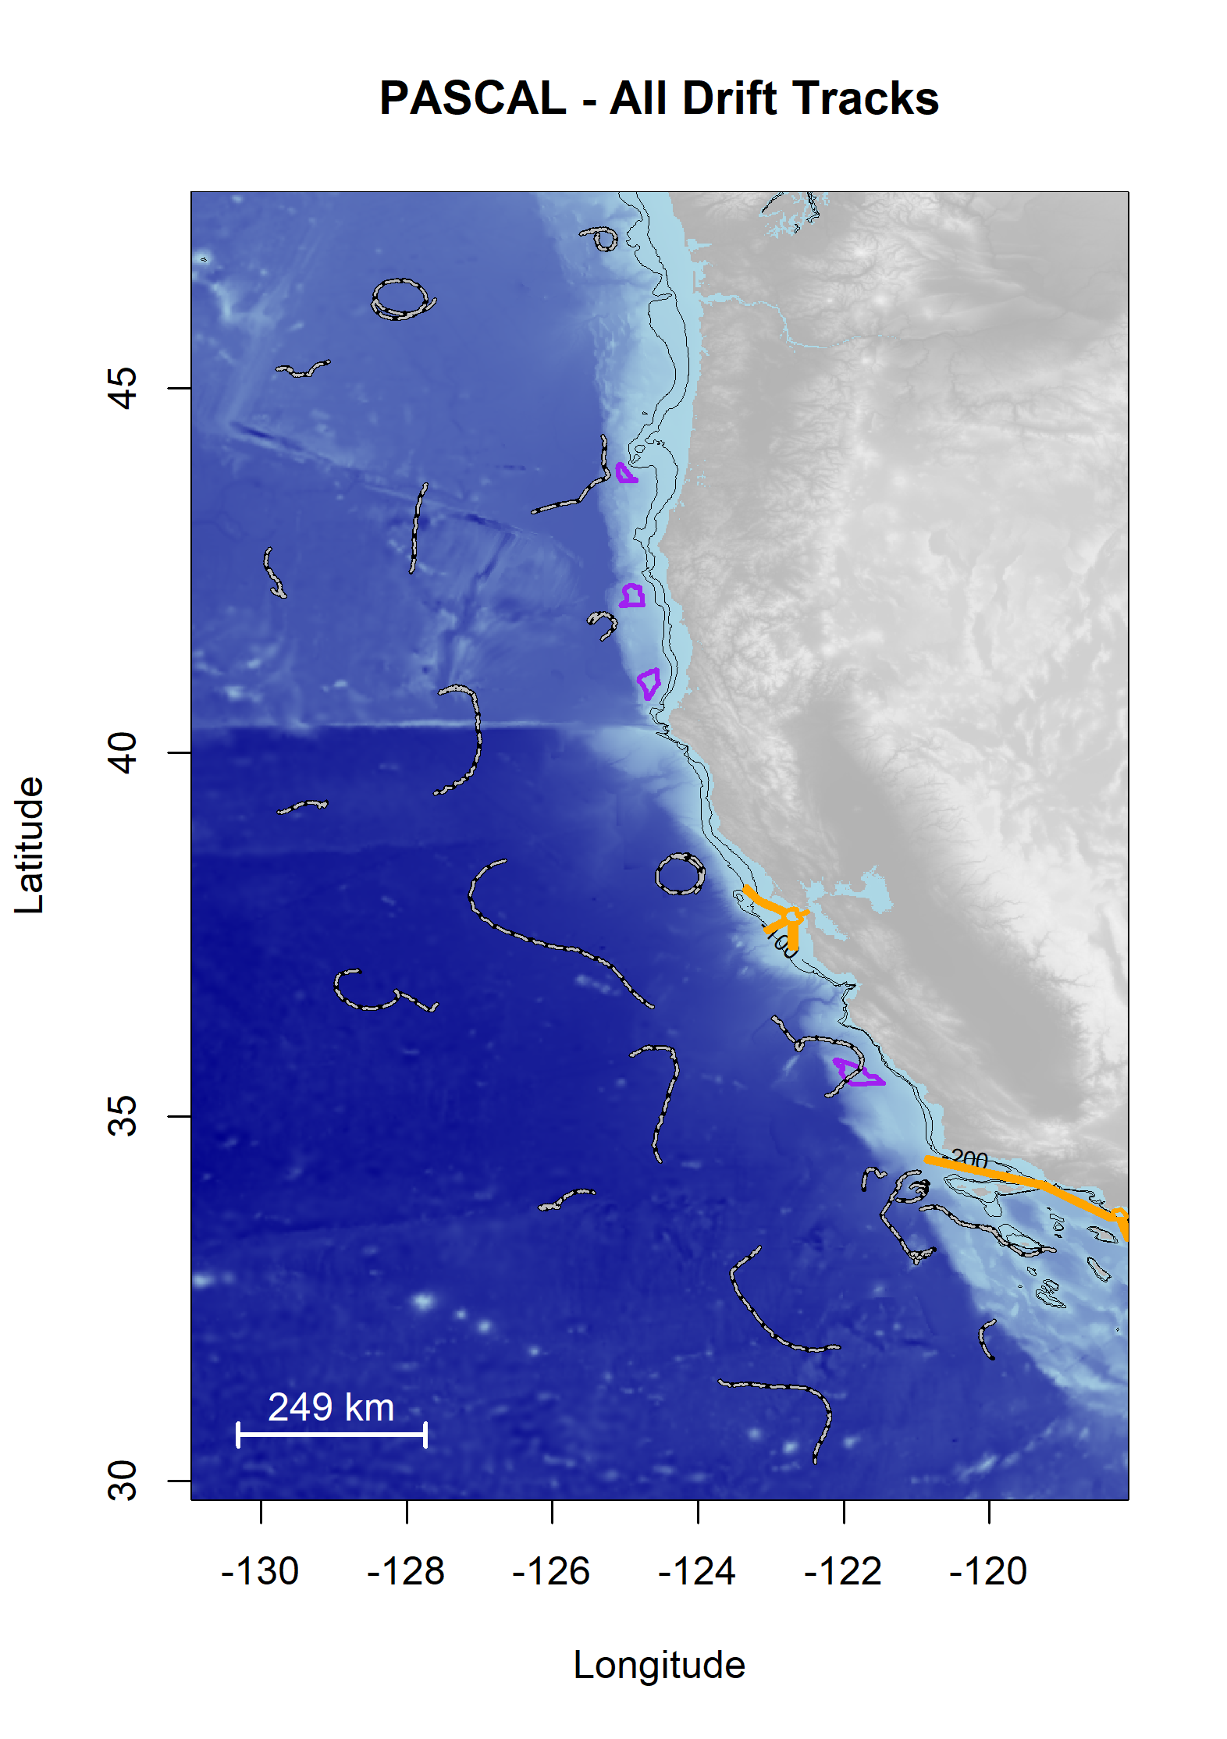

Figure ‑. Plot of all successful drifts deployed during the PASCAL Survey.

Drifts are shown as black/white lines; Wind Energy Areas are outlined in purple, and shipping lanes for entry to San Francisco Bay and in Southern California Bight are outlined in yellow

Data were analyzed following methods consistent with the Adrift data analysis, with slight modifications to address duty cycled data. The power spectral density plots (PSD) can be found online.[45]

Each of the major odontocete groups were detected during the PASCAL study (Figure B‑2).

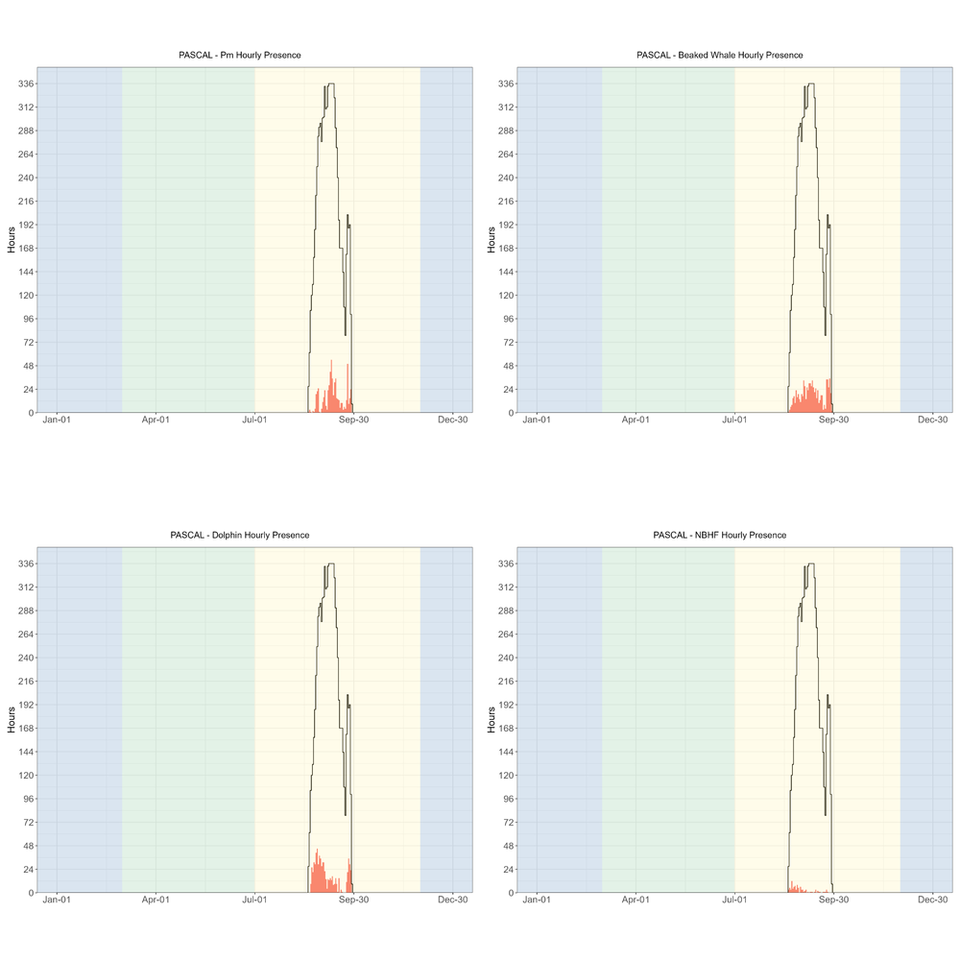

Figure ‑. Hourly presence of sperm whales, beaked whales, dolphins, and NBHF during the PASCAL 2016 survey.

Hourly presence (x axis) of sperm whales (top left), beaked whales (top right), dolphins (lower left), and NBHF (lower right) for months (y axis) and seasons (color bands) during the PASCAL 2016 survey. Black lines represent total available hours (effort) and bottom graph shows total effort for survey. Blue shading represents winter, green represents upwelling, and yellow represents the post-upwelling oceanographic season.

Blue whale detections were dominated by song, as the low hourly presence of D calls indicates that A/B (song) calls dominated the blue whale detections (Figure B‑3). Likewise, detection of fin whales was dominated by 20 Hz calls (Figure B‑3). There were no calls associated with Bryde's or Gray whales.

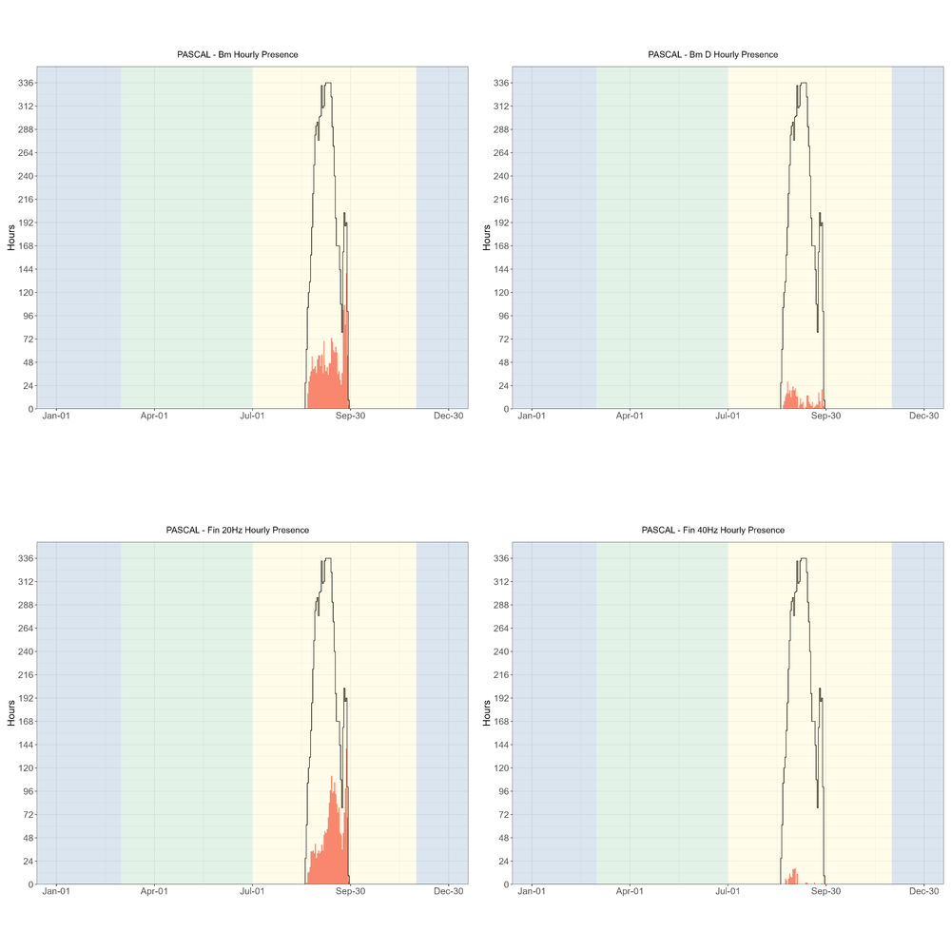

Figure ‑. Hourly presence of blue whales (all calls), blue whale D calls, fin whale 20 Hz, and fin whale 40 Hz during the PASCAL 2016 survey.

Hourly presence (x axis) of blue whales (all calls, top left), (b) blue whale D calls (top right), fin whale 20 Hz (lower left), and fin whale 40 Hz (lower right) for months (y axis) and seasons (color bands) during the PASCAL 2016 survey. Black lines represent total available hours (effort) and bottom graph shows total effort for survey. Blue shading represents winter, green represents upwelling, and yellow represents the post-upwelling oceanographic season.

There were few hourly detections of humpback whales (hourly presence plots can be found in our GitHub Repository.[46] Most of the PASCAL deployments were further offshore than the Adrift deployments, and this offshore distribution may be the reason for such low detection rates.

There were a few calls associated with sei and minke whales. There is little known about the vocal repertoire of sei whales in the Pacific Ocean, although a single encounter with four loud low-frequency downsweeps were detected and considered as 'possible' sei whale vocalizations (see spectrogram in GitHub Repository.[47] Minke whale boings are seasonal vocalizations and more frequently detected during the winter.

A complete list of successful drifting acoustic recorder deployments during the PASCAL survey are provided in Table B‑1 . Sites include Washington (WAS), Columbia River (COL), Oregon (ORE), Humboldt (HUM), Mendocino (MND), Point Arena (PTA), Monterey Bay (MBY), Morro Bay (MOB), Channel Islands (CHI), San Diego (SND), and Baja California Norte (BCN). See Figure 3.1 for more information on regions.

Table ‑. Summary of PASCAL deployments.

|  |  |  |  |  |  |  |  |  |  |  |  |  |  |  |  |  |  |  |  |  |  |  |  |  |  |  |  |
| --- | --- | --- | --- | --- | --- | --- | --- | --- | --- | --- | --- | --- | --- | --- | --- | --- | --- | --- | --- | --- | --- | --- | --- | --- | --- | --- | --- |
| **Drift ID** | **Site** | **Status** | **Deploy Date** | **Deploy Lat** | **Deploy Long** | **Recover Date** | | | | **Recover Lat** | | | | **Recover Long** | | **Recorder** | | **SR (kHz)** | | **Duty Cycle** | | **HP Depth (m)** | | **Data Start Date** | | **Data End Date** | |
| PASCAL_001 | ORE | Complete | 8/19/2016 | 44.35 | −125.31 | 8/31/2016 | | | | 43.29 | | | | −126.29 | | ST4300 | | 288 | | 2 min per 10 | | 100 | | 8/20/2016 | | 8/31/2016 | |
| PASCAL_002 | HUM | Complete | 8/21/2016 | 41.49 | −125.36 | 9/1/2016 | | | | 41.9 | | | | −125.32 | | ST4300 | | 288 | | 2 min per 10 | | 100 | | 8/20/2016 | | 9/1/2016 | |
| PASCAL_003 | MND | Complete | 8/21/2016 | 38.57 | −124.36 | 9/2/2016 | | | | 38.08 | | | | −124.03 | | ST4300 | | 288 | | 2 min per 10 | | 100 | | 8/21/2016 | | 9/2/2016 | |
| PASCAL_004 | MBY | Complete | 8/22/2016 | 36.35 | −122.95 | 9/3/2016 | | | | 36.05 | | | | −122.68 | | ST4300 | | 288 | | 2 min per 10 | | 100 | | 8/22/2016 | | 9/3/2016 | |
| PASCAL_005 | CHI | Complete | 8/22/2016 | 34.21 | −121.43 | 9/4/2016 | | | | 33.99 | | | | −121.72 | | ST4300 | | 288 | | 2 min per 10 | | 100 | | 8/22/2016 | | 9/4/2016 | |
| PASCAL_006 | BCN | Complete | 8/24/2016 | 32.19 | −119.91 | 9/12/2016 | | | | 32.61 | | | | −119.50 | | ST4300 | | 288 | | 2 min per 2 | | 100 | | 8/24/2016 | | 8/30/2016 | |
| PASCAL_007 | BCN | Complete | 8/25/2016 | 31.37 | −123.71 | 9/13/2016 | | | | 30.24 | | | | −122.39 | | SM3M | | 256 | | Continuous | | 100 | | 8/25/2016 | | 9/13/2016 | |
| PASCAL_008 | CHI | Complete | 8/26/2016 | 33.76 | −125.92 | 9/14/2016 | | | | 33.95 | | | | −125.39 | | SM2Bat | | 192 | | 2 min per 4 | | 100 | | 8/26/2016 | | 9/14/2016 | |
| PASCAL_009 | MBY | Complete | 8/27/2016 | 36.54 | −127.57 | 9/15/2016 | | | | 36.99 | | | | −128.64 | | ST300 | | 48 | | 2 min per 2 | | 100 | | 8/27/2016 | | 9/15/2016 | |
| PASCAL_009 | MBY | Complete | 8/27/2016 | 36.54 | −127.57 | 9/15/2016 | | | | 36.99 | | | | −128.64 | | ST4300 | | 288 | | 2 min per 10 | | 100 | | 8/27/2016 | | 9/15/2016 | |
| PASCAL_010 | MND | Complete | 8/27/2016 | 39.25 | −129.19 | 9/16/2016 | | | | 39.18 | | | | −129.76 | | SM3M | | 256 | | Continuous | | 100 | | 8/27/2016 | | 9/17/2016 | |
| PASCAL_011 | ORE | Complete | 8/28/2016 | 42.24 | −129.85 | 9/17/2016 | | | | 42.79 | | | | −129.87 | | SM2Bat | | 192 | | 2 min per 4 | | 100 | | 8/28/2016 | | 9/17/2016 | |
| PASCAL_012 | COL | Complete | 8/29/2016 | 45.26 | −129.78 | 9/17/2016 | | | | 45.37 | | | | −129.07 | | ST4300 | | 288 | | 2 min per 10 | | 100 | | 8/29/2016 | | 9/17/2016 | |
| PASCAL_013 | COL | Complete | 8/29/2016 | 46.23 | −127.61 | 9/18/2016 | | | | 46.33 | | | | −128.11 | | SM3M | | 256 | | 2 min per 2 | | 100 | | 8/29/2016 | | 9/15/2016 | |
| PASCAL_014 | WAS | Unusable | 8/30/2016 | 47.11 | −125.61 | 9/18/2016 | | | | 47.11 | | | | −125.38 | | SM2Bat | | 192 | | 2 min per 4 | | 100 | | 8/30/2016 | | 9/18/2016 | |
| PASCAL_015 | ORE | Complete | 8/31/2016 | 43.68 | −127.74 | 9/16/2016 | | | | 41.64 | | | | −129.28 | | ST4300 | | 288 | | 2 min per 2 | | 100 | | 8/31/2016 | | 9/5/2016 | |
| PASCAL_016 | HUM | Complete | 9/1/2016 | 40.81 | −127.54 | 9/20/2016 | | | | 39.43 | | | | −127.61 | | ST4300 | | 288 | | 2 min per 10 | | 100 | | 9/1/2016 | | 9/21/2016 | |
| PASCAL_017 | PTA | Complete | 9/2/2016 | 38.52 | −126.64 | 9/21/2016 | | | | 36.51 | | | | −124.62 | | SM3M | | 256 | | Continuous | | 100 | | 9/2/2016 | | 9/21/2016 | |
| PASCAL_018 | MBY | Complete | 9/3/2016 | 35.84 | −124.92 | 9/22/2016 | | | | 34.38 | | | | −124.52 | | SM2Bat | | 192 | | 2 min per 4 | | 100 | | 9/3/2016 | | 9/22/2016 | |
| PASCAL_019 | CHI | Complete | 9/4/2016 | 33.22 | −123.16 | 9/23/2016 | | | | 31.83 | | | | −122.06 | | ST4300 | | 288 | | 2 min per 10 | | 100 | | 9/4/2016 | | 9/23/2016 | |
| PASCAL_020 | CHI | Complete | 9/6/2016 | 33.14 | −118.99 | 9/29/2016 | | | | 33.73 | | | | −120.95 | | ST4300 | | 288 | | 2 min per 10 | | 100 | | 9/7/2016 | | 9/29/2016 | |
| PASCAL_021 | MOB | Complete | 9/4/2016 | 35.29 | −122.24 | 9/25/2016 | | | | 36 | | | | −122.56 | | ST4300 | | 288 | | 2 min per 10 | | 100 | | 9/3/2016 | | 9/25/2016 | |
| PASCAL_022 | SND | Complete | 9/5/2016 | 33.06 | −120.99 | 9/28/2016 | | | | 34.24 | | | | −120.95 | | ST4300 | | 288 | | 2 min per 10 | | 100 | | 9/5/2016 | | 9/28/2016 | |
| PASCAL_023 | SND | Complete | 9/24/2016 | 33 | −121.00 | 9/28/2016 | | | | 33.11 | | | | −120.92 | | ST4300 | | 288 | | 2 min per 2 | | 100 | | 9/24/2016 | | 9/28/2016 | |
| PASCAL_024 | SND | Complete | 9/24/2016 | 33.08 | −120.98 | 9/28/2016 | | | | 33.14 | | | | −120.81 | | ST300 | | 288 | | 2 min per 2 | | 100 | | 9/24/2016 | | 9/28/2016 | |
| PASCAL_024 | SND | Complete | 9/24/2016 | 33.08 | −120.98 | 9/28/2016 | | | | 33.14 | | | | −120.81 | | ST4300 | | 288 | | 2 min per 2 | | 100 | | 9/24/2016 | | 9/28/2016 | |
| **Table B-1. Summary of PASCAL deployments, con’t.** | | | | | |  |  |  |  | |  |  |  | |  | |  | |  | |  | |  | |  | |  | |
| **Drift ID** | **Site** | **Status** | **Deploy Date** | **Deploy Lat** | **Deploy Long** | **Recover Date** | | | | **Recover Lat** | | | | **Recover Long** | | **Recorder** | | **SR (kHz)** | | **Duty Cycle** | | **HP Depth (m)** | | **Data Start Date** | | **Data End Date** | |
| PASCAL_025 | SND | Complete | 9/24/2016 | 33.14 | −121.06 | 9/28/2016 | | | | 33.18 | | | | −120.75 | | ST4300 | | 288 | | 2 min per 2 | | 100 | | 9/24/2016 | | 9/28/2016 | |
| PASCAL_026 | CHI | Complete | 9/24/2016 | 34.35 | −121.08 | 9/26/2016 | | | | 34.09 | | | | −120.84 | | ST300 | | 288 | | 2 min per 2 | | 250 | | 9/24/2016 | | 9/26/2016 | |
| PASCAL_026 | CHI | Complete | 9/24/2016 | 34.35 | −121.08 | 9/26/2016 | | | | 34.09 | | | | −120.84 | | ST4300 | | 288 | | 2 min per 2 | | 100 | | 9/24/2016 | | 9/26/2016 | |
| PASCAL_027 | CHI | Complete | 9/24/2016 | 34.06 | −121.05 | 9/26/2016 | | | | 34.1 | | | | −120.86 | | ST4300 | | 288 | | 2 min per 2 | | 100 | | 9/24/2016 | | 9/26/2016 | |
| PASCAL_028 | CHI | Complete | 9/24/2016 | 33.97 | −120.99 | 9/29/2016 | | | | 33.86 | | | | −121.26 | | ST4300 | | 288 | | 2 min per 2 | | 100 | | 9/24/2016 | | 9/29/2016 | |
| PASCAL_029 | CHI | Complete | 9/26/2016 | 34.05 | −121.05 | 9/28/2016 | | | | 33.97 | | | | −120.87 | | ST4300 | | 288 | | 2 min per 2 | | 100 | | 9/26/2016 | | 9/28/2016 | |
| PASCAL_029 | CHI | Complete | 9/26/2016 | 34.05 | −121.05 | 9/28/2016 | | | | 33.97 | | | | −120.87 | | ST300 | | 288 | | 2 min per 2 | | 250 | | 9/26/2016 | | 9/28/2016 | |
| PASCAL_030 | CHI | Complete | 9/26/2016 | 34.04 | −121.08 | 9/28/2016 | | | | 34.02 | | | | −120.86 | | ST4300 | | 288 | | 2 min per 2 | | 100 | | 9/26/2016 | | 9/28/2016 | |

3. CCES Expanded Datasets

CCES was a multidisciplinary survey of the marine ecosystem from the US-Canada border south to Northern Baja California, Mexico. Background information on this survey as well as preliminary analysis of beaked whale, sperm whale, and narrow band high frequency species are provided in (Simonis 2020). A map of tracklines is provided in Figure C‑1.

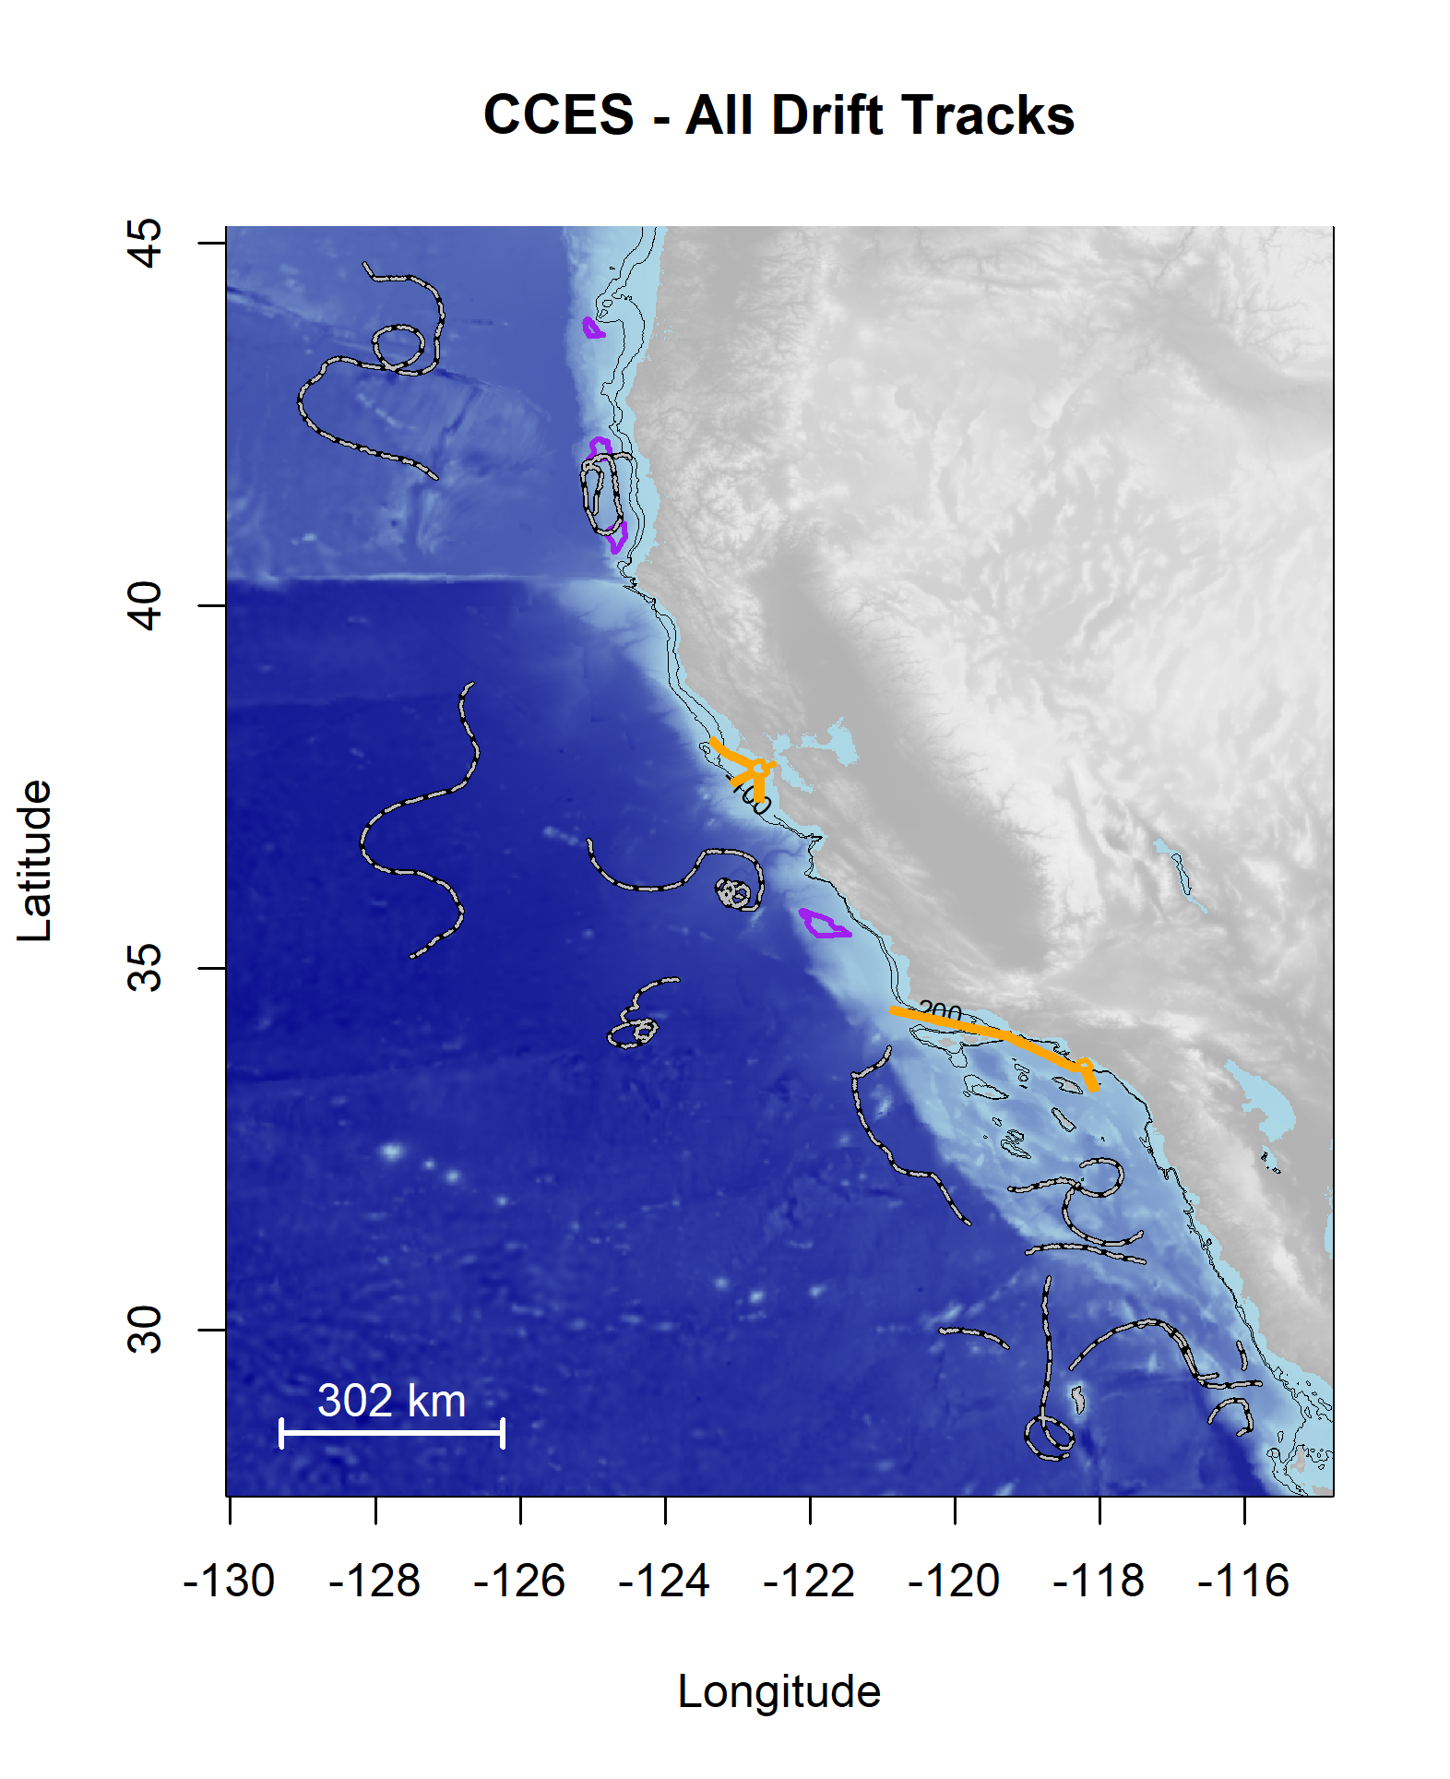

Figure ‑. Plot of all successful drifts deployed during the CCES Survey.

Drifts are shown as black/white lines; Wind Energy Areas are outlined in purple, and shipping lanes for entry to San Francisco Bay are outlined in yellow.

Data were analyzed following methods consistent with the Adrift data analysis, with slight modifications to address duty cycled data. The power spectral density plots (PSD) can be found online.[48]

Each of the major odontocete groups were detected during the CCES study (Figure C‑2).

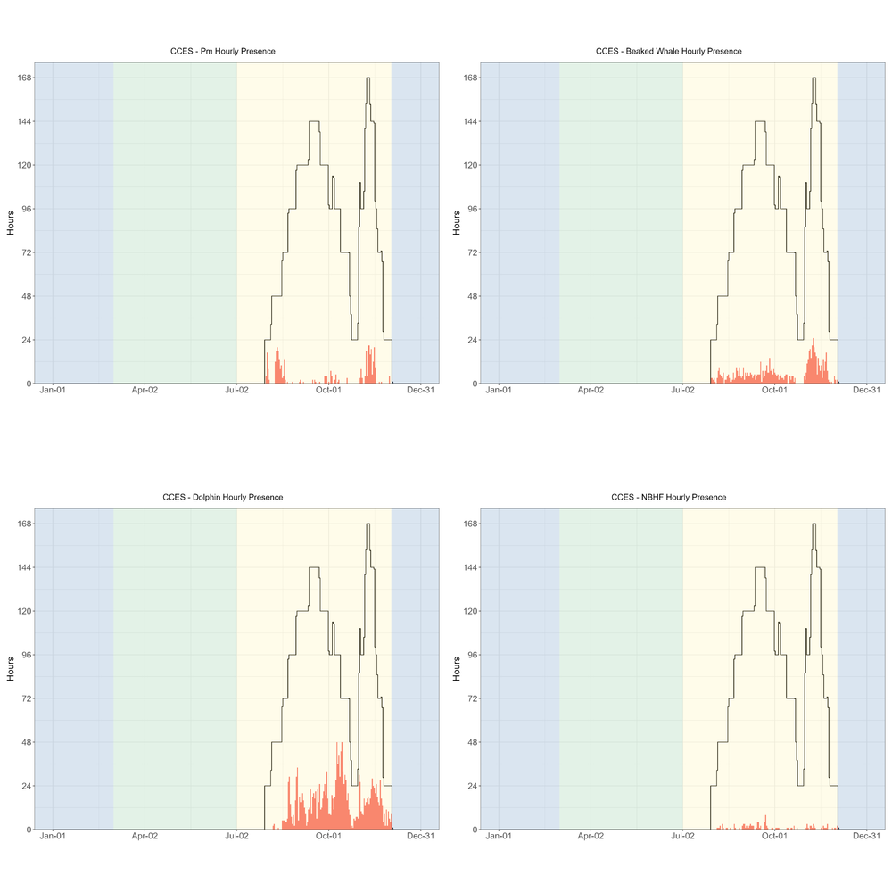

Figure ‑. Hourly presence of sperm whales, beaked whales, dolphins, and narrow band high frequency species during the CCES 2018 survey.

Hourly presence (y axis) of sperm whales (top left), beaked whales (top right), dolphins (lower left), and narrow band high frequency species (lower right) for months (x axis) and seasons (color bands) during the CCES 2018 survey. Black lines represent total available hours (effort) and bottom graph shows total effort for survey. Blue shading represents winter, green represents upwelling, and yellow represents the post-upwelling oceanographic season.

Blue whale detections were dominated by song, as the low hourly presence of D calls indicates that A/B (song) calls dominated the blue whale detections (Figure C‑3). There were a few minke whale detections in the later months of the survey. Detection of fin whales was dominated by 20 Hz calls (Figure C‑3). There were no Fin whale 40 Hz calls, or calls associated with Bryde's, sei, or gray whales.

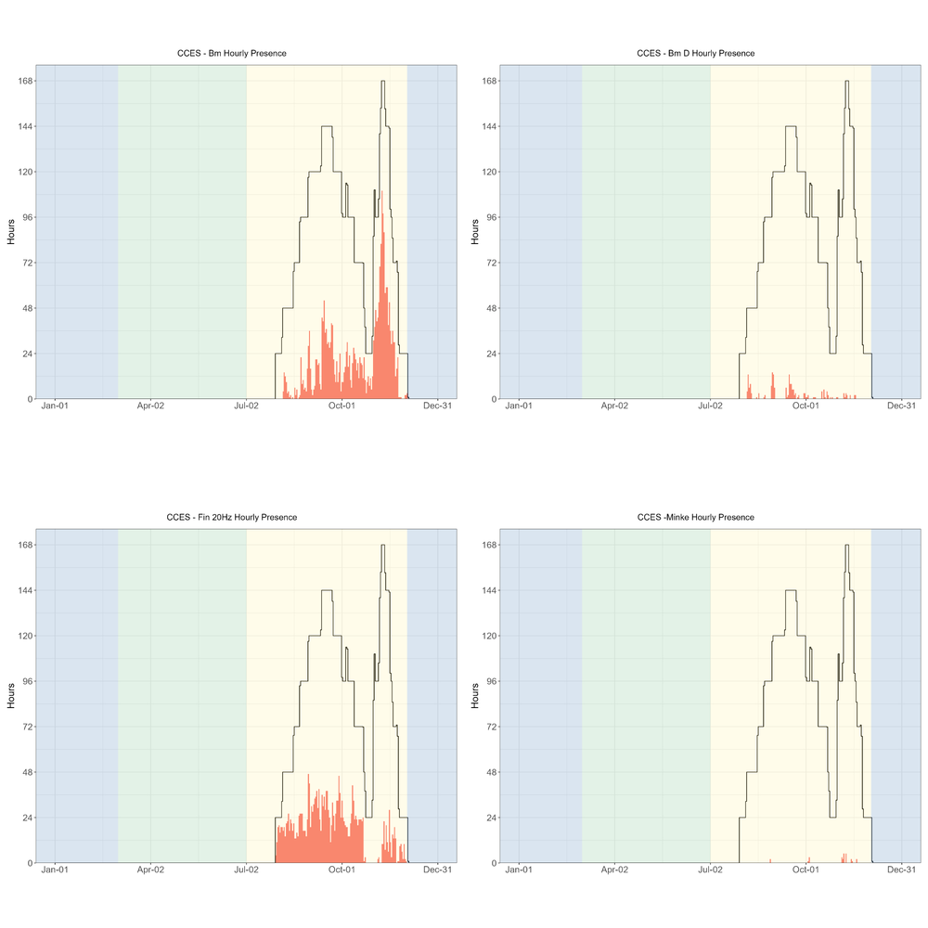

Figure ‑. Hourly presence of blue whales (all calls), blue whale D calls, fin whale 20 Hz, and minke whale calls during the CCES 2018 survey.

Hourly presence (y axis) of blue whales (all calls, top left), blue whale D calls (top right), fin whale 20 Hz (lower left), and minke whale calls (lower right) for months (x axis) and seasons (color bands) during the CCES 2018 survey. Black lines represent total available hours (effort) and bottom graph shows total effort for survey. Blue shading represents winter, green represents upwelling, and yellow represents the post-upwelling oceanographic season.

There were few hourly detections of humpback whales (hourly presence plots can be found in our GitHub Repository.[49] Most of the CCES deployments were further offshore than the Adrift deployments, and this offshore distribution may be the reason for such low detection rates.

A complete list of successful drifting recorder deployments during the CCES survey are provided in Table C‑1. Sites include Humboldt (HUM), Point Arena (PTA), Morro Bay (MOB), Channel Islands (CHI), and Baja California Norte (BCN). See Figure 3.1 for more information on regions.

Table ‑. Summary of CCES Deployments.

|  |  |  |  |  |  |  |  |  |  |  |  |  |  |  |
| --- | --- | --- | --- | --- | --- | --- | --- | --- | --- | --- | --- | --- | --- | --- |
| **Drift ID** | **Site** | **Status** | **Deploy Date** | **Deploy Lat** | **Deploy Long** | **Recover Date** | **Recover Lat** | **Recover Long** | **Recorder** | **SR (kHz)** | **Duty Cycle** | **HP Depth (m)** | **Data Start Date** | **Data End Date** |
| **CCES_004** | HUM | Complete | 7/25/2018 | 45.08 | −128.21 | 10/13/2018 | 41.76 | −127.15 | SM3M | 256 | 2 min per 20 | 100 | 7/30/2018 | 10/12/2018 |
| **CCES_007** | HUM | Complete | 8/5/2018 | 41.26 | −125.02 | 10/22/2018 | 42.04 | −124.48 | ST4300HF | 288 | 2 min per 20 | 150 | 8/5/2018 | 9/22/2018 |
| **CCES_008** | HUM | Complete | 8/16/2018 | 38.95 | −126.64 | 10/10/2018 | 34.38 | −128.32 | ST4300HF | 288 | 2 min per 20 | 150 | 8/16/2018 | 10/1/2018 |
| **CCES_010** | PTA | Complete | 8/22/2018 | 36.76 | −125.06 | 10/22/2018 | 35.97 | −122.94 | ST4300HF | 576 | 2 min per 20 | 150 | 8/22/2018 | 10/21/2018 |
| **CCES_012** | MOB | Complete | 8/30/2018 | 34.83 | −123.81 | 10/6/2018 | 34.03 | −124.39 | ST4300HF | 288 | 2 min per 20 | 150 | 8/30/2018 | 10/6/2018 |
| **CCES_013** | CHI | Complete | 9/11/2018 | 33.9 | −120.91 | 10/23/2018 | 31.44 | −119.78 | ST4300HF | 288 | 2 min per 20 | 150 | 9/11/2018 | 10/23/2018 |
| **CCES_014** | BCN | Complete | 10/5/2018 | 32.27 | −118.26 | 11/1/2018 | 31.95 | −119.25 | ST4300HF | 576 | 2 min per 20 | 150 | 10/5/2018 | 11/1/2018 |
| **CCES_016** | BCN | Complete | 10/30/2018 | 31.35 | −117.42 | 11/21/2018 | 32.13 | −118.03 | ST4300HF | 576 | 2 min per 10 | 150 | 10/30/2018 | 11/15/2018 |
| **CCES_017** | BCN | Complete | 10/31/2018 | 30.73 | −118.69 | 11/24/2018 | 28.29 | −118.44 | SM3M | 256 | 2 min per 4 | 100 | 10/31/2018 | 11/24/2018 |
| **CCES_018** | BCN | Complete | 10/31/2018 | 30.01 | −120.18 | 11/23/2018 | 29.51 | −118.82 | ST4300HF | 576 | 2 min per 6 | 150 | 10/31/2018 | 11/16/2018 |
| **CCES_019** | BCN | Complete | 11/1/2018 | 30.05 | −117.46 | 11/27/2018 | 28.4 | −115.55 | ST4300HF | 576 | 2 min per 10 | 150 | 11/1/2018 | 11/18/2018 |
| **CCES_020** | BCN | Complete | 11/5/2018 | 29.46 | −118.39 | 11/22/2018 | 29.39 | −116.34 | ST4300HF | 576 | 2 min per 10 | 150 | 11/5/2018 | 11/22/2018 |
| **CCES_021** | BCN | Complete | 11/6/2018 | 29.47 | −116.01 | 11/11/2018 | 29.82 | −116.08 | ST4300HF | 576 | 2 min per 6 | 150 | 11/6/2018 | 11/11/2018 |
| **CCES_022** | BCN | Complete | 11/7/2018 | 28.72 | −116.48 | 11/27/2018 | 28.28 | −116.68 | ST4300HF | 576 | 2 min per 10 | 150 | 11/7/2018 | 11/23/2018 |
| **CCES_023** | BCN | Complete | 11/22/2018 | 30.93 | −117.38 | 12/3/2018 | 31.05 | −119.01 | ST4300HF | 576 | 2 min per 5 | 150 | 11/22/2018 | 12/3/2018 |

1. Education and Outreach Details
   1. Formal and Information Education and Outreach

* "Bringing Ocean Acoustics Data to Classrooms"- Educator workshop to develop K-12 lesson plans based on passive acoustic datasets. Partners include San Diego County Office of Education and UCSD's Center for Research on Educational Equity, Assessment & Teaching Excellence. August 3-6, 2020.
* "Eavesdropping on the Ocean" Data Nugget.[50]
  1. Participatory research (aka "Citizen Science")

Ocean Voices, Zooniverse

* Collaboration with Dagny Ysais, SFSU (San Francisco State University) Master's student
* Beta version of online acoustic data analysis[51]
* Supporting code available.[52]
  1. Public access to acoustic data and tools
* Soundcloud[53] access to sample audio files (biological and anthropogenic sounds)
* Public Soundscape literature repository.[54]
  1. Media
* Will San Francisco’s wind farms damage underwater life? Here’s what scientists are finding.[55] San Francisco Chronicle, July 7 2022.
* How could offshore wind impact marine life off SLO County coast? Experts listen for answers.[56] San Luis Obispo Tribune. March 20, 2023.
  + 1. Blog Posts
* NOAA's Ocean Exploration Expedition Mission Logs: Partnerships for Common Goals: Acoustic Buoy to Study Marine Mammals in the California Current,[57] October 3, 2019
* Sound Bytes: Passive Acoustics Starts with the Right Equipment,[58] October 21, 2021
* Sound Bytes: The Power of Partnerships,[59] November 22, 2021
* Sound Bytes: Fresh Catch – Lessons from a Fisherman,[60] December 7, 2021
* Sound Bytes: Visualizing Marine Soundscapes Through CalSound,[61] December 16, 2021
* Sound Bytes: DriftWatch—What to Do When Buoys Go Rogue,[62] January 20, 2022
* Sound Bytes: The Coolest Pool You’ve Ever Seen,[63] February 3, 2022
* Sound Bytes: How I Acquired My Superpower,[64] February 10, 2022
* Sound Bytes: Out To Sea And Off To The Races,[65] March 3, 2022
* Sound Bytes: Ohana Means family,[66] April 6, 2022
* Sound Bytes: Hooking Young Students on Research,[67] May 3, 2022
* Sound Bytes: A High School Student’s Journey Into Marine Acoustic Research,[68] July 12, 2022
* Sound Bytes: Why We Look at Sound, and How You Can Help!,[69] September 23, 2022
* Sound Bytes: What We Can Learn From How Indigenous Peoples Listen,[70] October 11, 2022
* Sound Bytes: Championing Open Science,[71] December 7, 2022
* Sound Bytes: Gearing up for Field Work,[72] February 28, 2023
* Sound Bytes: Adventures of a Drifting Buoy,[73] April 25, 2023
* Sound Bytes: Learning Through Experience,[74] July 10, 2023
* Sound Bytes: Waving Goodbye to Adrift Fieldwork,[75] December 26, 2023
  1. Student and Intern Projects
* Pacific white-sided and Risso's dolphin acoustic monitoring in a warming California Current.[76] Alexandra Fiske, Seatech intern, Oakland Technical High School, 2021-2022
* Diurnal and Nocturnal Delphinid Echolocation Click Patterns off the California Coast in 2018.[77] Keisha Askoak, Seatech intern, Mt. Edgecumbe High School, 2022-23
* Occurrence of Anthropogenic Noise and Humpback Whales in California in 2018.[78] Audrey Bahnke, Sarah Bahnke, Virginia Pearson, Seatech interns, Mt. Edgecumbe High School, 2022-23.
* Spatial patterns in humpback whale song in central California waters.[79] Virginia Pearson, Seatech intern, Mt. Edgecumbe High School, 2023-24
* Spatial and temporal patterns of Bocaccio rockfish chorusing in central California.[80] Gale McCrary, Rie Christensen, Seatech interns, Mt. Edgecumbe High School, 2023-24.
* Using passive acoustic data to assess sperm whale population structure in the California Current. NOAA EPP Scholar Brittany Melton.
* 2021 NOAA EPP Projects: Humpback Whale Acoustics. NOAA EPP Scholar Maya Philipp.
* Assessing noise exposure to beaked and sperm whales in the California Current. Marina Bozinovic, Master of Science thesis, SFSU.
* Classifying species producing narrowband high-frequency echolocation clicks in the California Current. Jackson Vanfleet-Brown, Master of Science thesis, SFSU

|  |  |
| --- | --- |
| Image result for department of interior logo | **U.S. Department of the Interior (DOI)**  DOI protects and manages the Nation's natural resources and cultural heritage; provides scientific and other information about those resources; and honors the Nation’s trust responsibilities or special commitments to American Indians, Alaska Natives, and affiliated island communities. |
| BOEM Logo with wave through O | **Bureau of Ocean Energy Management (BOEM)**  BOEM’s mission is to manage development of U.S. Outer Continental Shelf energy and mineral resources in an environmentally and economically responsible way. |
|  | **BOEM Environmental Studies Program**  The mission of the Environmental Studies Program is to provide the information needed to predict, assess, and manage impacts from offshore energy and marine mineral exploration, development, and production activities on human, marine, and coastal environments. The proposal, selection, research, review, collaboration, production, and dissemination of each of BOEM’s Environmental Studies follows the DOI Code of Scientific and Scholarly Conduct, in support of a culture of scientific and professional integrity, as set out in the DOI Departmental Manual (305 DM 3). |

1. https://sael-swfsc.github.io/adrift-field-methods/content/Hardware-Summary.html
2. https://www.oceanscienceanalytics.com/
3. https://sael-swfsc.github.io/adrift-analysis-methods/
4. https://sael-swfsc.github.io/adrift-analysis-methods/content/DataArchive/DataPrep.html
5. https://github.com/SAEL-SWFSC/Adrift/blob/main/supplement/OSA_ADRIFT_060_UID1_Event.pdf
6. https://github.com/MarineBioAcousticsRC/Triton
7. https://sael-swfsc.github.io/adrift-analysis-methods/content/ToothedWhales/SpermWhales-Detection.html
8. http://pamguard.org/
9. https://sael-swfsc.github.io/adrift-analysis-methods/content/ToothedWhales/BeakedWhales-Detection.html
10. https://github.com/taikiSan21/roboj
11. https://sael-swfsc.github.io/adrift-analysis-methods/content/ToothedWhales/Dolphins-Detection.html
12. https://sael-swfsc.github.io/adrift-analysis-methods/content/ToothedWhales/NBHF-Detection.html
13. https://sael-swfsc.github.io/adrift-analysis-methods/content/BaleenWhales/Overview.html#blue-whales
14. https://github.com/SAEL-SWFSC/Adrift/blob/main/supplement/OSA_NMSF_2023.578_Project_Report.pdf
15. https://sael-swfsc.github.io/adrift-analysis-methods/content/BaleenWhales/Overview.html#fin-20-hz-adrift
16. https://github.com/SAEL-SWFSC/Adrift/blob/main/supplement/OSA_NMSF_2023.578_Project_Report.pdf
17. https://store.birds.cornell.edu/collections/raven-sound-software
18. https://sael-swfsc.github.io/adrift-analysis-methods/content/BaleenWhales/Overview.html#gray-and-humpack
19. https://seamap.env.duke.edu/species/180530
20. https://sael-swfsc.github.io/adrift-analysis-methods/content/BaleenWhales/Overview.html#fin-20-hz-adrift
21. https://github.com/SAEL-SWFSC/Adrift/blob/main/supplement/OSA_NMSF_2023.578_Project_Report.pdf
22. https://github.com/SAEL-SWFSC/Adrift/blob/main/figs/PossSei_Pascal010.png
23. https://sael-swfsc.github.io/adrift-analysis-methods/content/BaleenWhales/Overview.html#gray-and-humpack
24. https://seamap.env.duke.edu/dataset/861
25. https://sael-swfsc.github.io/adrift-analysis-methods/content/BaleenWhales/Overview.html#minke
26. https://sanctsound.ioos.us
27. https://sael-swfsc.github.io/adrift-analysis-methods/content/DataArchive/DataQualityCheck.html#scan-ltsa-for-noisy-data
28. https://sael-swfsc.github.io/adrift-analysis-methods/content/Soundscapes/Metrics.html#detect-vessels
29. https://apps-nefsc.fisheries.noaa.gov/pacm
30. https://sael-swfsc.github.io/adrift-analysis-methods/content/DataArchive/TethysDeployments.html
31. https://cran.r-project.org
32. https://drive.google.com/file/d/1VE2-jXCJet4iO_4bWywwW0dPtOK1BcLA/view
33. https://drive.google.com/file/d/1MsorXXkcHk8YNyHgldJ_-ApASLcEkoJy/view
34. https://drive.google.com/file/d/17qMPka0tTKjmF8jlAQD24QiWRzs3E9P4/view
35. https://www.sdcoe.net/ngss/phenomena-and-the-ngss
36. https://datanuggets.org/2024/04/eavesdropping-on-the-ocean
37. https://www.zooniverse.org/projects/annelistens/ocean-voices
38. https://github.com/TaikiSan21/wav2mp3
39. https://www.fisheries.noaa.gov/science-blog/sound-bytes-fresh-catch-lessons-fisherman
40. https://www.fisheries.noaa.gov/science-blog/sound-bytes-gearing-field-work
41. https://www.fisheries.noaa.gov/science-blog/sound-bytes-hooking-young-students-research
42. https://www.fisheries.noaa.gov/taxonomy/term/1000356091
43. https://www.ncei.noaa.gov/maps/passive-acoustic-data/
44. https://apps-nefsc.fisheries.noaa.gov/pacm
45. https://github.com/SAEL-SWFSC/Adrift/blob/main/figs/PASCAL_PSD_SeasonRegion.png
46. https://github.com/SAEL-SWFSC/Adrift/blob/main/figs/PASCAL_humpbackSongSocial_HourlyPresence.png
47. https://github.com/SAEL-SWFSC/Adrift/blob/main/figs/PossSei_Pascal010.png
48. https://github.com/SAEL-SWFSC/Adrift/blob/main/figs/CCES_PSD_SeasonRegion.png
49. https://github.com/SAEL-SWFSC/Adrift/blob/main/figs/CCES_humpbackSongSocial_HourlyPresence.png
50. https://datanuggets.org/2024/04/eavesdropping-on-the-ocean
51. https://www.zooniverse.org/projects/annelistens/ocean-voices
52. https://github.com/asimonis/OceanVoices
53. https://soundcloud.com/southwestacousticecology
54. https://www.zotero.org/groups/58164/soundscape
55. https://www.sfchronicle.com/climate/article/california-wind-farm-17277935.php#photo-22656909
56. https://www.sanluisobispo.com/news/local/environment/article273259360.html
57. https://oceanexplorer.noaa.gov/explorations/19express/logs/oct3/oct3.html
58. https://www.fisheries.noaa.gov/science-blog/sound-bytes-passive-acoustics-starts-right-equipment
59. https://www.fisheries.noaa.gov/science-blog/sound-bytes-power-partnerships
60. https://www.fisheries.noaa.gov/science-blog/sound-bytes-fresh-catch-lessons-fisherman
61. https://www.fisheries.noaa.gov/science-blog/sound-bytes-visualizing-marine-soundscapes-through-calsound
62. https://www.fisheries.noaa.gov/science-blog/sound-bytes-driftwatch-what-do-when-buoys-go-rogue
63. https://www.fisheries.noaa.gov/science-blog/sound-bytes-coolest-pool-youve-ever-seen
64. https://www.fisheries.noaa.gov/science-blog/sound-bytes-how-i-acquired-my-superpower
65. https://www.fisheries.noaa.gov/science-blog/sound-bytes-out-sea-and-races
66. https://www.fisheries.noaa.gov/science-blog/sound-bytes-ohana-means-family
67. https://www.fisheries.noaa.gov/science-blog/sound-bytes-hooking-young-students-research
68. https://www.fisheries.noaa.gov/science-blog/sound-bytes-high-school-students-journey-marine-acoustic-research
69. https://www.fisheries.noaa.gov/science-blog/sound-bytes-why-we-look-sound-and-how-you-can-help
70. https://www.fisheries.noaa.gov/science-blog/sound-bytes-what-we-can-learn-how-indigenous-peoples-listen
71. https://www.fisheries.noaa.gov/science-blog/sound-bytes-championing-open-science
72. https://www.fisheries.noaa.gov/science-blog/sound-bytes-gearing-field-work
73. https://www.fisheries.noaa.gov/science-blog/sound-bytes-adventures-drifting-buoy
74. https://www.fisheries.noaa.gov/science-blog/sound-bytes-learning-through-experience
75. https://www.fisheries.noaa.gov/science-blog/sound-bytes-waving-goodbye-adrift-fieldwork
76. https://www.youtube.com/watch?v=eGEglgvAQY8
77. https://youtu.be/qkdHeOOh0VY?t=2070
78. https://www.youtube.com/watch?v=qkdHeOOh0VY&t=1078s
79. https://youtu.be/XU-3Fo1XcBw?feature=shared
80. https://youtu.be/XU-3Fo1XcBw?feature=shared